Cusco & Machu Picchu, Andes, Peru
The Inca heartland is not a port — it is a pilgrimage. A multi-day overland journey takes cruise passengers from the Pacific coast into the clouds, past colonial Cusco, through the Sacred Valley, and finally to the stone citadel that has awed the world for centuries.
🏔️ Overland excursion (not a pier/tender stop) · 🕒 Minimum 2 nights / 3 days required · 💵 Currency: Peruvian Sol (PEN); USD widely accepted · 🗣️ Language: Spanish & Quechua · ✈️ Requires domestic flight Lima–Cusco
✍️ MY DAY IN PORT (FILL IN)
Ship / Date
In port | arrive ______ · all aboard ______
Booked excursion
Notes / meeting point
GETTING ASHORE
- Getting There: Fly from Lima (LIM) to Cusco (CUZ) — ~1 hr 20 min; then train + shuttle bus to Machu Picchu
- Altitude: Cusco: 11,152 ft (3,400 m); Machu Picchu: ~7,972 ft (2,430 m) — acclimatize carefully
- Best For: Bucket-list Inca ruins, Andean culture, Sacred Valley villages, train scenery
- Don't Miss: Machu Picchu citadel, Qorikancha in Cusco, train ride through Urubamba gorge, Ollantaytambo fortress
GETTING AROUND
- 🚕 Taxi: S/12–S/25 (~$3–$7 USD) — Taxis are plentiful in Cusco city. Official airport taxis charge S/15–25 for the short 5 km ride to Plaza de Armas. Nego
- 📱 Rideshare: ✅ Uber, Cabify, inDrive
TOP THINGS TO DO
- Machu Picchu Citadel — Classic Circuit — The 15th-century Inca estate perched on a cloud-forest ridge.
- Cusco City — Inca & Colonial Highlights — Walk the Plaza de Armas, enter Qorikancha (Temple of the Sun, partly destroyed to build the Santo Domingo Convent on top), and…
- Sacred Valley — Ollantaytambo & Pisac — The fertile Urubamba Valley between Cusco and Machu Picchu.
- Huayna Picchu or Machu Picchu Mountain Hike — Add-on hikes with separately ticketed access.
- Luxury Hiram Bingham Train Experience — PeruRail's premium Belmond Hiram Bingham train departs Poroy (near Cusco) for Aguas Calientes with gourmet meals, live Andean…
BEST WALKS
- Cusco Old City Centre Walk: 1.5–2 hrs | Easy (mostly flat) | Altitude: 11,152 ft — Stroll Cusco's historic core: begin at the Plaza de Armas, duck into the Cusco Cathedral (free…
- Aguas Calientes Town Wander: 30–45 min | Very easy | Altitude: 6,700 ft — The base town for Machu Picchu is compact and lively.
WEATHER · DAYLIGHT · MONEY
Month | High °F | Low °F | Rainy days
May | 61 | 43 | 10
Jul | 63 | 40 | 4
Sep | 64 | 44 | 12
Daylight: May 5:59AM–5:28PM · Jul 6:12AM–5:35PM · Sep 5:42AM–5:43PM
cruiseports.org/cusco-machu-picchu · Confirm terminal & all-aboard time with your ship

Cusco & Machu Picchu, Andes, Peru — Port Map
Red = walkable sights · Amber = excursions farther out · P = cruise terminal
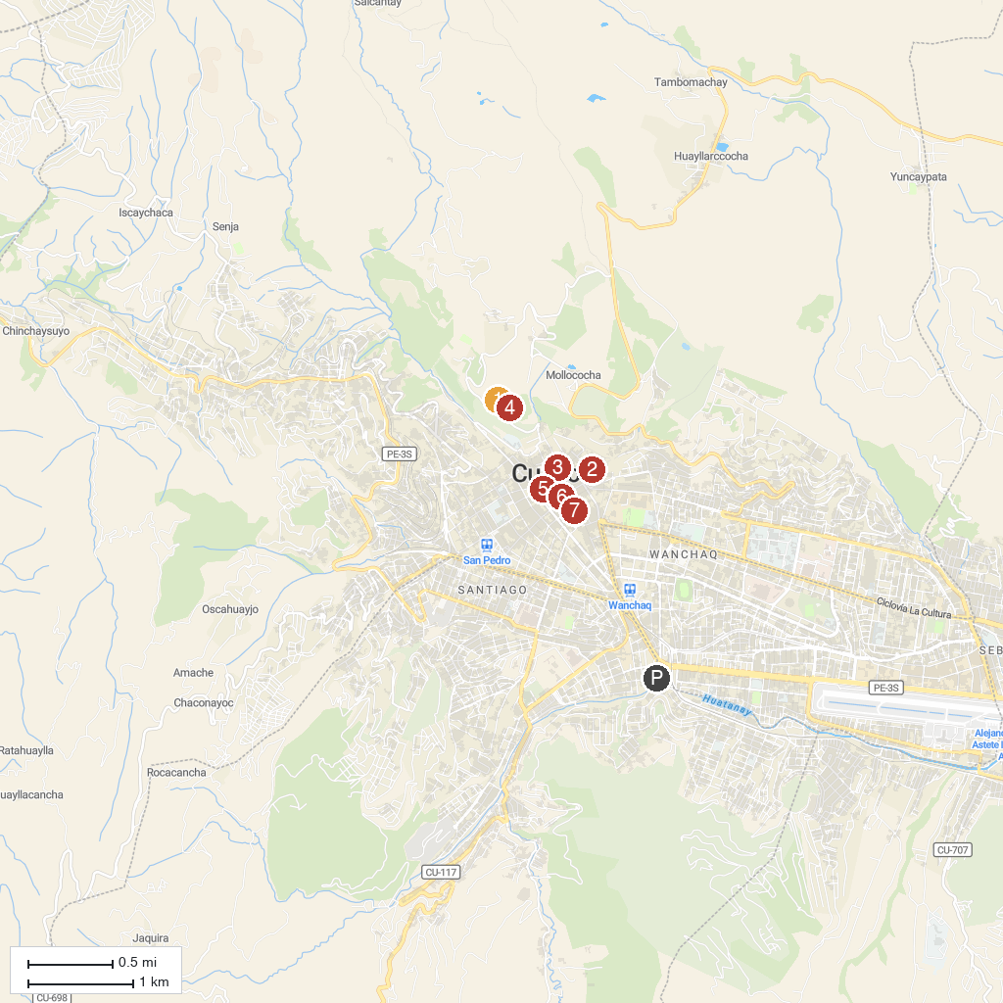
MAP KEY
1. Muyuq Marka | 5. Plaza de Armas
2. Templo del San Blas | 6. Museo Maximo Laura
3. Museo de Arte Precolombino Larco | 7. Dirección Desconcentrada de Cultura Cusco
4. Saqsaywaman
P. Cruise port / terminal
Map © MapTiler © OpenStreetMap contributors · cruiseports.org

