Curieuse Island, Seychelles
About a kilometre north of Praslin, Curieuse is an uninhabited Marine National Park where giant Aldabra tortoises roam free, Coco de Mer palms grow wild, and the only 'facility' is a restored colonial doctor's house.
⚓ Tender only (wet landing) · 🕒 Typical call: 4–6 hrs · 💵 Seychellois Rupee (SCR) / no shops on island · 🗣️ Seychellois Creole / English / French · 🐢 Marine National Park — park fee required
✍️ MY DAY IN PORT (FILL IN)
Ship / Date
In port | arrive ______ · all aboard ______
Booked excursion
Notes / meeting point
GETTING ASHORE
- Docking: Tender / zodiac — wet landing on sand at Baie Laraie
- Walk to highlights: Tortoises 5 min from landing; Doctor's House ~45 min trail
- Best For: Wildlife, nature, beaches, hiking
- Don't Miss: Free-roaming giant tortoises at the sanctuary nursery
GETTING AROUND
- 🚕 Taxi: ~€60/person (includes park entry) — Private water taxis from Praslin offer flexible scheduling to reach Curieuse. Price typically includes the marine park e
- 📱 Rideshare: ❌ not available
TOP THINGS TO DO
- Giant Tortoise Sanctuary — Roughly 250 Aldabra giant tortoises were introduced here in 1978 and now roam free across the island.
- Cross-Island Trail & Mangrove Boardwalk — A 1.5 km trail links Baie Laraie to Anse St.
- Doctor's House Museum — A beautifully restored French Creole colonial villa that served the island's leper colony (1829–1965).
- Anse St. José Beach & Swimming — The island's best swimming beach — powdery white sand framed by Seychellois granite boulders and calm turquoise water.
- Creole Beach BBQ Lunch — Most full-day excursions include a traditional Seychellois BBQ on the beach: grilled fish, Creole chicken, saffron rice, and…
BEST WALKS
- Baie Laraie to Anse St. José Trail: 1.5 km · 45–60 min · Moderate — The island's signature walk: begin at the tortoise nursery at Baie Laraie, cross the mangrove…
WEATHER · DAYLIGHT · MONEY
Month | High °F | Low °F | Rainy days
May | 83 | 79 | 23
Jul | 78 | 77 | 15
Sep | 80 | 77 | 18
Daylight: May 6:15AM–6:10PM · Jul 6:26AM–6:19PM · Sep 6:10AM–6:14PM
cruiseports.org/curieuse-island-seychelles · Confirm terminal & all-aboard time with your ship

Curieuse Island, Seychelles — Port Map
Red = walkable sights · Amber = excursions farther out · P = cruise terminal
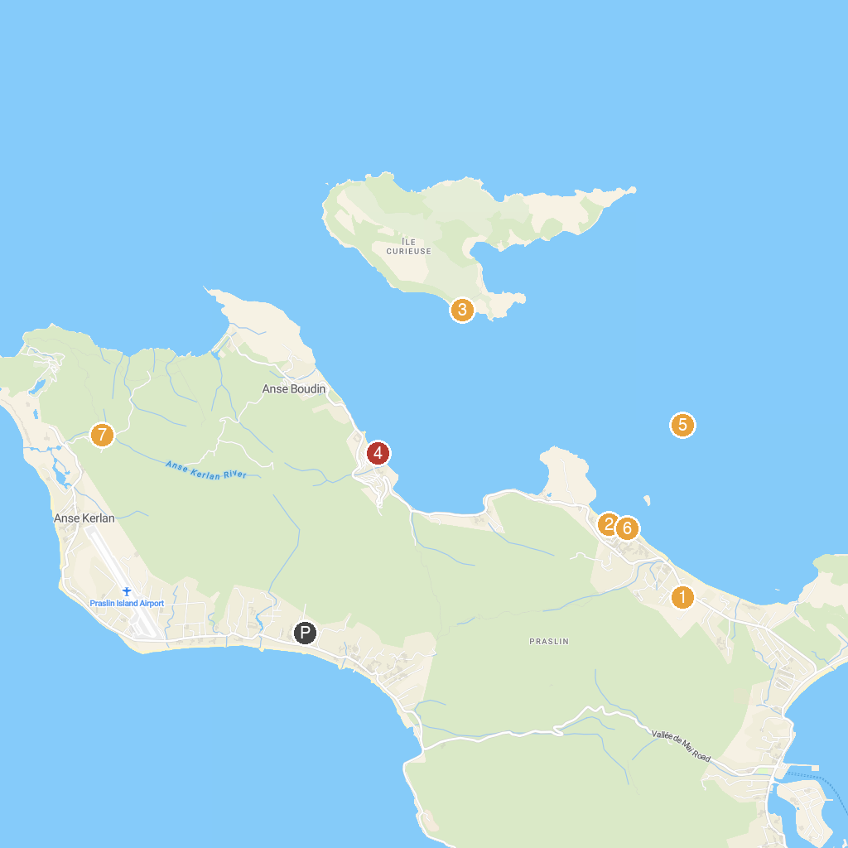
MAP KEY
1. Praslin Museum | 5. Anse Takamaka
2. Geoli Charters - Group Tours, Private Charters & Glass Bottom Boat | 6. Snorkeling St.Pierre
3. L’Union Estate Farm | 7. Gallery Passerose’s horizontal palm tree
4. Anse St. Jose | 8. Mont Plaisir to Anse Georgette Nature Trail
P. Cruise port / terminal
Map © MapTiler © OpenStreetMap contributors · cruiseports.org

