Culebra, Puerto Rico, USA
A tender-only gem in the Spanish Virgin Islands, Culebra delivers white-sand Flamenco Beach, sea turtle snorkeling, and a refreshingly undeveloped island vibe — no chain hotels, no mega-ship crowds.
⚓ Tender (no pier) · 🕒 Typical call: 6-8 hrs · 💵 US Dollar (USD) · 🗣️ Spanish & English · 🐢 Sea turtles & reefs
✍️ MY DAY IN PORT (FILL IN)
Ship / Date
In port | arrive ______ · all aboard ______
Booked excursion
Notes / meeting point
GETTING ASHORE
- Docking: 100% tender — ships anchor in Ensenada Honda; tenders land at Dewey town dock
- Walk to center: You arrive in Dewey town center; Flamenco Beach is 2.5 mi (need transport)
- Best For: World-class beach days, snorkeling with sea turtles, unspoiled island escape
- Don't Miss: Flamenco Beach's Navy tanks — graffiti-covered WWII-era Sherman tanks right on the sand
GETTING AROUND
- 🚕 Taxi: $5–$10/person — Shared vans wait at the ferry terminal and are the main local transport. Most common run is to Flamenco Beach; cash only
- 📱 Rideshare: ❌ not available
TOP THINGS TO DO
- Flamenco Beach Day — Consistently ranked among the world's top beaches — a horseshoe of blinding white sand with calm turquoise water.
- Sea Turtle Snorkeling — The Luis Peña Channel Marine Reserve around Tamarindo Beach is one of the Caribbean's best spots to snorkel with wild sea turtles.
- Culebrita Island Day Trip — Water taxis from Dewey dock ferry you to this tiny uninhabited island.
- Golf Cart Island Exploration — Rent a golf cart or Jeep and roam Culebra on your own schedule — Flamenco Beach, Zoni Beach's turtle nesting grounds, the…
- Dewey Lunch & Local Flavor — Wander Dewey's colorful streets and eat like a local.
BEST WALKS
- Dewey Village Stroll: 15 min · Flat · Free — From the tender dock, wander Dewey's handful of streets past colorful Caribbean buildings, the…
- Dock to Melones Beach: 15 min walk · Easy · Free snorkeling — Head west along the waterfront from the dock to reach Melones Beach — rocky but with excellent…
WEATHER · DAYLIGHT · MONEY
Month | High °F | Low °F | Rainy days
May | 81 | 78 | 12
Jul | 83 | 80 | 16
Sep | 84 | 80 | 18
Daylight: May 5:47AM–6:47PM · Jul 5:53AM–7:00PM · Sep 6:09AM–6:23PM
cruiseports.org/culebra · Confirm terminal & all-aboard time with your ship

Culebra, Puerto Rico, USA — Port Map
Red = walkable sights · Amber = excursions farther out · P = cruise terminal
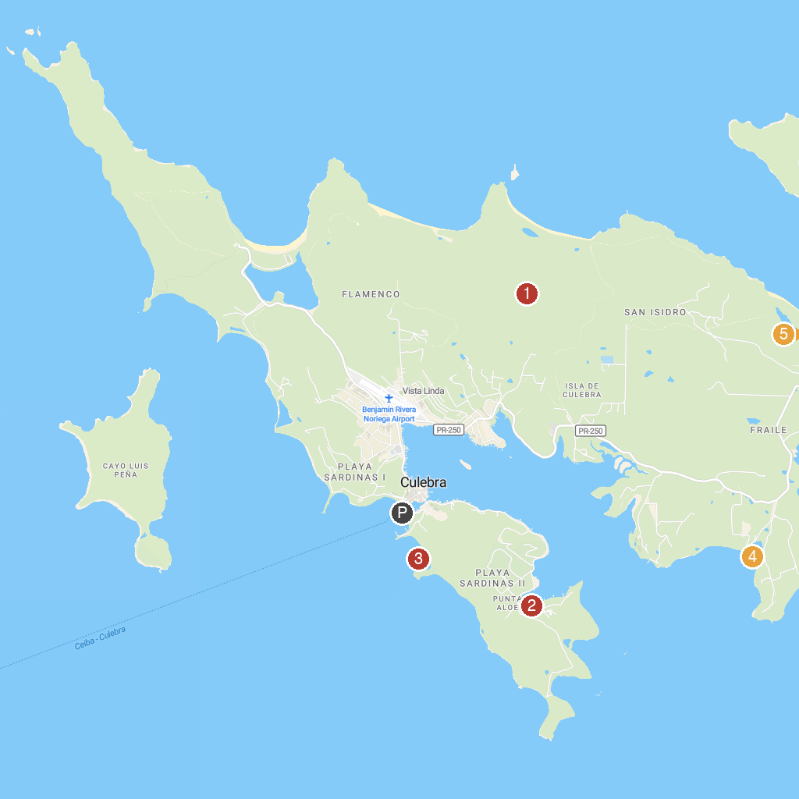
MAP KEY
1. Culebra National Wildlife Refuge | 4. Playa Mosquito
2. Captain Bill's Catamaran Charter | 5. Playa Zoni
3. Playa Dátiles
P. Cruise port / terminal
Map © MapTiler © OpenStreetMap contributors · cruiseports.org

