Culebra Island, Puerto Rico, USA
One of the Caribbean's last unspoiled islands — no high-rises, no fast food, just blindingly white sand, neon-turquoise water, and sea turtles. Only small ships call here, and that's exactly the point.
⚓ Tender only (no pier) · 🕒 Typical call: 6-8 hrs · 💵 US Dollar · 🗣️ English & Spanish
✍️ MY DAY IN PORT (FILL IN)
Ship / Date
In port | arrive ______ · all aboard ______
Booked excursion
Notes / meeting point
GETTING ASHORE
- Docking: Tender to Dewey ferry dock — all ships anchor in Ensenada Honda
- Walk to center: Immediate — tender drops at Dewey town dock
- Best For: Beaches, snorkeling with sea turtles, unspoiled Caribbean vibe
- Don't Miss: Flamenco Beach & the graffiti-covered WWII Navy tanks on the sand
GETTING AROUND
- 🚕 Taxi: $5–$10/person — Shared taxi vans wait at the Dewey dock and ferry terminal. The most common route is to Flamenco Beach — about $5–$10 pe
- 📱 Rideshare: ❌ not available
TOP THINGS TO DO
- Flamenco Beach — Consistently ranked one of the world's top beaches, Flamenco is a horseshoe of white sand and calm turquoise water.
- Snorkel with Sea Turtles at Tamarindo Beach — The Luis Peña Marine Reserve off Tamarindo and Melones beaches is home to green sea turtles, spotted eagle rays, and healthy coral.
- Day Trip to Isla Culebrita — Water taxi to this uninhabited sister island reveals 'The Jacuzzi' natural tidal pool, Playa Tortuga (nesting sea turtle beach)…
- Kayak the Luis Peña Marine Reserve — Paddle through mangrove channels and into the protected reserve for a chance to spot turtles, rays, and tropical fish.
- Golf Cart Island Exploration — Rent a golf cart in Dewey and drive the entire island at your own pace — Flamenco Beach, Zoni Beach (with views to St.
BEST WALKS
- Dewey Town Stroll: 0.5 mi · Flat · 20 min — Dewey is tiny and walkable end-to-end in 20 minutes.
WEATHER · DAYLIGHT · MONEY
Month | High °F | Low °F | Rainy days
May | 81 | 78 | 12
Jul | 83 | 80 | 16
Sep | 84 | 80 | 18
Daylight: May 5:47AM–6:47PM · Jul 5:53AM–7:00PM · Sep 6:09AM–6:23PM
cruiseports.org/culebra-island · Confirm terminal & all-aboard time with your ship

Culebra Island, Puerto Rico, USA — Port Map
Red = walkable sights · Amber = excursions farther out · P = cruise terminal
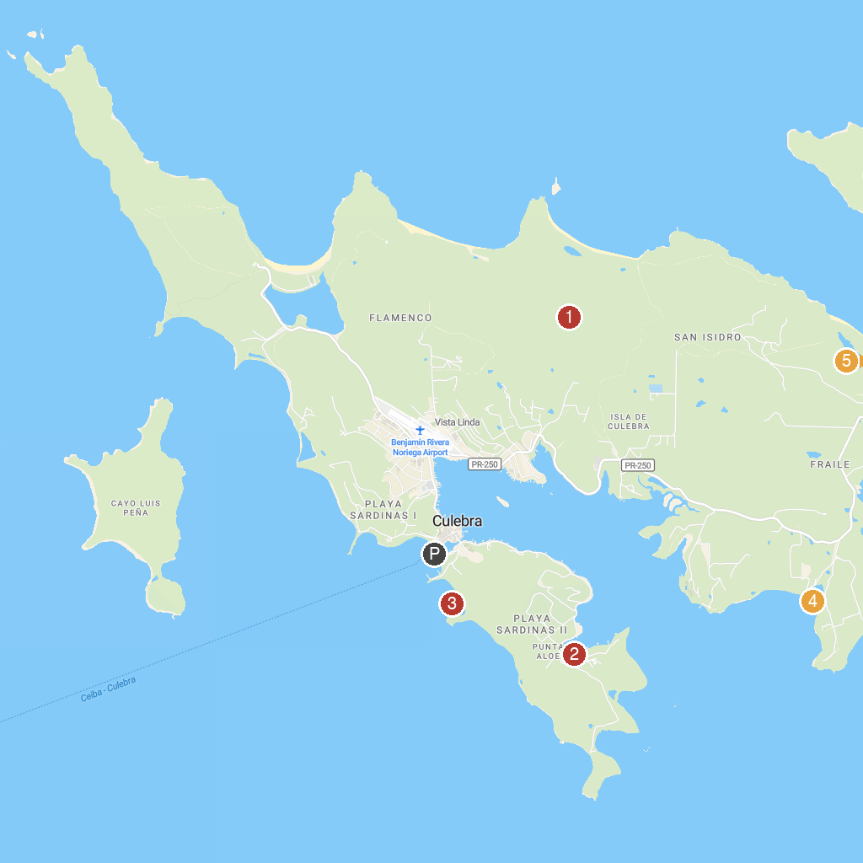
MAP KEY
1. Culebra National Wildlife Refuge | 4. Playa Mosquito
2. Captain Bill's Catamaran Charter | 5. Playa Zoni
3. Playa Dátiles
P. Cruise port / terminal
Map © MapTiler © OpenStreetMap contributors · cruiseports.org

