Crotone, Calabria, Italy
One of Magna Graecia's mightiest cities, Crotone trades ancient columns and a brooding Spanish castle for an authentic, unhurried Southern Italian port day — fiery food, golden sand, and zero tourist crowds.
⚓ Docked (pier) · 🕒 Typical call: 6–9 hrs · 💶 Euro (€) · 🗣️ Italian
✍️ MY DAY IN PORT (FILL IN)
Ship / Date
In port | arrive ______ · all aboard ______
Booked excursion
Notes / meeting point
GETTING ASHORE
- Docking: Pier (Riva quay / Molo Foraneo) — 5–15 min walk to centre
- Walk to centre: ~800 m to Piazza Pitagora (10–15 min)
- Best For: Ancient Greek history, beaches, Calabrian food & wine
- Don't Miss: Castle of Charles V, Capo Colonna ruins, 'Nduja & Cirò wine
GETTING AROUND
- 🚕 Taxi: €5–8 — Taxis are available at the port and offer a short, inexpensive ride to the old town or city center. No advance booking t
TOP THINGS TO DO
- Capo Colonna — Temple of Hera Lacinia — One solitary Doric column stands on a headland 10 km from port — the last remnant of a vast Greek sanctuary.
- Le Castella Aragonese Castle — A dramatic 15th-century fortress built on a tiny island connected to the Calabrian shore by a stone causeway, framed by turquoise…
- Santa Severina — Medieval Hilltop Village — One of Italy's 'Most Beautiful Villages', this Norman-castle town sits above the Neto river valley with a rare Byzantine…
- National Archaeological Museum of Crotone — Downtown museum holding the 'Treasure of Hera' and artefacts from Kroton, once one of the most powerful cities of ancient Magna…
- City Beach & Lido Day — Crotone's sandy Ionian beach begins steps from the port.
BEST WALKS
- Port to Piazza Pitagora & the Castle: ~1 km · 15 min · Easy — Walk the Lungomare promenade from the pier to the main square, then climb a few steps to the…
- Historic Centre Loop: ~1.5 km · 25 min · Easy — From the castle, dive into the labyrinthine centro storico — narrow medieval alleys, the Cathedral…
WEATHER · DAYLIGHT · MONEY
Month | High °F | Low °F | Rainy days
May | 74 | 58 | 8
Jul | 90 | 72 | 3
Sep | 82 | 67 | 8
Daylight: May 5:38AM–7:57PM · Jul 5:38AM–8:16PM · Sep 6:33AM–6:59PM
cruiseports.org/crotone · Confirm terminal & all-aboard time with your ship

Crotone, Calabria, Italy — Port Map
Red = walkable sights · Amber = excursions farther out · P = cruise terminal
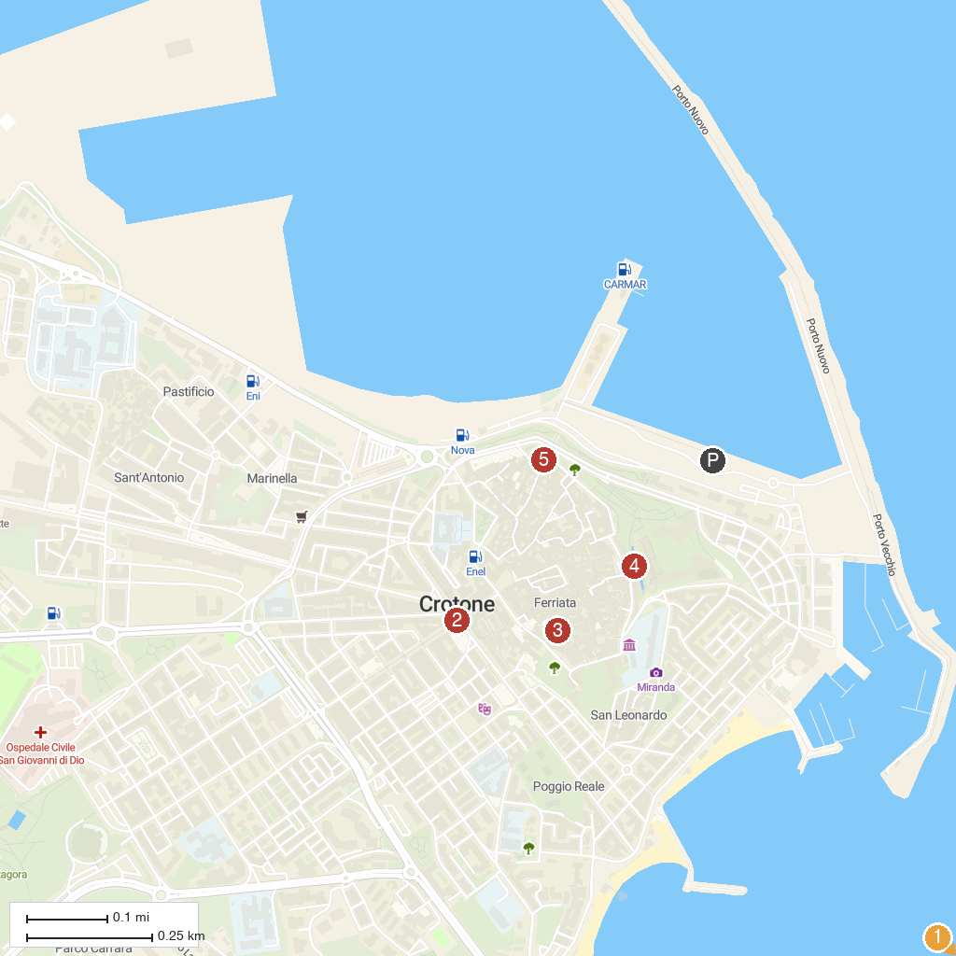
MAP KEY
1. Archaeological Site of Cape Colonna | 4. Charles V Castle
2. Piazza Pitagora | 5. Palazzo Giunti
3. Church of Santa Chiara
P. Cruise port / terminal
Map © MapTiler © OpenStreetMap contributors · cruiseports.org

