Crisfield, Maryland, USA
The self-proclaimed Crab Capital of the World, Crisfield sits at the tip of Maryland's Eastern Shore — a slow-paced Chesapeake Bay town built quite literally on a foundation of oyster shells.
⚓ Docked (City Dock / Somers Cove) · 🕒 Typical call: 6-8 hrs · 💵 US Dollar · 🗣️ English · 🦀 Seafood destination
✍️ MY DAY IN PORT (FILL IN)
Ship / Date
In port | arrive ______ · all aboard ______
Booked excursion
Notes / meeting point
GETTING ASHORE
- Docking: Docked at City Dock or Somers Cove Marina; small-ship port only (American Cruise Lines)
- Walk to center: 0–3 min to Main Street and waterfront from the dock
- Best For: Maryland blue crabs, island cruises to Smith & Tangier Islands, Chesapeake Bay history
- Don't Miss: A steamed crab lunch at Linton's, the J. Millard Tawes Historical Museum, and sunset over the Sound
GETTING AROUND
- 🚕 Taxi: $8 one-way within Crisfield; $14 round-trip — Crisfield Transportation (Big City Cab & Somerset Shuttle) serves the port at Somers Cove Marina. The marina is already
- 📱 Rideshare: ✅ Uber
TOP THINGS TO DO
- Smith Island Day Trip — Ferry across Tangier Sound to Maryland's only inhabited offshore island — a watermen's community reachable only by boat.
- Tangier Island Cruise — Board a passenger ferry to Tangier Island, Virginia — a unique island community with its own distinct dialect and way of life.
- J. Millard Tawes Historical Museum — Step inside Crisfield's story at this waterfront museum — from the region's Native American heritage and the Annemessex people…
- Steamed Blue Crabs at Linton's — Crisfield earned its 'Crab Capital of the World' title for good reason.
- Janes Island State Park Kayak — Just outside town, Janes Island State Park offers a maze of undisturbed salt marsh channels perfect for kayaking.
BEST WALKS
- Waterfront & Main Street Stroll: 0.5 miles · Easy · 20-30 min — Walk from the dock along the Somers Cove waterfront to Main Street.
WEATHER · DAYLIGHT · MONEY
Month | High °F | Low °F | Rainy days
May | 72 | 60 | 11
Jul | 85 | 75 | 12
Sep | 79 | 69 | 10
Daylight: May 5:53AM–8:07PM · Jul 5:53AM–8:25PM · Sep 6:45AM–7:10PM
cruiseports.org/crisfield-md · Confirm terminal & all-aboard time with your ship

Crisfield, Maryland, USA — Port Map
Red = walkable sights · Amber = excursions farther out · P = cruise terminal
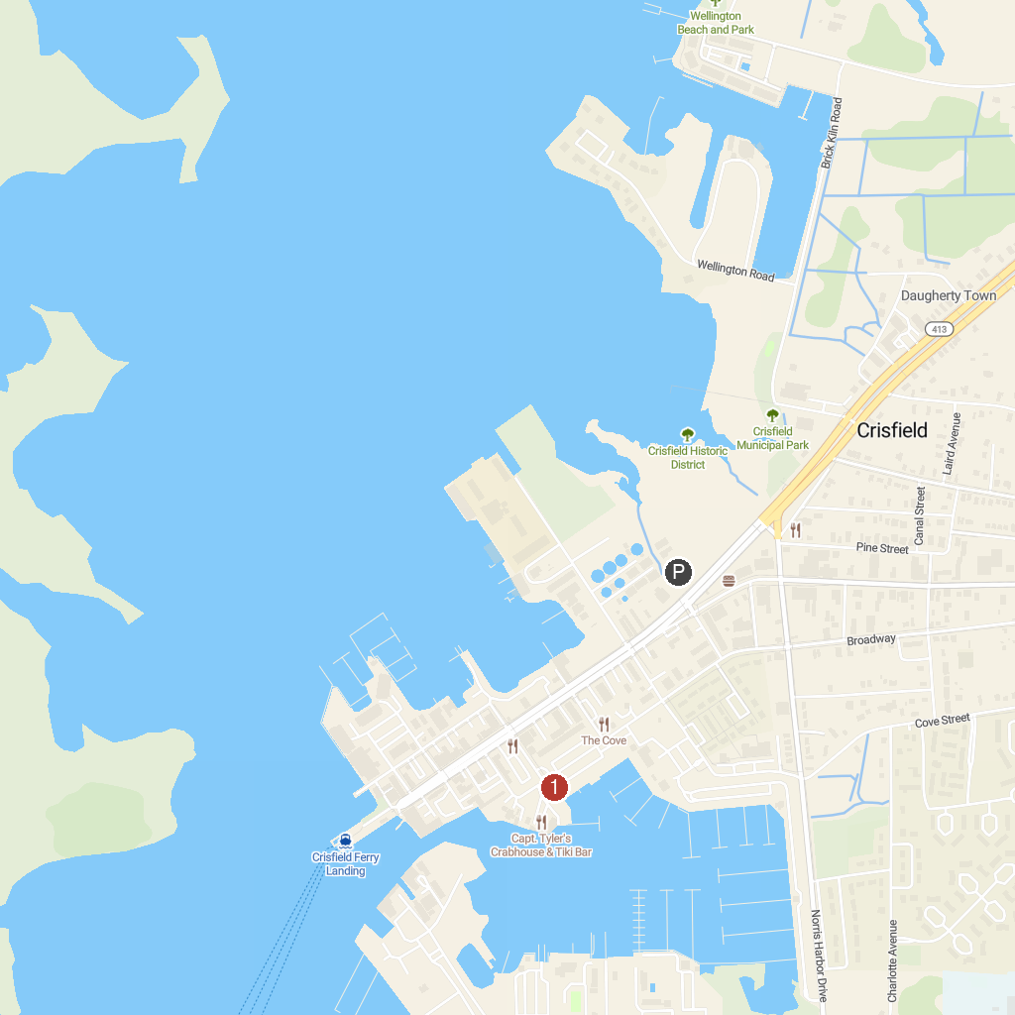
MAP KEY
1. Delmarva Discovery Museum | 5. Guard Shore Beach
2. Somerset County Recreation and Parks | 6. Cypress Park
3. J Millard Tawes Historical Museum | 7. Eastern Shore Railway Museum
4. Tangier History Museum
P. Cruise port / terminal
Map © MapTiler © OpenStreetMap contributors · cruiseports.org

