Crinan, Argyll, Scotland
At the western end of the 200-year-old Crinan Canal, this impossibly small harbour punches above its weight — ancient kingdoms, an Atlantic rainforest, beavers, and langoustines landed metres from your plate.
⚓ Tender (anchor in Loch Crinan) · 🕒 Typical call: 5–7 hrs · 💷 Currency: GBP · 🗣️ English (Scottish Gaelic heritage) · 🚢 Small ships & expedition vessels only
✍️ MY DAY IN PORT (FILL IN)
Ship / Date
In port | arrive ______ · all aboard ______
Booked excursion
Notes / meeting point
GETTING ASHORE
- Docking: Tender — ships anchor in Loch Crinan; tenders land at canal sea-lock pontoon
- Walk to centre: 0 min — village is the pontoon; end-to-end in 10 min on foot
- Best For: History, nature walks, Atlantic rainforest, Scotland's finest seafood
- Don't Miss: Kilmartin Glen prehistoric monuments & Dunadd Fort (needs transport)
GETTING AROUND
- 🚕 Taxi: £17–£21 — Pre-book local taxis (KJ Cars or Octopus Cars) to Lochgilphead, the nearest town ~7 miles away. Journey takes about 11 m
TOP THINGS TO DO
- Kilmartin Glen — Scotland's Prehistoric Heartland — Over 800 ancient monuments — stone circles, burial cairns, and standing stones — pack a six-mile valley rated among the most…
- Dunadd Fort — Throne of the Gaelic Kings — Climb this dramatic rocky crag rising from the Moine Mhòr wetlands to stand where early Scottish kings were crowned.
- Knapdale Beaver Trail — Walk the trail around Barnluasgan Loch in Knapdale Forest — the site of Scotland's first licensed wild beaver reintroduction.
- Corryvreckan Whirlpool Boat Trip — The world's third-largest whirlpool churns in the Gulf of Corryvreckan between Jura and Scarba.
- Crinan Wood — Atlantic Rainforest Walk — Follow the 1.5-mile loop trail through ancient oak woodland draped in moss and ferns directly behind the Crinan Hotel.
BEST WALKS
- Canal Basin & Towpath Stroll: 1–2 miles · Easy · 45 min — From the sea-lock pontoon, walk east along the canal towpath watching yachts work the hand-cranked…
- Crinan Wood Viewpoint Loop: 1.5 miles · Moderate · 1 hr — Take the signed trail uphill behind the Crinan Hotel through ancient oak and birch.
WEATHER · DAYLIGHT · MONEY
Month | High °F | Low °F | Rainy days
May | 55 | 45 | 16
Jul | 61 | 53 | 19
Sep | 59 | 51 | 18
Daylight: May 5:08AM–9:29PM · Jul 4:57AM–9:58PM · Sep 6:54AM–7:39PM
cruiseports.org/crinan · Confirm terminal & all-aboard time with your ship

Crinan, Argyll, Scotland — Port Map
Red = walkable sights · Amber = excursions farther out · P = cruise terminal
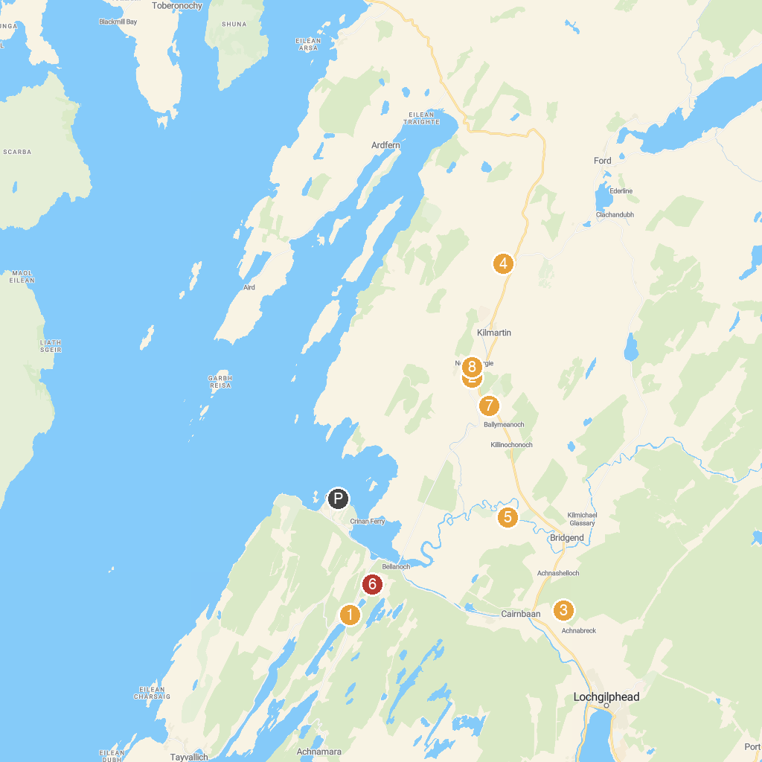
MAP KEY
1. Knapdale Scottish Beaver Trail | 5. Dunadd Fort
2. Nether Largie Standing Stones | 6. Argyll Beaver & Wildlife Visitor Centre
3. Achnabreac Forest | 7. Dunchraigaig Cairn
4. Carnasserie Castle | 8. Nether Largie South Cairn
P. Cruise port / terminal
Map © MapTiler © OpenStreetMap contributors · cruiseports.org

