Cres, Kvarner, Croatia
One of the Adriatic's largest islands, Cres trades mass tourism for griffon vultures, pristine lakes, cliff-top villages, and lamb roasted over open fire — 'No Stress on Cres' is no marketing line.
⚓ Tender (most ships anchor offshore) · 🕒 Typical call: 6-8 hrs · 💶 Currency: Euro (€) · 🗣️ Language: Croatian (Italian & English widely spoken)
✍️ MY DAY IN PORT (FILL IN)
Ship / Date
In port | arrive ______ · all aboard ______
Booked excursion
Notes / meeting point
GETTING ASHORE
- Docking: Tender for most ships; smaller vessels can dock at Cres Town pier
- Walk to center: 0 min — tender drops at historic Mandrač harbor
- Best For: Nature lovers, slow-travel fans, off-the-beaten-path seekers
- Don't Miss: Griffon vulture centre in Beli and the cliff village of Lubenice
GETTING AROUND
- 🚕 Taxi: €5–€15 — Local taxis are available near the harbor. Fares within Cres Town are modest; longer island transfers (e.g. to Valun or
- 📱 Rideshare: ✅ Uber
TOP THINGS TO DO
- Griffon Vulture Rescue Centre, Beli — Drive 30 min north to the eco-village of Beli where the Caput Insulae centre rehabilitates injured Eurasian griffon vultures…
- Lubenice — Clifftop Village & Sveti Ivan Beach — A 4,000-year-old stone village perched 378 m above the Adriatic with only a handful of permanent residents.
- Lake Vrana Scenic Drive — Croatia's largest natural lake sits in the island's interior — its bottom lies 74 m below sea level while its surface is above it.
- Cres Town Medieval Walk & Museum — Explore Porta Marcella gate, the 16th-century Venetian tower, the Church of St Mary of the Snow, and the Petris (Arsan-Petris)…
- Kovačine & Melin Beach — A 15–20 min walk west of the harbor along the coastal promenade leads to Kovačine beach — pebble shore, pine shade, crystal-clear…
BEST WALKS
- Mandrač to Kovačine Beach Promenade: 2.5 km • 20 min • Easy flat path — From the harbor, follow the coastal lungomare west past the campsite road to Kovačine beach.
- Cres Old Town Heritage Loop: 1 km • 30 min • Easy — Start at Porta Marcella gate, walk the town walls to the Venetian tower, cut through Trg Frane…
- Olive Tree Path (Staza Portula): 3 km loop • 1 hr • Easy-moderate — A signposted trail from the edge of town through ancient stone-walled olive groves — some trees…
WEATHER · DAYLIGHT · MONEY
Month | High °F | Low °F | Rainy days
May | 68 | 59 | 12
Jul | 83 | 73 | 7
Sep | 74 | 66 | 10
Daylight: May 5:33AM–8:24PM · Jul 5:30AM–8:45PM · Sep 6:41AM–7:12PM
cruiseports.org/cres-island-croatia · Confirm terminal & all-aboard time with your ship

Cres, Kvarner, Croatia — Port Map
Red = walkable sights · Amber = excursions farther out · P = cruise terminal
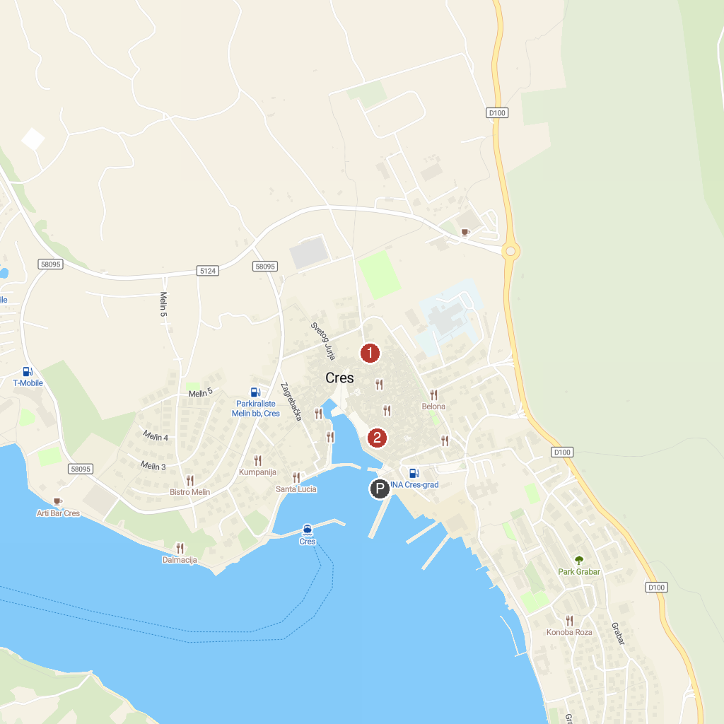
MAP KEY
1. Frankopan Castle | 3. Grad Cres
2. Semisubmarine Krk | 4. Cres Museum
P. Cruise port / terminal
Map © MapTiler © OpenStreetMap contributors · cruiseports.org

