Cousin Island, Seychelles
One of the Indian Ocean's last truly wild islands — fearless seabirds nest inches from your feet, giant tortoises roam freely, and hawksbill turtles come ashore on pristine granite beaches. Only small expedition ships call here, and every visit is a guided, conservation-funded experience.
⚓ Tender — warden boats only (no pier) · 🕒 Typical call: 3-4 hrs (Mon–Fri only) · 💵 Entrance fee: ~SCR 600 / €40 per person · 🗣️ English & Seychellois Creole · 🌿 Nature reserve — guided visits only
✍️ MY DAY IN PORT (FILL IN)
Ship / Date
In port | arrive ______ · all aboard ______
Booked excursion
Notes / meeting point
GETTING ASHORE
- Docking: Anchor offshore; transfer to reserve warden patrol boats ~200 m from shore
- Best For: Wildlife photography, rare endemic birds, hawksbill turtles, pristine beaches
- Don't Miss: Seychelles warbler, Seychelles fody, fearless white terns, giant tortoises
- Important Limits: Open Mon–Fri 9:45 am–12:30 pm only; no restaurants, shops, or toilets on island
GETTING AROUND
- 🚕 Taxi: SCR 250–600 (~$15–$37 USD) — If tendering at Baie Sainte Anne on Praslin, government-regulated taxis are available at the jetty. Confirm fares before
TOP THINGS TO DO
- Guided Nature Walk with Reserve Wardens — The island's own young conservationists lead a ~90-minute circuit through granite outcrops, coastal forest, and nesting colonies.
- Hawksbill Turtle Watching — Cousin Island hosts one of the densest nesting populations of hawksbill turtles in the Indian Ocean.
- Birdwatching — Seychelles Endemics — Cousin Island is one of the last strongholds of the Seychelles warbler and Seychelles fody, both globally threatened species.
BEST WALKS
- Guided Island Circuit: ~1.5 km · Easy · ~90 min · Guided only — A single looping trail led by reserve wardens takes in the granite interior, coastal forest…
WEATHER · DAYLIGHT · MONEY
Month | High °F | Low °F | Rainy days
May | 30 | 26 | 10
Jul | 28 | 24 | 8
Sep | 29 | 25 | 9
Daylight: May 5:50AM–8:44PM · Jul 5:47AM–9:05PM · Sep 6:59AM–7:30PM
cruiseports.org/cousin-island-seychelles · Confirm terminal & all-aboard time with your ship

Cousin Island, Seychelles — Port Map
Red = walkable sights · Amber = excursions farther out · P = cruise terminal
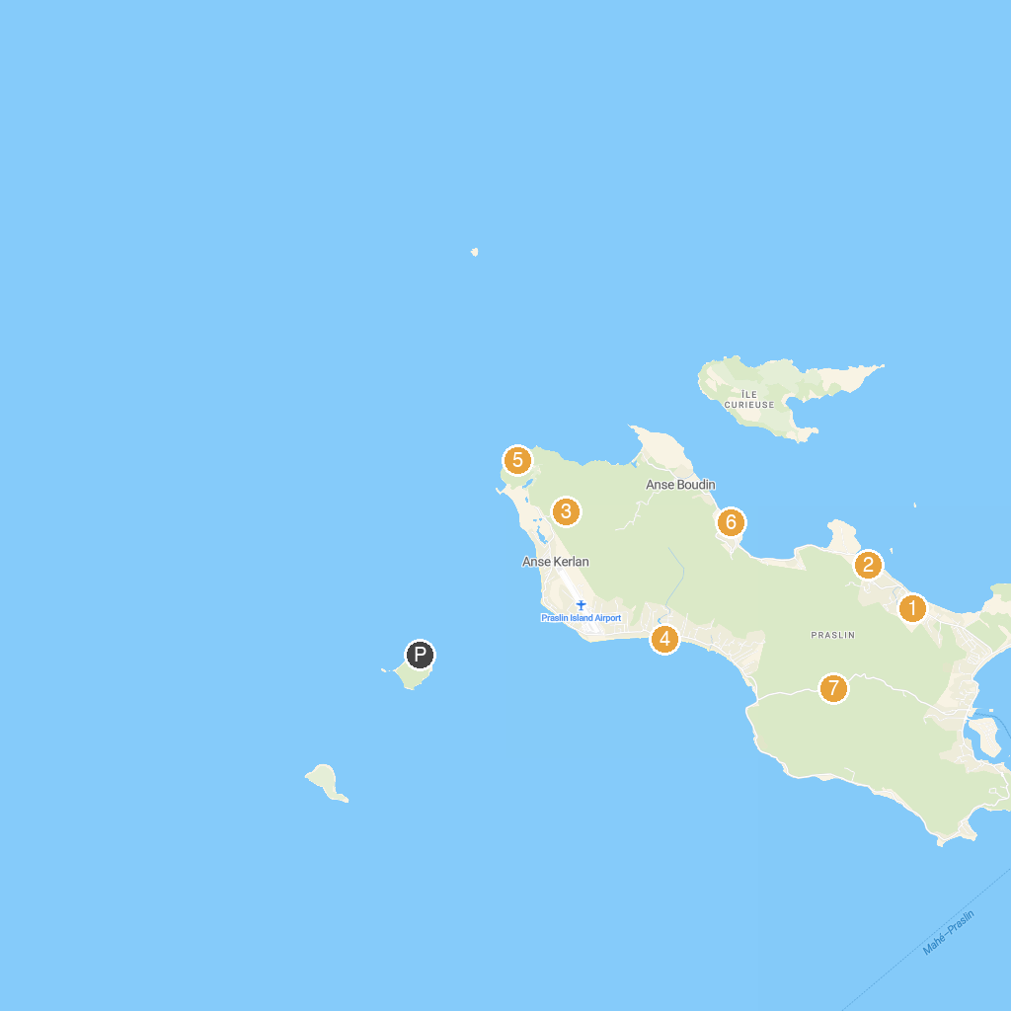
MAP KEY
1. Praslin Museum | 5. Anse Georgette
2. Geoli Charters - Group Tours, Private Charters & Glass Bottom Boat | 6. Anse Takamaka
3. Mont Plaisir to Anse Georgette Nature Trail | 7. Praslin National Park Waterfall
4. Grand Anse Beach
P. Cruise port / terminal
Map © MapTiler © OpenStreetMap contributors · cruiseports.org

