Côte d'Azur, French Riviera, France
Cliff-hugging villages, glamorous harbors, and the bluest water in Europe — the Côte d'Azur packs four distinct worlds into a single, rail-connected coastline. Dock in one port, explore them all.
⚓ Mixed: Tender (Cannes & Villefranche) / Pier (Monaco & small-ship Nice) · 🕒 Typical call: 8–10 hrs · 💶 Currency: Euro (€) · 🗣️ French (English widely spoken in tourist areas) · 🚆 Coastal TER train links all four ports
✍️ MY DAY IN PORT (FILL IN)
Ship / Date
In port | arrive ______ · all aboard ______
Booked excursion
Notes / meeting point
GETTING ASHORE
- Docking: Cannes & Villefranche: tender. Monaco: pier at Port Hercule. Nice (Port Lympia): small ships only (<190m by berth length)
- Walk to center: Instant at Cannes & Villefranche tender docks. Monaco: 10 min flat + elevator to Monaco-Ville. Nice: 15–20 min or 5 min by tram
- Best For: Glamour, beaches, hilltop villages, casino culture, world-class food and art
- Don't Miss: Monaco's Formula 1 circuit, Cannes' Île Sainte-Marguerite, Villefranche's Rue Obscure, Nice's socca at Chez Pipo
GETTING AROUND
- 🚕 Taxi: €10–€35 depending on port — Taxis are metered and widely available. Nice Port Lympia to city center runs €15–€20; Cannes tender pier is walkable to
- 📱 Rideshare: ✅ Uber, Bolt
- 🚌 Hop-on hop-off: ✅
TOP THINGS TO DO
- Monaco Full Day: Formula 1, Casino & the Rock — Walk the actual F1 Grand Prix circuit around Port Hercule, then take the elevator or bus up to Monaco-Ville's medieval lanes and…
- Èze Village & Perfume Factories — Perched 1,400ft above the sea, this eagle's-nest medieval village is one of the most dramatic sights on the Riviera.
- Îles de Lérins from Cannes — A 15-minute ferry from Cannes' Vieux Port drops you on Île Sainte-Marguerite, the wooded island where the 'Man in the Iron Mask'…
- Vieux Nice: Food Market, Old Town & Castle Hill — Dive into Cours Saleya's morning flower-and-produce market, wander the Italian-influenced maze of Vieux Nice, then take the free…
- Beach Day at Plage des Marinières, Villefranche — A 10-minute flat walk from the Villefranche tender dock leads to one of the best free beaches on the Riviera — a long crescent of…
BEST WALKS
- Villefranche Old Town & Cocteau Chapel Loop: 1.5 miles · 45–60 min · easy (flat old town, gentle slopes) — From the tender dock, walk along Quai de l'Amiral Courbet past waterfront restaurants to the tiny…
- Cannes: La Croisette to Le Suquet: 2 miles · 1–1.5 hrs · easy (one moderate hill to Le Suquet) — Step off the tender directly onto the Vieux Port and walk east along La Croisette, the palm-lined…
- Monaco: Harbor Walk to Monaco-Ville: 1.5 miles · 1–1.5 hrs · moderate (vertical — use public elevators) — From Port Hercule, walk the F1 start/finish line painted on the quay, then head around the harbor…
WEATHER · DAYLIGHT · MONEY
Month | High °F | Low °F | Rainy days
May | 70 | 57 | 9
Jul | 83 | 70 | 4
Sep | 77 | 65 | 6
Daylight: May 6:05AM–8:49PM · Jul 6:03AM–9:09PM · Sep 7:10AM–7:40PM
cruiseports.org/cote-dazur · Confirm terminal & all-aboard time with your ship

Côte d'Azur, French Riviera, France — Port Map
Red = walkable sights · Amber = excursions farther out · P = cruise terminal
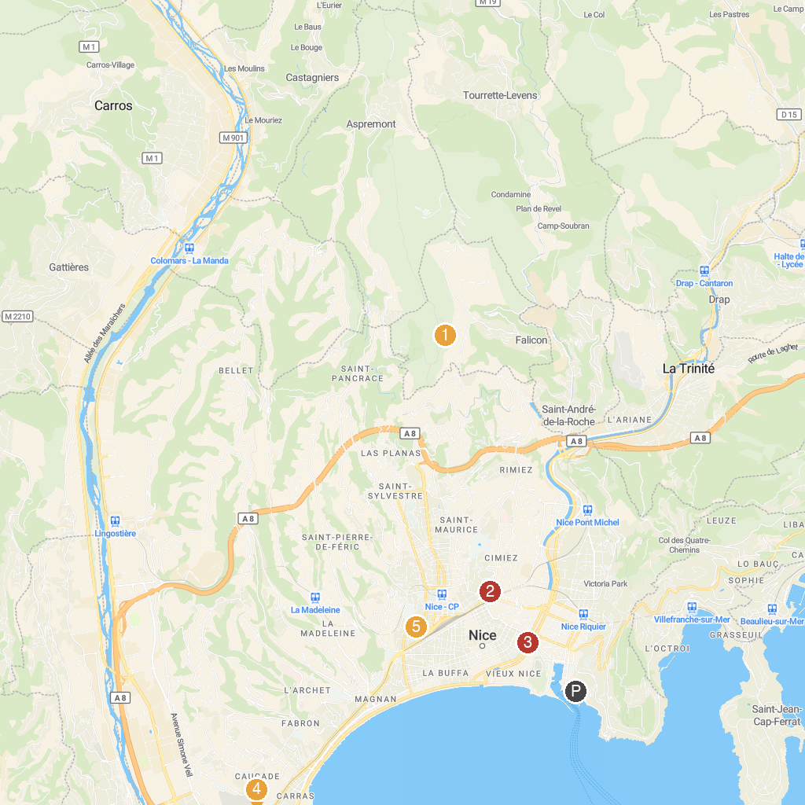
MAP KEY
1. Pyramid of Falicon | 5. Modern and Contemporary Art Museum (MAMAC)
2. Marc Chagall National Museum | 6. Parc Phœnix
3. Casino de Monte-Carlo | 7. Musée océanographique de Monaco
4. Prince's Palace of Monaco | 8. Cathédrale Saint-Nicolas de Nice
P. Cruise port / terminal
Map © MapTiler © OpenStreetMap contributors · cruiseports.org

