Cornwall, Ontario, Canada
A bilingual St. Lawrence River city where Loyalist heritage meets the dramatic story of ten villages flooded to build the Seaway — and the waterfront park is steps from the dock.
⚓ Pier (direct dock) · 🕒 Typical call: 6-8 hrs · 💵 Canadian Dollar (CAD) · 🗣️ English & French
✍️ MY DAY IN PORT (FILL IN)
Ship / Date
In port | arrive ______ · all aboard ______
Booked excursion
Notes / meeting point
GETTING ASHORE
- Docking: Direct pier at Cornwall Harbour — no tender needed
- Walk to centre: 10–15 min to downtown Pitt Street; Lamoureux Park is steps away
- Best For: History buffs, waterfront walks, local food, day trips to Upper Canada Village
- Don't Miss: The Historic SDG Jail tour and the Lost Villages story
GETTING AROUND
- 🚕 Taxi: CAD $8–$15 to downtown — Three local taxi companies serve the port: Choice Taxi (613-938-8899), Tip Top Taxi (613-932-2727), and Veterans Blue Li
TOP THINGS TO DO
- Upper Canada Village — One of Canada's largest living-history museums, 30 min west in Morrisburg.
- Historic SDG Jail Tour — Built in 1833 and active until 2002, this is one of Canada's oldest surviving prisons.
- Lost Villages Museum — Ten historic buildings relocated before ten villages were deliberately flooded in 1958 for the St.
- Waterfront Trail Bike Ride — Rent a bike at Marina 200 and follow the paved Waterfront Trail along the St.
- Cornwall-Style Pizza & Local Food — Cornwall has its own distinct pizza style: thick crust, spiced sweet sauce, and toppings buried under a blanket of local…
BEST WALKS
- Waterfront & Lamoureux Park Loop: 1.5 km · 20–30 min · Flat, paved — From the pier, walk through Lamoureux Park past the Clock Tower and Rotary Eco-Gardens with views…
- Waterfront to Downtown Cornwall: 1 km · 12–15 min · Flat — Walk north from the waterfront up to Pitt Street, the main downtown strip.
WEATHER · DAYLIGHT · MONEY
Month | High °F | Low °F | Rainy days
May | 71 | 52 | 12
Jul | 85 | 67 | 12
Sep | 77 | 60 | 10
Daylight: May 5:49AM–8:14PM · Jul 5:49AM–8:33PM · Sep 6:47AM–7:13PM
cruiseports.org/cornwall-on · Confirm terminal & all-aboard time with your ship

Cornwall, Ontario, Canada — Port Map
Red = walkable sights · Amber = excursions farther out · P = cruise terminal
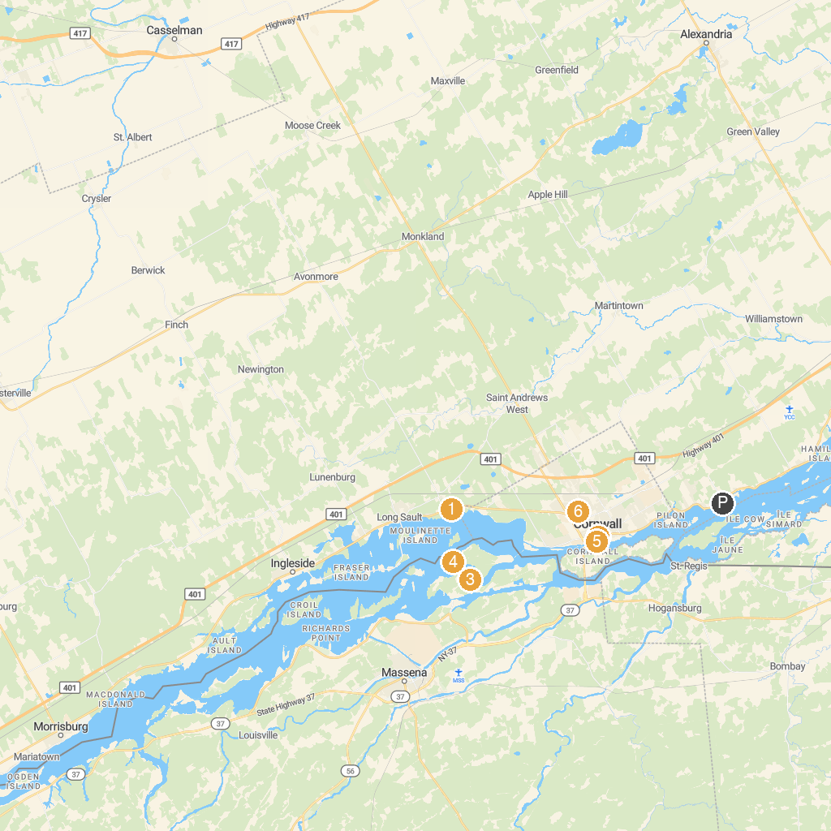
MAP KEY
1. Ault Park | 4. Robert Moses State Park - Thousand Islands
2. Rush Hour Escapes Cornwall | 5. Cornwall Community Museum & Archives
3. Nicandri Nature Center | 6. St. Theresa Park
P. Cruise port / terminal
Map © MapTiler © OpenStreetMap contributors · cruiseports.org

