Corner Brook, Newfoundland, Canada
Newfoundland's second city sits at the mouth of the Humber River, ringed by the ancient Long Range Mountains. Ships dock at the pier — step off and you're a short shuttle ride from wild trails, world-class ziplines, and some of the warmest hospitality in the Atlantic.
⚓ Pier (docked) · 🕒 Typical call: 7-9 hrs · 💵 Canadian Dollar (CAD) · 🗣️ English (Newfoundland dialect) · 🌦️ Layer up — weather changes fast
✍️ MY DAY IN PORT (FILL IN)
Ship / Date
In port | arrive ______ · all aboard ______
Booked excursion
Notes / meeting point
GETTING ASHORE
- Docking: Pier — ships dock at the Corner Brook Port Corporation Western Terminal; no tendering
- Walk to centre: ~1.5 km (1 mile) to West Street downtown; free shuttle usually provided
- Best For: Nature, hiking, ziplines, Newfoundland culture & cuisine
- Don't Miss: Captain James Cook National Historic Site (Crow Hill) and Steady Brook Falls zipline
GETTING AROUND
- 🚕 Taxi: CAD $15–20 (city), CAD $15–20 (Captain Cook Monument) — Taxis wait at the dock when ships are in port. Base fare ~CAD $3 plus ~$3/km. Local companies include City Wide Taxi, St
- 📱 Rideshare: ❌ not available
TOP THINGS TO DO
- Gros Morne National Park — A UNESCO World Heritage Site 75–90 minutes north, famous for dramatic fjords and the Tablelands — a rare place where the Earth's…
- Marble Zip Tours — Steady Brook Falls — Zipline directly over the 60-metre (200 ft) Steady Brook Falls at Marble Mountain Resort, just 10 minutes from the port.
- Captain James Cook National Historic Site — A monument to explorer James Cook, who charted these waters in 1767, perched atop Crow Hill (Cook's Lookout) high above the city.
- Bay of Islands & Fishing Village Drive — Follow Captain Cook's Trail along the Bay of Islands to charming outport communities like Lark Harbour.
- A Flavor of Corner Brook — Food, Frolic & Fish — Sample toutons with molasses, fresh cod tongues, and partridgeberry treats on a guided culinary walk through downtown.
BEST WALKS
- Corner Brook Stream Trail to Margaret Bowater Park: 2-3 km · Easy · 45-60 min · Free — From the Glynmill Inn, follow this well-maintained wooded trail along the stream to Margaret…
- Downtown West Street Stroll: 1-2 km · Easy · 30-45 min · Free — Hop off the shuttle at the Visitor Information Chalet and wander West Street for local shops, the…
WEATHER · DAYLIGHT · MONEY
Month | High °F | Low °F | Rainy days
May | 52 | 37 | 14
Jul | 72 | 57 | 14
Sep | 63 | 51 | 16
Daylight: May 5:39AM–8:57PM · Jul 5:34AM–9:20PM · Sep 6:59AM–7:33PM
cruiseports.org/corner-brook-nl · Confirm terminal & all-aboard time with your ship

Corner Brook, Newfoundland, Canada — Port Map
Red = walkable sights · Amber = excursions farther out · P = cruise terminal
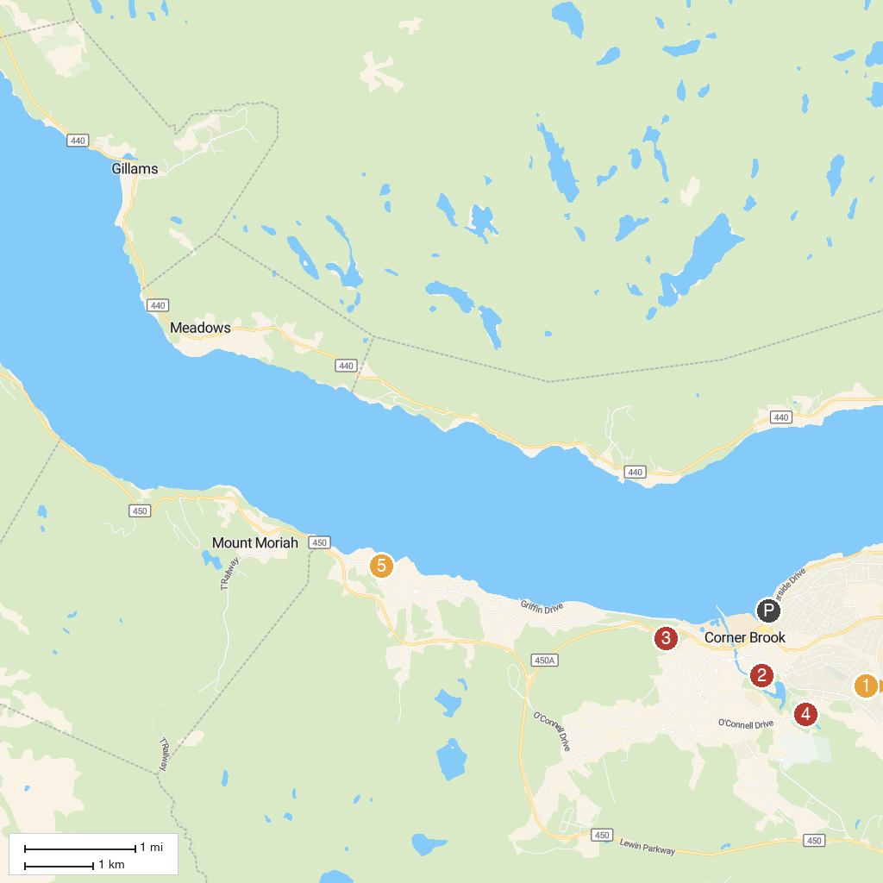
MAP KEY
1. Marble Zip Tours | 4. Margaret​ Bowater Park
2. Corner Brook Stream Trail | 5. Bartlett's Point Park
3. Captain James Cook Historic Site
P. Cruise port / terminal
Map © MapTiler © OpenStreetMap contributors · cruiseports.org

