Corigliano Calabro, Calabria, Italy
Where medieval hilltop Calabria meets crystalline Ionian shoreline. Corigliano Calabro is Southern Italy in its rawest, most welcoming form — castles, spicy food, and beaches you'll have nearly to yourself.
⚓ Docked (pier) · 🕒 Typical call: 7-9 hrs · 💶 Euro (€) — carry cash · 🗣️ Italian (minimal English) · 🍋 Best May–Oct
✍️ MY DAY IN PORT (FILL IN)
Ship / Date
In port | arrive ______ · all aboard ______
Booked excursion
Notes / meeting point
GETTING ASHORE
- Docking: Pier — ships dock at Porto di Corigliano (380 m quay, 6–10 m depth)
- Walk to centre: Schiavonea beach ~1.5 km; Historic Centro ~7.5 km (taxi required)
- Best For: Authentic Calabrian culture, castle visits, beach days, local food
- Don't Miss: Castello Ducale and a bowl of pasta with 'nduja in the hilltop village
GETTING AROUND
- 🚕 Taxi: €12–€15 — Taxis available at the port. The ride to Corigliano Calabro historic center (approx. 4–5 km) costs around €12–€15. Agree
TOP THINGS TO DO
- Castello Ducale di Corigliano — One of Southern Italy's best-preserved Norman-Aragonese castles.
- Codex Purpureus & Rossano Old Town — The Diocesan Museum in Rossano houses a 6th-century Byzantine Gospel on purple vellum — a UNESCO-recognized masterpiece.
- Amarelli Licorice Factory, Rossano — The Amarelli family has been producing licorice on this estate since 1731.
- Schiavonea Beach Day — The wide Ionian beach at Schiavonea is a short walk from the pier.
- Corigliano Historic Centre Walk — Wander medieval lanes, stone arches, and steep staircases in the hilltop centro storico.
BEST WALKS
- Schiavonea Lungomare Stroll: 1.5 km each way | Flat | 30–40 min return — From the port gate, follow the coast road north to the Lungomare promenade.
- Corigliano Centro Storico Lanes: 1-2 km loop | Hilly | 45-60 min | Taxi up required — Take a taxi to the castle, then spend an hour weaving through the medieval centre's narrow stepped…
WEATHER · DAYLIGHT · MONEY
Month | High °F | Low °F | Rainy days
May | 73 | 58 | 8
Jul | 89 | 72 | 2
Sep | 80 | 66 | 6
Daylight: May 5:39AM–8:01PM · Jul 5:39AM–8:20PM · Sep 6:35AM–7:02PM
cruiseports.org/corigliano-calabro · Confirm terminal & all-aboard time with your ship

Corigliano Calabro, Calabria, Italy — Port Map
Red = walkable sights · Amber = excursions farther out · P = cruise terminal
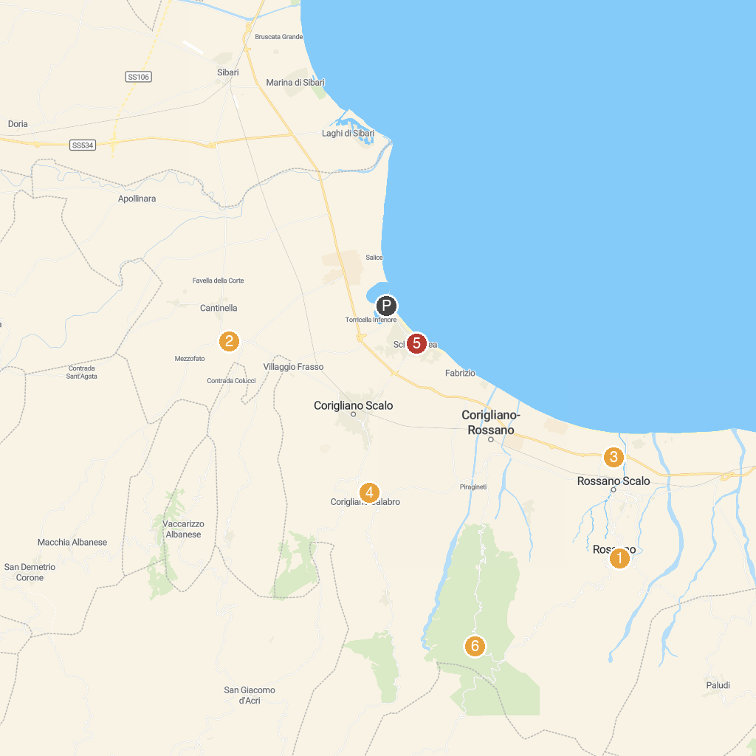
MAP KEY
1. Museum of the Diocese and the Rossano Codex | 4. Chiesa di Sant'Antonio
2. Castello di San Mauro | 5. Fiera Palace at Schiavonea
3. Museo della Liquirizia "Giorgio Amarelli" | 6. I Giganti del Cozzo del Pesco
P. Cruise port / terminal
Map © MapTiler © OpenStreetMap contributors · cruiseports.org

