Corfu, Ionian Islands, Greece
A lush Ionian island where Venetian campaniles, British colonnades, and French arcades share the same UNESCO skyline. The Old Town is one of the best walk-off cruise ports in Greece.
⚓ Docked (New Port / Neo Limani) · 🕒 Typical call: 8–10 hrs · 💶 Euro (EUR) · 🗣️ Greek · English widely spoken
✍️ MY DAY IN PORT (FILL IN)
Ship / Date
In port | arrive ______ · all aboard ______
Booked excursion
Notes / meeting point
GETTING ASHORE
- Docking: Alongside — New Port
- Walk to Old Town: ~20 min on foot
- Best For: Old Town · History · Beaches
- Don't Miss: Old Venetian Fortress & Liston
GETTING AROUND
- 🚕 Taxi: ~€10 — Metered taxis wait at the cruise terminal and reach Corfu Old Town in about 10–15 minutes. Fares are regulated; base rat
- 📱 Rideshare: ✅ Uber, Bolt
- 🚌 Hop-on hop-off: ✅ City Sightseeing Corfu
TOP THINGS TO DO
- Corfu Old Town — UNESCO Walking Tour — Wander the Venetian lanes of Campiello, the French-built Liston arcade, the Palace of St.
- Achilleion Palace & Gardens — Empress Sisi of Austria's neoclassical hilltop retreat, filled with statues of Achilles and sweeping views over the Ionian Sea.
- Paleokastritsa & West Coast — Dramatic limestone cliffs, three turquoise bays, and a clifftop Byzantine monastery.
- Kanoni & Mouse Island (Vlacherna) — The tiny white chapel on an islet connected by a causeway is Corfu's most-photographed icon.
- Island Drive: Highlands & Villages — Rent a car and loop through the olive-covered hills to Pelekas village, Glyfada beach, and the atmospheric village of Lakones…
BEST WALKS
- New Port → Old Town → Old Fortress: ~2.5 km one-way · 1–1.5 hrs · easy — Walk north from the cruise pier along the waterfront promenade into the Old Town.
- Campiello Quarter — Venetian Backstreets: ~1.5 km loop · 45 min · easy — Dive into the medieval Campiello neighbourhood behind the main square.
- New Fortress & Northern Waterfront: ~1 km · 30 min · easy — The 16th-century Venetian New Fortress overlooks the New Port from a rocky promontory.
WEATHER · DAYLIGHT · MONEY
Month | High °F | Low °F | Rainy days
May | 71 | 61 | 9
Jul | 86 | 74 | 2
Sep | 79 | 70 | 9
Daylight: May 6:26AM–8:47PM · Jul 6:25AM–9:06PM · Sep 7:21AM–7:48PM
cruiseports.org/corfu · Confirm terminal & all-aboard time with your ship

Corfu, Ionian Islands, Greece — Port Map
Red = walkable sights · Amber = excursions farther out · P = cruise terminal
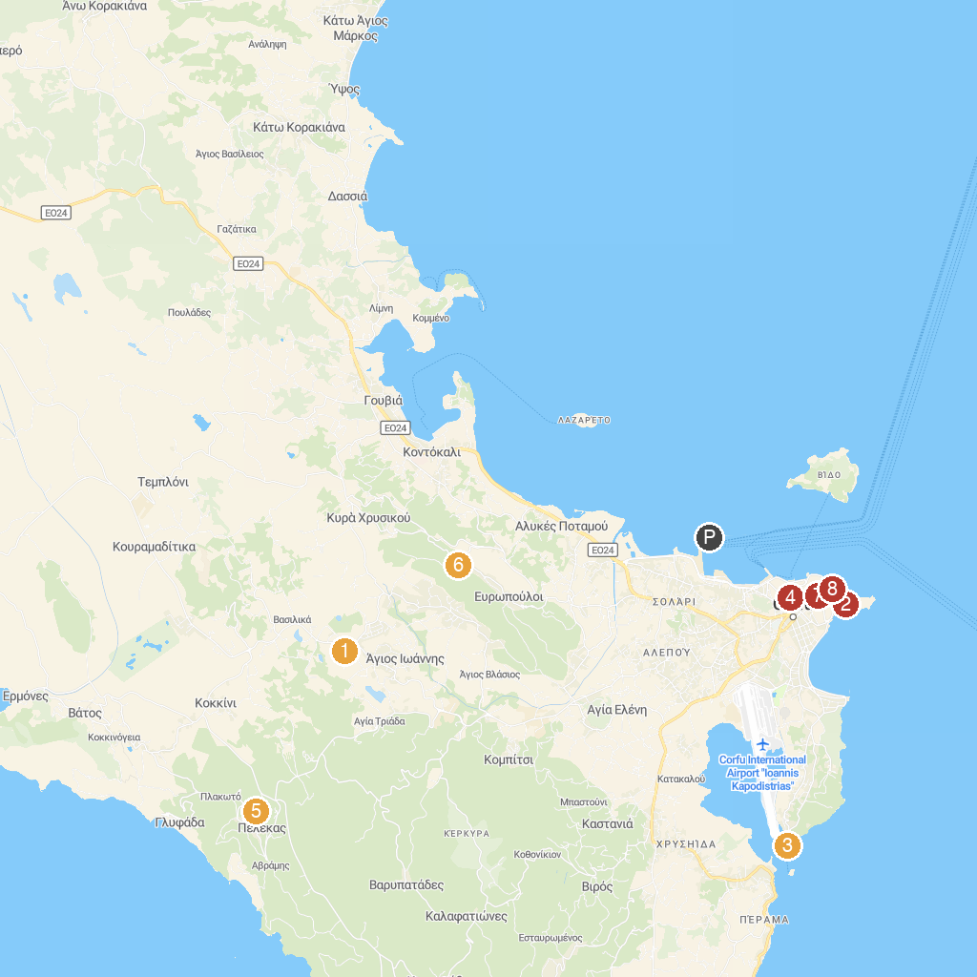
MAP KEY
1. Aqualand | 5. Kaiser William II Observatory
2. Old Fortress | 6. Capodistrias Museum - Centre for Capodistrian Studies
3. Holy Monastery of Panagia Vlacherna | 7. Banknote Museum of the Ionian Bank
4. New Fortress | 8. Municipal Gallery of Corfu
P. Cruise port / terminal
Map © MapTiler © OpenStreetMap contributors · cruiseports.org

