Corfu Island, Ionian Islands, Greece
Greece's greenest island pairs a UNESCO-listed Venetian Old Town with crystalline Ionian beaches, centuries-old fortresses, and the hilltop palace of an empress — all manageable in a single cruise day.
⚓ Docked (New Port) · 🕒 Typical call: 8-10 hrs · 💶 Currency: Euro · 🗣️ Language: Greek
✍️ MY DAY IN PORT (FILL IN)
Ship / Date
In port | arrive ______ · all aboard ______
Booked excursion
Notes / meeting point
GETTING ASHORE
- Docking: Cruise ships dock at Corfu New Port (Néo Limáni), a 15-20 min walk or short taxi ride from Old Town.
- Walk to centre: ~15-20 min on foot along the seafront from the pier gates to the edge of Corfu Old Town.
- Best For: History, culture, beaches, and easy independent exploration.
- Don't Miss: The UNESCO Old Town warren of Venetian lanes and the Achilleion Palace with its panoramic gardens.
GETTING AROUND
- 🚕 Taxi: €25–€35 — Fixed-price taxis and pre-booked transfers from the cruise terminal to Corfu Town take about 5–10 minutes. Pre-booking o
- 📱 Rideshare: ✅ Uber, Bolt
- 🚌 Hop-on hop-off: ✅
TOP THINGS TO DO
- Corfu UNESCO Old Town Walk — Wander the Venetian laneways (Kantounia), the grand Liston arcade, the Spianada Esplanade, and the Church of Saint Spyridon.
- Achilleion Palace & Gardens — The hilltop neoclassical palace built for Empress Elisabeth of Austria (Sisi) is Corfu's most iconic landmark.
- Paleokastritsa & Monastery — Corfu's most celebrated natural bay — turquoise coves beneath dramatic limestone cliffs topped by a working Byzantine monastery.
- Glyfada Beach — One of Corfu's longest sandy beaches on the west coast, backed by pine hills.
- Sea Kayaking the Ionian Coast — Paddle sea caves, sea arches, and hidden coves along Corfu's dramatic coastline.
BEST WALKS
- Old Town & Fortresses Loop: ~3 km | 60-90 min | Easy — Start at the Spianada (Esplanade), the largest public square in Greece and the Balkans.
- Liston & Market Stroll: ~1.5 km | 30-45 min | Easy — A relaxed loop along the elegant Liston arcade (modelled on Paris's Rue de Rivoli), through the…
WEATHER · DAYLIGHT · MONEY
Month | High °F | Low °F | Rainy days
May | 71 | 61 | 9
Jul | 86 | 74 | 2
Sep | 79 | 70 | 9
Daylight: May 6:26AM–8:47PM · Jul 6:25AM–9:06PM · Sep 7:21AM–7:48PM
cruiseports.org/corfu-island · Confirm terminal & all-aboard time with your ship

Corfu Island, Ionian Islands, Greece — Port Map
Red = walkable sights · Amber = excursions farther out · P = cruise terminal
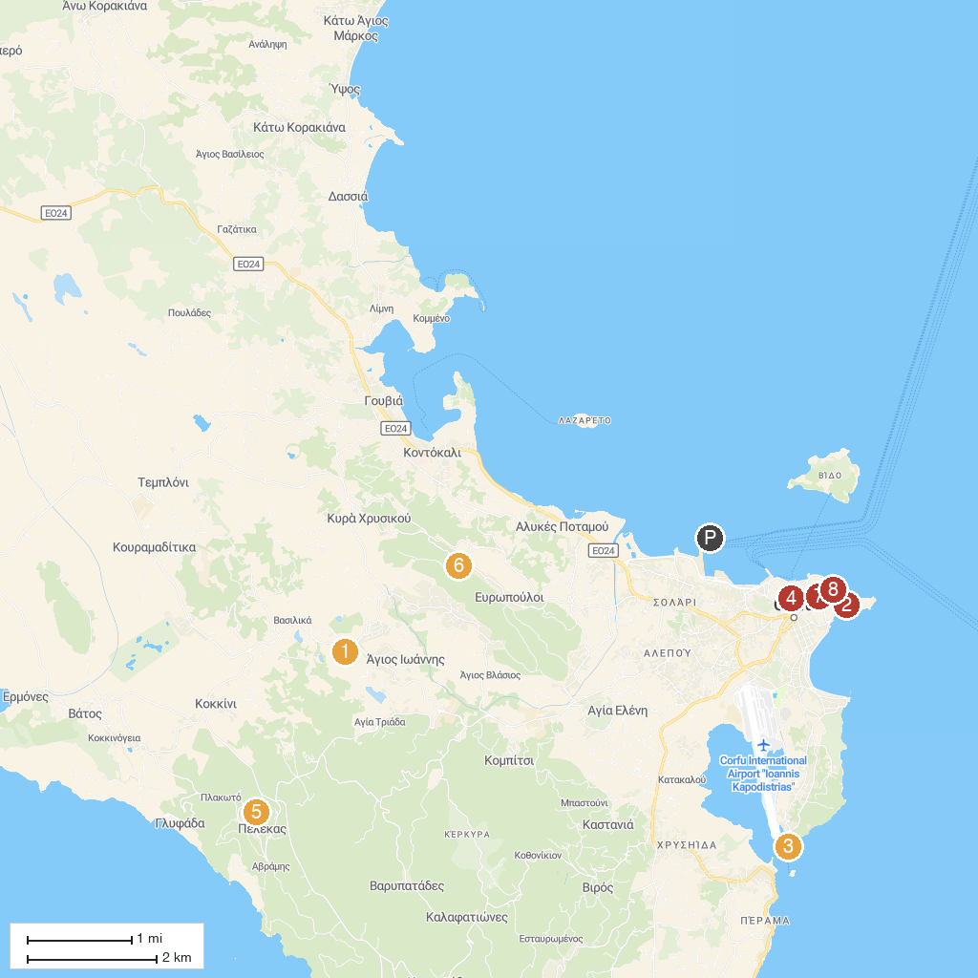
MAP KEY
1. Aqualand | 5. Kaiser William II Observatory
2. Old Fortress | 6. Capodistrias Museum - Centre for Capodistrian Studies
3. Holy Monastery of Panagia Vlacherna | 7. Banknote Museum of the Ionian Bank
4. New Fortress | 8. Municipal Gallery of Corfu
P. Cruise port / terminal
Map © MapTiler © OpenStreetMap contributors · cruiseports.org

