Córdoba, Andalusia, Spain
Home to Europe's most extraordinary mosque-turned-cathedral, Córdoba is a city where Roman, Moorish, and Christian layers stack on top of each other in a single afternoon. Ships call at Seville — Córdoba is a 90-minute coach ride that completely delivers.
⚓ Shore excursion from Seville (coach transfer) · 🕒 Typical call: 8–10 hrs (full day from Seville) · 💶 Currency: Euro (€) · 🗣️ Language: Spanish · 🌡️ Best season: Apr–Jun, Sep–Oct
✍️ MY DAY IN PORT (FILL IN)
Ship / Date
In port | arrive ______ · all aboard ______
Booked excursion
Notes / meeting point
GETTING ASHORE
- Docking: Ships berth in Seville; Córdoba is ~90 min by coach (approx 140 km)
- Walk to Mezquita: 10–15 min from coach drop-off near Puerta de Almódovar
- Best For: Islamic-Christian history, medieval streets, food & wine
- Don't Miss: The Mezquita-Cathedral interior and the flower-filled Calleja de las Flores
GETTING AROUND
- 🚕 Taxi: €5–€12 — Taxis are readily available from Córdoba train station to the Mezquita and city center (~2 km). Useful if you have limit
- 🚌 Hop-on hop-off: ✅
TOP THINGS TO DO
- Mezquita-Cathedral of Córdoba — The defining monument of Córdoba — a vast 8th-century mosque with a forest of 856 columns supporting striped red-and-white…
- Jewish Quarter (La Judería) & Calleja de las Flores — One of Spain's best-preserved medieval Jewish quarters, with whitewashed lanes, flower-draped walls, and the small 14th-century…
- Alcázar de los Reyes Cristianos — Fortified palace of the Christian monarchs, where Columbus pitched his New World voyage to Isabella and Ferdinand.
- Roman Bridge & Torre de la Calahorra — The 1st-century BC Puente Romano crosses the Guadalquivir in 16 arches and is free to walk.
- Andalusian Tapas & Wine in the Old City — Córdoba's tapas scene is outstanding.
BEST WALKS
- Old City Loop: Mezquita to Roman Bridge: 2–2.5 km · Easy · 1.5–2 hrs — The essential Córdoba walk.
- Plaza de la Corredera & Tapas Bars: 0.8 km · Easy · 45 min — Head north from the Mezquita to Plaza de la Corredera, Córdoba's grand arcaded square (the only one…
WEATHER · DAYLIGHT · MONEY
Month | High °F | Low °F | Rainy days
May | 82 | 55 | 5
Jul | 98 | 67 | 0
Sep | 89 | 62 | 3
Daylight: May 7:57AM–6:28PM · Jul 8:14AM–6:31PM · Sep 7:15AM–7:08PM
cruiseports.org/cordoba · Confirm terminal & all-aboard time with your ship

Córdoba, Andalusia, Spain — Port Map
Red = walkable sights · Amber = excursions farther out · P = cruise terminal
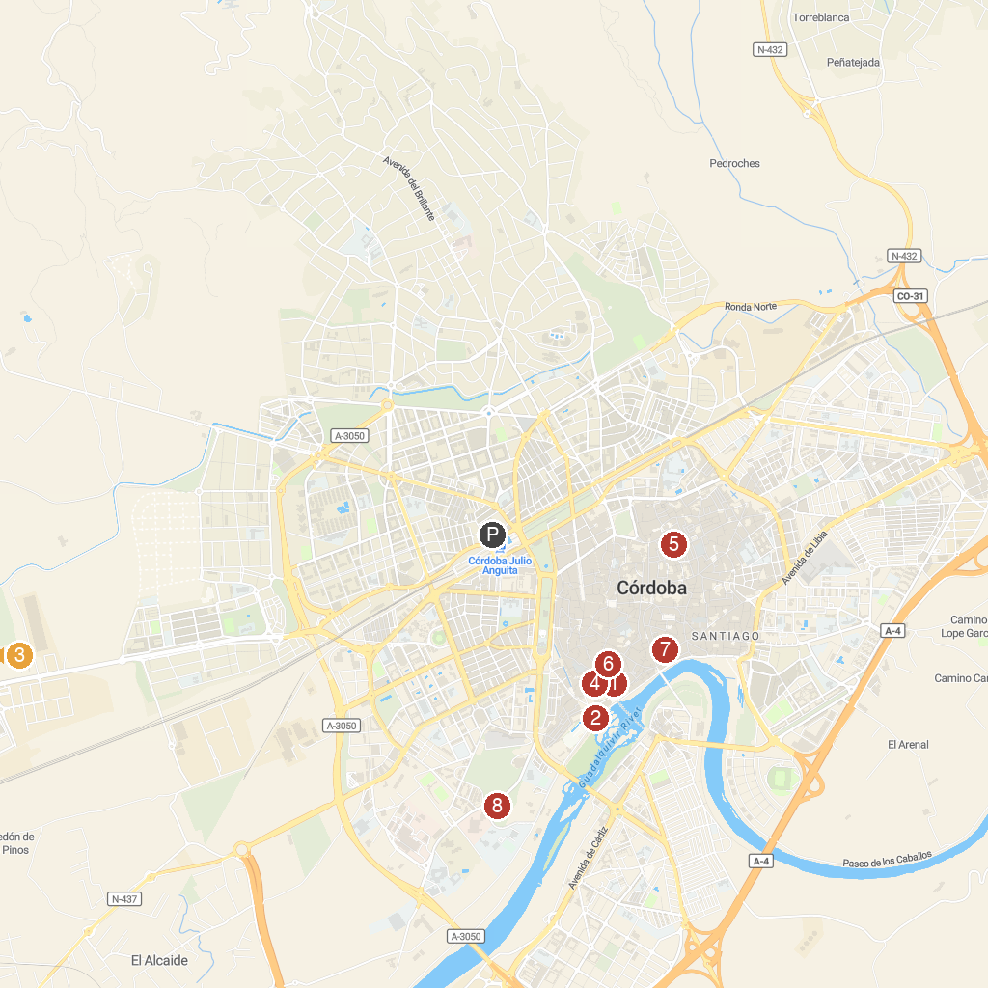
MAP KEY
1. Mosque-Cathedral Monumental Site of Córdoba | 5. Palacio de Viana
2. Alcázar de los Reyes Cristianos | 6. Tablao Flamenco Arte y Sabores de Córdoba
3. Medina Azahara - Conjunto Arqueológico Madinat al-Zahra | 7. Museum of Fine Arts of Cordoba
4. Filmoteca de Córdoba | 8. La Ciudad de los Niños
P. Cruise port / terminal
Map © MapTiler © OpenStreetMap contributors · cruiseports.org

