Cooktown, Queensland, Australia
The first place Captain Cook set foot in Australia, Cooktown feels like the real frontier — history, Indigenous culture, and wild tropics meeting at the edge of Cape York.
⚓ Tender port · 🕒 Typical call: 6–8 hrs · 💵 Australian Dollar (AUD) · 🗣️ English · 🐊 Crocodile country — no ocean swimming
✍️ MY DAY IN PORT (FILL IN)
Ship / Date
In port | arrive ______ · all aboard ______
Booked excursion
Notes / meeting point
GETTING ASHORE
- Docking: Tender to Cooktown Wharf (Endeavour River)
- Walk to centre: 2–5 min flat walk from the wharf to Charlotte St
- Best For: History, Indigenous culture, scenic lookouts, river wildlife
- Don't Miss: The original HMS Endeavour anchor at the Cooktown Museum
GETTING AROUND
- 🚕 Taxi: AUD $3.80 flag fall + ~$2.88/km — Cooktown has a limited local taxi service. Taxis are inexpensive for short hops but availability can be scarce — book ah
- 📱 Rideshare: ❌ not available
TOP THINGS TO DO
- Cooktown Museum (James Cook Museum) — The must-do.
- Grassy Hill Lookout — Climb to the same hilltop where Cook stood in 1770 to chart a way through the reef.
- Endeavour River Crocodile Cruise — Local operators run 1–2 hour river cruises departing near the wharf.
- Milbi Wall & Charlotte Street Historic Walk — The Milbi Wall near the wharf is a vivid Indigenous mosaic telling the Guugu Yimithirr story of Cook's arrival.
- Cooktown Botanic Gardens & Nature's Powerhouse — Established in 1878 — among Queensland's oldest — these tropical gardens sit within the 62-hectare Gallop Botanic Reserve and…
BEST WALKS
- Wharf to Charlotte Street Foreshore Loop: 1.5 km · 20–30 min · Flat · Free — Walk from the tender wharf along the Endeavour River esplanade past the Milbi Wall and…
- Botanic Gardens & Nature's Powerhouse: 2 km from wharf · 45 min walk · Mostly flat — Follow Botanic Gardens Road from Charlotte Street into the gardens.
WEATHER · DAYLIGHT · MONEY
Month | High °F | Low °F | Rainy days
May | 80 | 73 | 11
Jul | 77 | 69 | 7
Sep | 80 | 72 | 4
Daylight: May 6:33AM–5:57PM · Jul 6:46AM–6:03PM · Sep 6:14AM–6:14PM
cruiseports.org/cooktown-qld · Confirm terminal & all-aboard time with your ship

Cooktown, Queensland, Australia — Port Map
Red = walkable sights · Amber = excursions farther out · P = cruise terminal
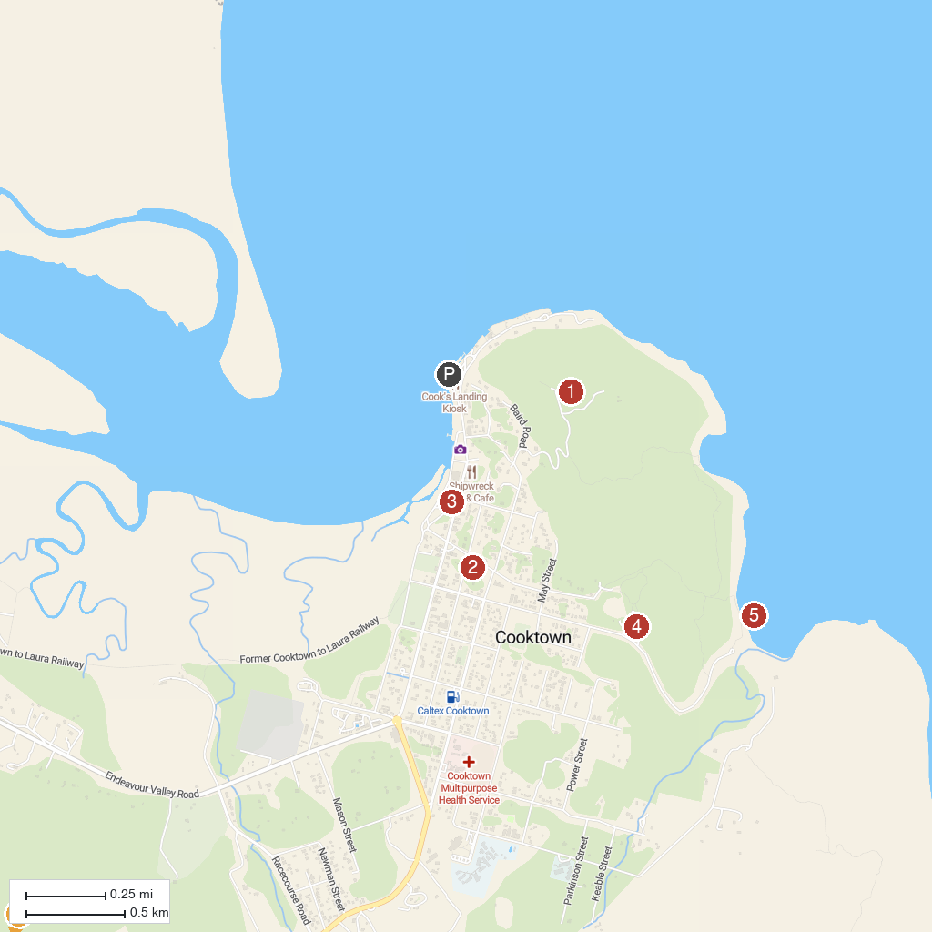
MAP KEY
1. Grassy Hill Lookout | 4. Cooktown Botanic Gardens
2. Cooktown Museum | 5. Finch Bay
3. Cooktown History Centre | 6. Keatings Lagoon Conservation Park
P. Cruise port / terminal
Map © MapTiler © OpenStreetMap contributors · cruiseports.org

