Concarneau, Brittany, France
A living fishing port built around a granite-island fortress — step through the Ville Close gates and medieval Brittany is right there, minutes from the tender dock.
⚓ Tender port · 🕒 Typical call: 6-8 hrs · 💶 Euro (€) · 🗣️ French
✍️ MY DAY IN PORT (FILL IN)
Ship / Date
In port | arrive ______ · all aboard ______
Booked excursion
Notes / meeting point
GETTING ASHORE
- Docking: Tender to the main harbor quay, directly opposite the Ville Close gate
- Walk to center: 1-2 min from tender dock to Ville Close entrance
- Best For: Medieval history, fishing culture, Breton food, coastal walks
- Don't Miss: Walking the Ville Close ramparts and the Musée de la Pêche trawler
GETTING AROUND
- 🚕 Taxi: €55–€130+ — Taxis are available for excursions to nearby towns. Expect roughly €55–€62 to Pont-Aven and €97–€131 to Quimper dependin
- 📱 Rideshare: ✅ Uber
TOP THINGS TO DO
- Ville Close — The Walled Island — Cross the footbridge onto this granite island fortress and walk cobblestone lanes lined with artisan shops, crêperies, and…
- Musée de la Pêche — Inside the Ville Close, this fishing museum explores Concarneau's identity as one of France's top tuna ports.
- Glénan Islands Boat Trip — The Glénan Archipelago, 15 km offshore, has turquoise water and white sand beaches that look Caribbean.
- Day Trip to Pont-Aven — Paul Gauguin painted here, and the village has barely changed — riverside mills, galleries, and the Musée de Pont-Aven make it…
- Day Trip to Quimper — The Finistère capital has a soaring Gothic cathedral (Saint-Corentin), medieval pedestrian streets, and renowned hand-painted…
BEST WALKS
- Ville Close Ramparts Loop: 1.5 km · 30-45 min · Easy — From the tender quay, cross the footbridge into the Ville Close.
- Coastal Path to Plage des Sables Blancs: 2 km · 25-30 min each way · Easy — Head north from the harbor along the Sentier Côtier (GR34) past the Marinarium and around the…
WEATHER · DAYLIGHT · MONEY
Month | High °F | Low °F | Rainy days
May | 63 | 50 | 12
Jul | 72 | 59 | 10
Sep | 68 | 56 | 10
Daylight: May 6:37AM–9:47PM · Jul 6:32AM–10:09PM · Sep 7:53AM–8:27PM
cruiseports.org/concarneau · Confirm terminal & all-aboard time with your ship

Concarneau, Brittany, France — Port Map
Red = walkable sights · Amber = excursions farther out · P = cruise terminal
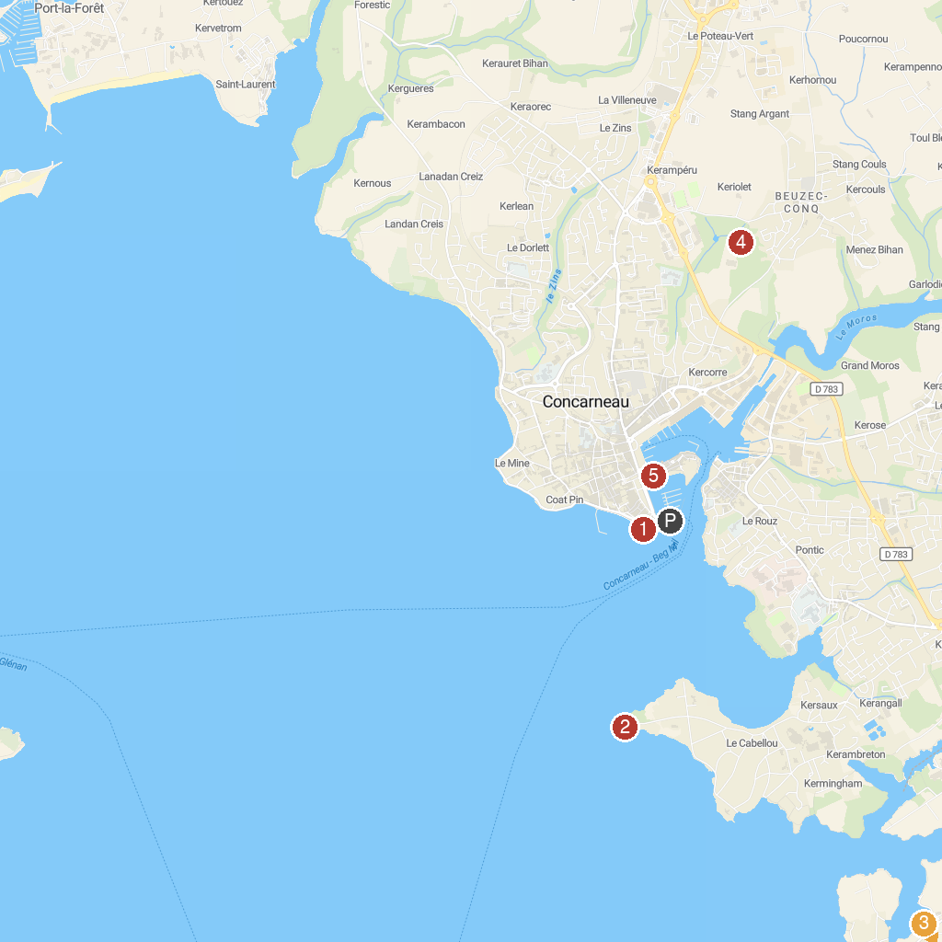
MAP KEY
1. Marine Biological Station and Concarneau Marinarium | 5. Château de Keriolet
2. le Fort du Cabellou | 6. Closed City of Concarneau
3. Plage Tregunc | 7. Église du Port ou église Saint-Thomas Becket
4. Musée du bord de mer
P. Cruise port / terminal
Map © MapTiler © OpenStreetMap contributors · cruiseports.org

