Como, Lombardy, Italy
Ringed by snowcapped Alps and lined with Belle Époque villas, Lake Como is northern Italy at its most cinematic. The city of Como is your gateway — elegant, walkable, and the launchpad for an unforgettable day on the water.
⚓ Shore excursion destination (no ocean terminal) · 🕒 Typical call: 6-8 hrs · 💶 Currency: Euro (€) · 🗣️ Language: Italian · 🚂 Arrive by coach or train from Genoa/Milan
✍️ MY DAY IN PORT (FILL IN)
Ship / Date
In port | arrive ______ · all aboard ______
Booked excursion
Notes / meeting point
GETTING ASHORE
- Docking: No ocean terminal — coaches or train transfer from Genoa (~2 hrs) via Milan
- Walk to centre: Piazza Cavour and the Lungolago are steps from Como San Giovanni station
- Best For: Lake scenery, villa gardens, Bellagio ferry, funicular views, Italian lunch
- Don't Miss: The Como–Brunate funicular and a fast ferry to Bellagio
GETTING AROUND
- 🚕 Taxi: €8–€15 — Metered taxis available at the port and train station area. Base fare ~€6.50 plus ~€3/km; most in-town trips are short a
- 📱 Rideshare: ✅ Uber
- 🚌 Hop-on hop-off: ✅
TOP THINGS TO DO
- Fast Ferry to Bellagio — The hydrofoil from Como's Navigazione Laghi terminal reaches Bellagio in about 45 minutes.
- Como–Brunate Funicular — A 7-minute funicular ride from the lower station at Piazza De Gasperi delivers you to Brunate village (~700 m), with sweeping…
- Como Cathedral & Tempio Voltiano — The Gothic-Renaissance Duomo di Como (Cattedrale di S.
- Villa Balbianello by Boat — One of Italy's most celebrated garden villas, Villa del Balbianello in Lenno juts dramatically into the lake on a wooded…
- Lungolago Promenade & Piazza Cavour — Como's lakefront promenade is perfect for a leisurely walk: palms, Belle Époque buildings, gelaterie, and the ornate Tempio…
BEST WALKS
- Lakefront & Historic Core: 1.5 km · ~30 min · Easy — A gentle loop taking in Como's best street-level highlights.
- Funicular Upper Town Walk: 0.8 km · ~20 min · Easy (uphill only by funicular) — Ride the funicular from Piazza De Gasperi to Brunate, then wander the quiet village lanes past the…
WEATHER · DAYLIGHT · MONEY
Month | High °F | Low °F | Rainy days
May | 69 | 54 | 17
Jul | 82 | 67 | 13
Sep | 73 | 60 | 11
Daylight: May 5:52AM–8:48PM · Jul 5:48AM–9:10PM · Sep 7:02AM–7:34PM
cruiseports.org/como · Confirm terminal & all-aboard time with your ship

Como, Lombardy, Italy — Port Map
Red = walkable sights · Amber = excursions farther out · P = cruise terminal
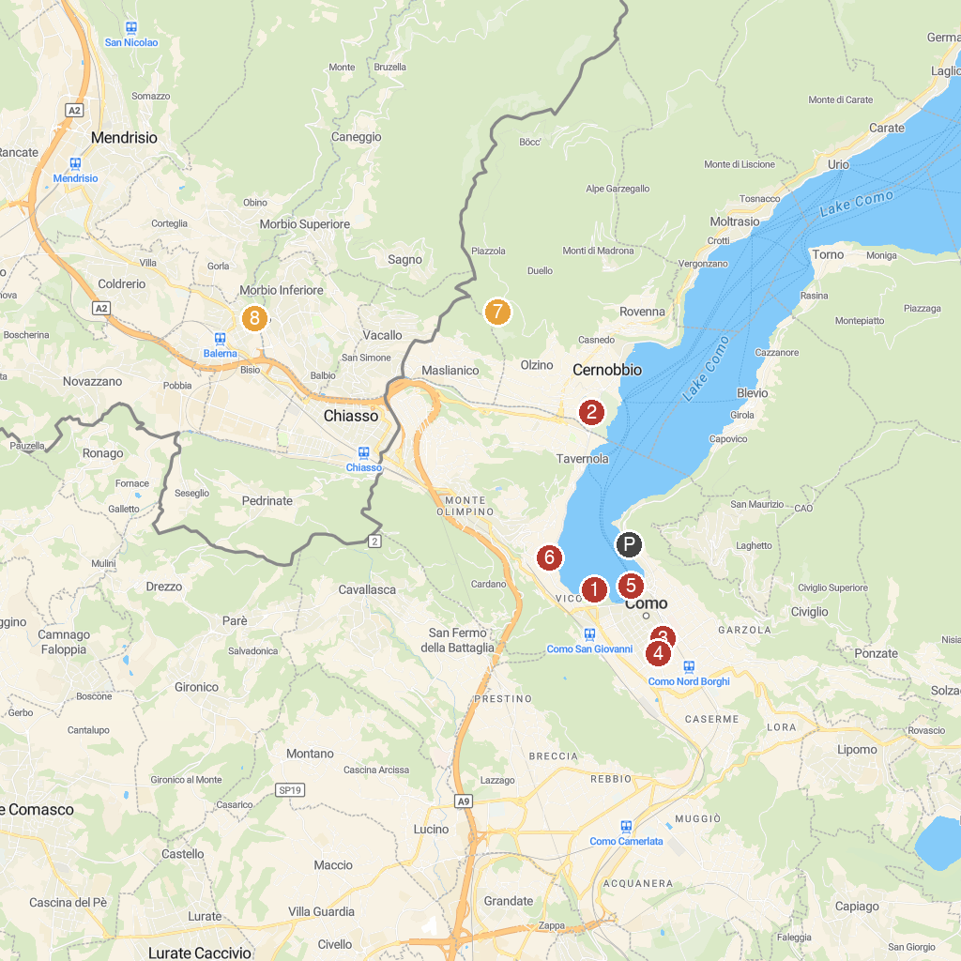
MAP KEY
1. War Memorial | 5. Life Electric
2. Museo Villa Bernasconi | 6. Villa Olmo
3. Museo Archeologico Giovio | 7. Croce dell'uomo
4. Porta Torre | 8. Parco delle Gole della Breggia
P. Cruise port / terminal
Map © MapTiler © OpenStreetMap contributors · cruiseports.org

