Colón, Colón Province, Panama
Panama's Atlantic port punches above its weight: the Gatun Locks are minutes away, howler monkeys roam Gatun Lake, and centuries-old Spanish forts dot the coast. Stay in the terminal or book a tour — the rewards are extraordinary.
⚓ Docked (Colón 2000 or Cristobal Pier) · 🕒 Typical call: 7-9 hrs · 💵 USD (official currency) · 🗣️ Spanish
✍️ MY DAY IN PORT (FILL IN)
Ship / Date
In port | arrive ______ · all aboard ______
Booked excursion
Notes / meeting point
GETTING ASHORE
- Docking: Colón 2000 Cruise Terminal or Cristobal Pier (Pier 6) — no tendering
- Walk to center: Colón 2000 has shops/restaurants on-site; downtown Colón not recommended on foot
- Best For: Panama Canal locks, rainforest wildlife, colonial history
- Don't Miss: Watching a Panamax ship transit the Gatun Locks
GETTING AROUND
- 🚕 Taxi: $40–$50 — Taxis wait at the Colón 2000 cruise terminal. Standard fare to Panama City is $40–50 for the ~50-minute drive. Negotiate
- 📱 Rideshare: ✅ Uber
TOP THINGS TO DO
- Gatun Locks & Canal Visitor Center — Watch ocean-going ships lift through the original Gatun Locks, the three-step flight of locks that has raised vessels to Gatun…
- Agua Clara Locks — Expanded Canal — See the newer Agua Clara Locks built in 2016 to accommodate Neo-Panamax ships.
- Monkey Island & Gatun Lake Boat Tour — Cruise Gatun Lake — an artificial lake formed during canal construction — to islands teeming with howler monkeys, white-faced…
- Portobelo UNESCO Ruins — The ruins of the Spanish colonial forts at Portobelo, a UNESCO World Heritage Site, tell the story of Spain's silver trade and…
- Embera Indigenous Village — Dugout canoe into Chagres National Park to visit an Embera village.
BEST WALKS
- Colón 2000 Terminal & Duty-Free Zone: Easy · 30-60 min · On-pier — Browse duty-free shops for Panamanian coffee, rum, electronics, and jewelry.
- Cristobal Artisan Market: Easy · 20-30 min · Adjacent to Pier 6 — If docked at Cristobal Pier, a small artisan market just outside the gate sells local crafts, molas…
WEATHER · DAYLIGHT · MONEY
Month | High °F | Low °F | Rainy days
May | 84 | 77 | 30
Jul | 83 | 76 | 30
Sep | 84 | 76 | 30
Daylight: May 5:59AM–6:32PM · Jul 6:07AM–6:43PM · Sep 6:09AM–6:19PM
cruiseports.org/colon · Confirm terminal & all-aboard time with your ship

Colón, Colón Province, Panama — Port Map
Red = walkable sights · Amber = excursions farther out · P = cruise terminal
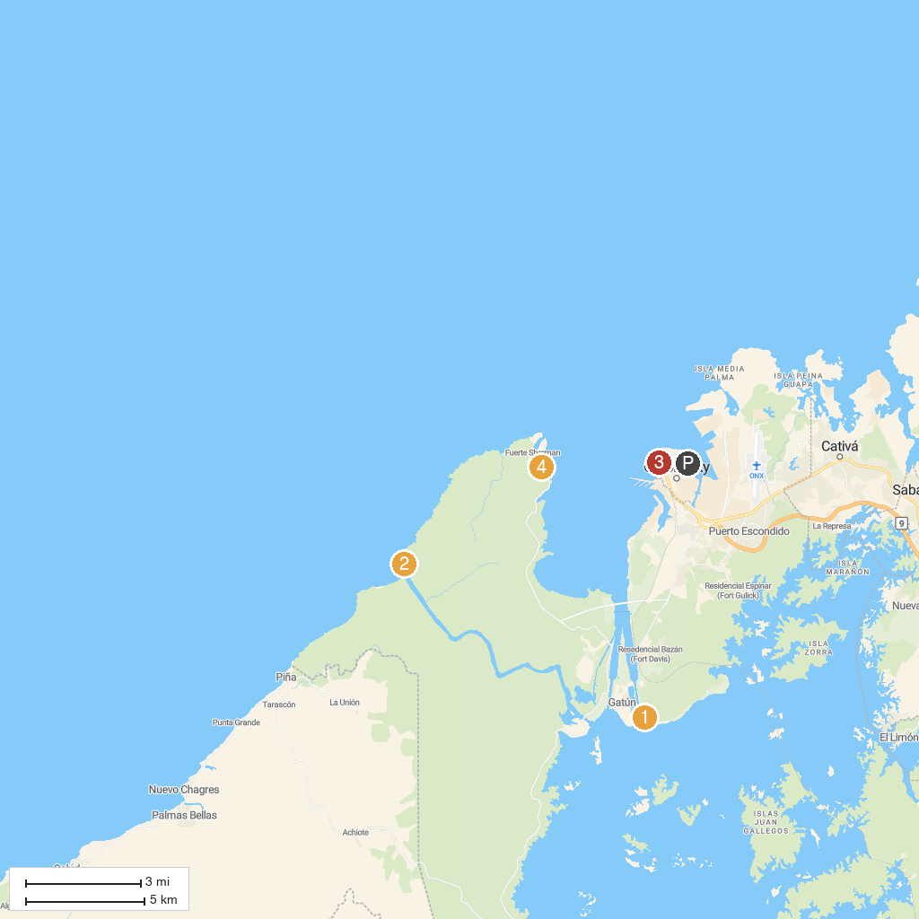
MAP KEY
1. Agua Clara Locks Visitor Center | 3. Inmaculada Concepción Cathedral
2. Castillo de San Lorenzo Real de Chagres | 4. Playa Sherman
P. Cruise port / terminal
Map © MapTiler © OpenStreetMap contributors · cruiseports.org

