Cochem, Rhineland-Palatinate, Germany
Perched on a bend of the Moselle, Cochem is everything a Rhine-and-Moselle river cruise promises: a neo-Gothic castle crowning the hill, steep Riesling slopes tumbling to the river, and a half-timbered Old Town you can explore in an afternoon.
⚓ Docked (Moselle Promenade) · 🕒 Typical call: 6-8 hrs · 💶 Euro (€) · 🗣️ German
✍️ MY DAY IN PORT (FILL IN)
Ship / Date
In port | arrive ______ · all aboard ______
Booked excursion
Notes / meeting point
GETTING ASHORE
- Docking: Ships tie up along the Moselle Promenade — town center is steps away
- Walk to center: 2-3 min on foot from gangway to Marktplatz
- Best For: Riesling tastings, Reichsburg Castle, scenic riverside strolling
- Don't Miss: Guided tour of Reichsburg Castle and a glass of local Moselle Riesling
GETTING AROUND
- 🚕 Taxi: €6–€12 — Local taxis (cochem-taxi.de) cover trips to Reichsburg Castle (hilltop), outlying wineries, and neighboring villages. Sh
- 📱 Rideshare: ❌ not available
- 🚌 Hop-on hop-off: ✅
TOP THINGS TO DO
- Reichsburg Castle Tour — Cochem's neo-Gothic hilltop fortress dates to around 1000 AD, was destroyed in 1689, and was painstakingly rebuilt in the 19th…
- Moselle Riesling Wine Tasting — The steep slate slopes around Cochem produce some of Germany's finest Riesling.
- Moselle River Cruise to Beilstein — A short riverboat excursion upstream to the tiny village of Beilstein — the 'Sleeping Beauty' of the Moselle — passes vineyards…
- Sesselbahn Chairlift to Pinnerkreuz — Ride the Cochem chairlift (Sesselbahn) from near the town bridge up to Pinnerkreuz for panoramic views over the Moselle bend, the…
- Bundesbank Bunker Museum — Beneath a residential hillside 4 km from town lies Germany's Cold War secret — a vast emergency vault built to store paper…
BEST WALKS
- Old Town & Marktplatz Loop: 1-2 km · 30-45 min · Easy — From the Moselle Promenade, walk into the Old Town and circle through the market square, past the…
- Castle Climb via Schlossberg: 2 km · 45-60 min · Moderate (steep ascent) — Walk from the Marktplatz up Schlossberg — the main pedestrian path to Reichsburg Castle.
- Moselle Promenade Riverside Stroll: 2-3 km · 30-45 min · Easy — A flat, scenic walk along the Moselle riverbank in both directions from the ship — past moored…
WEATHER · DAYLIGHT · MONEY
Month | High °F | Low °F | Rainy days
May | 66 | 49 | 12
Jul | 77 | 60 | 11
Sep | 69 | 54 | 8
Daylight: May 5:45AM–9:11PM · Jul 5:38AM–9:35PM · Sep 7:07AM–7:44PM
cruiseports.org/cochem · Confirm terminal & all-aboard time with your ship

Cochem, Rhineland-Palatinate, Germany — Port Map
Red = walkable sights · Amber = excursions farther out · P = cruise terminal
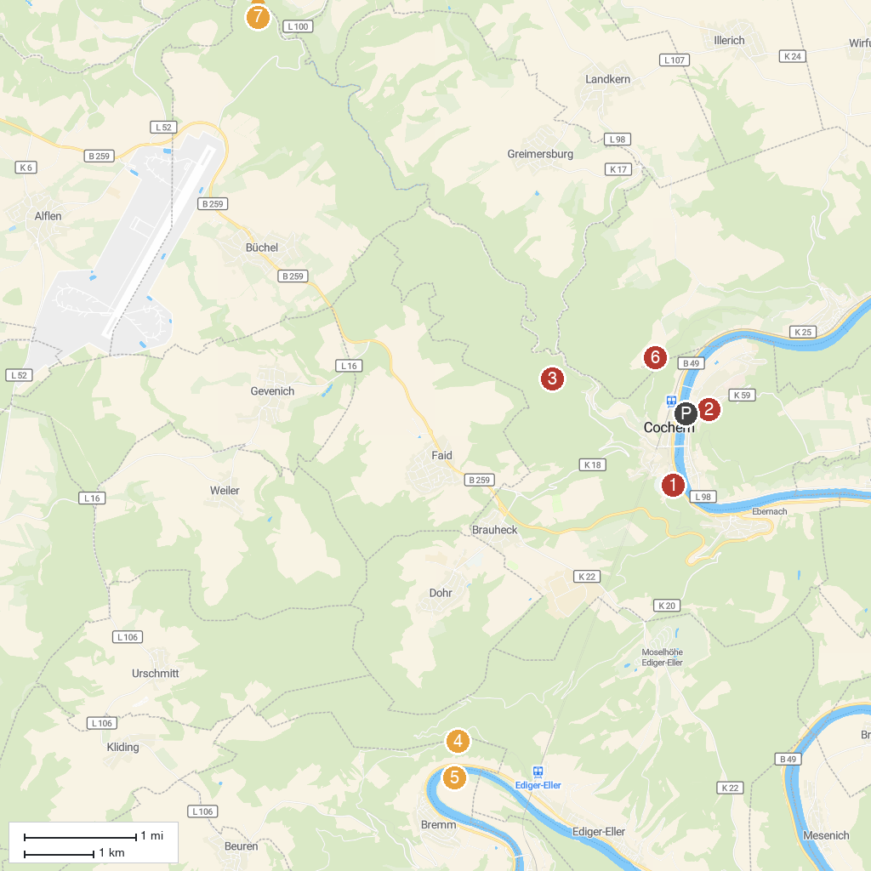
MAP KEY
1. Eltz Castle | 5. Mountain sanctuary on the Calmont
2. Cochem Castle | 6. Kloster Ruine Stuben
3. Bundesbank Bunker Cochem | 7. Wild- und Freizeitpark Klotten
4. Burgruine Winneburg | 8. Wasserfall bei Maria Martental, regional "Rausch" genannt
P. Cruise port / terminal
Map © MapTiler © OpenStreetMap contributors · cruiseports.org

