Coche Island, Nueva Esparta, Venezuela
One of the Caribbean's best-kept secrets, Coche is a flat, wind-swept island with mirror-like waters, empty white beaches, and kitesurfers carving across La Punta's legendary flats.
⚓ Tender port · 🕒 Typical call: 6-8 hrs · 💵 Venezuelan Bolívar / USD · 🗣️ Spanish
✍️ MY DAY IN PORT (FILL IN)
Ship / Date
In port | arrive ______ · all aboard ______
Booked excursion
Notes / meeting point
GETTING ASHORE
- Docking: Tender only — ships anchor offshore; tenders land at San Pedro de Coche
- Walk to center: 5 min from tender dock to San Pedro de Coche village
- Best For: Kitesurfing, windsurfing, deserted beaches, snorkeling
- Don't Miss: La Punta beach — 3 km of white sand, world-class kite flats
GETTING AROUND
- 🚕 Taxi: $5–10 USD — Informal taxis are available near the tender pier for short hops around the island. Agree on the fare before you get in
- 📱 Rideshare: ❌ not available
TOP THINGS TO DO
- Kitesurfing at La Punta — La Punta beach has hosted national and international championships.
- La Punta Beach Day — Three kilometres of white sand and calm turquoise water.
- Snorkeling the Offshore Reefs — Catamaran day trips from the island often stop at shallow offshore reefs with clear water and good fish life.
- Windsurfing & Water Sports — Beyond kitesurfing, Coche's steady winds support windsurfing, kayaking, and jet-skiing.
- San Pedro de Coche Village Walk — The small fishing village near the tender dock gives a glimpse of everyday island life.
BEST WALKS
- San Pedro de Coche Waterfront Stroll: Easy · ~1 km · 20 min — From the tender dock, walk along the San Pedro de Coche waterfront past fishing boats and local…
WEATHER · DAYLIGHT · MONEY
Month | High °F | Low °F | Rainy days
May | 80 | 77 | 2
Jul | 81 | 78 | 7
Sep | 83 | 80 | 9
Daylight: May 5:53AM–6:30PM · Jul 6:01AM–6:42PM · Sep 6:05AM–6:16PM
cruiseports.org/coche-island · Confirm terminal & all-aboard time with your ship

Coche Island, Nueva Esparta, Venezuela — Port Map
Red = walkable sights · Amber = excursions farther out · P = cruise terminal
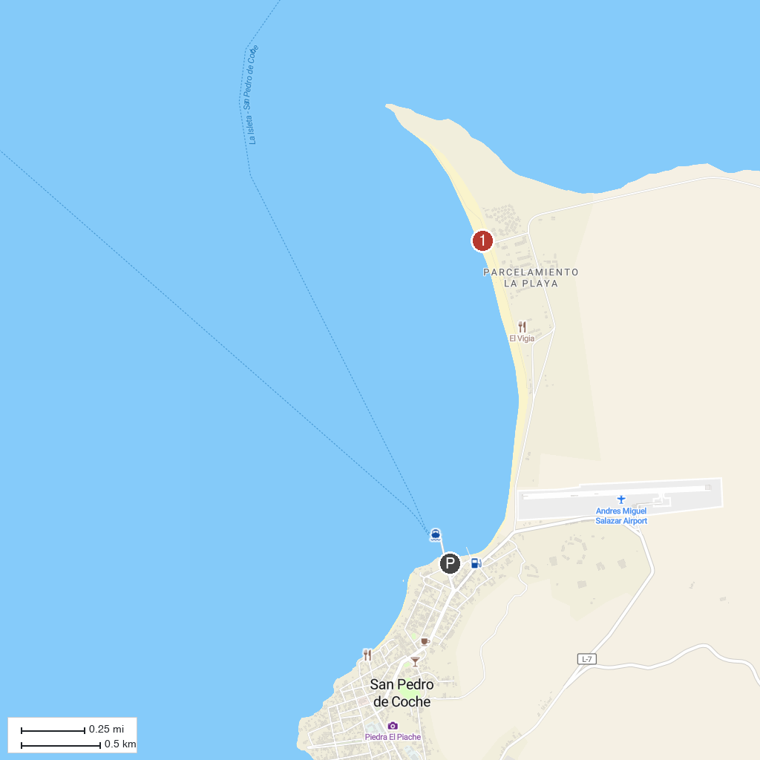
MAP KEY
1. Casa de la Cultura Ramón Vásquez Brito | 2. Coche Beach
P. Cruise port / terminal
Map © MapTiler © OpenStreetMap contributors · cruiseports.org

