Cobh, County Cork, Ireland
The last port of call for the Titanic, Cobh today welcomes cruise ships right into its colorful Victorian harbor. Cobh itself is walkable and charming; trains and taxis extend the day to Cork City, Blarney Castle, and beyond.
⚓ Docked — Deepwater Quay · 🕒 Typical call: 7–10 hrs · 💶 Currency: Euro (€) · 🗣️ Language: English (Irish)
✍️ MY DAY IN PORT (FILL IN)
Ship / Date
In port | arrive ______ · all aboard ______
Booked excursion
Notes / meeting point
GETTING ASHORE
- Docking: Deepwater Quay, town center — most ships dock here; mega-ships may use Ringaskiddy (~30 km by road, shuttle bus to Cork City provided)
- Walk to center: 2 min to Cobh Heritage Centre; 5 min to main street
- Best For: History lovers, Titanic fans, day-trippers to Cork & Blarney
- Don't Miss: Titanic Experience, Spike Island ferry, kissing the Blarney Stone
GETTING AROUND
- 🚕 Taxi: ~€35–45 one-way — Taxis and app-based services (Uber, Bolt) are available for door-to-door travel to Cork City. Best for groups or with lu
- 📱 Rideshare: ✅ Uber, Bolt
TOP THINGS TO DO
- Titanic Experience Cobh — The original White Star Line booking office tells the story of the 123 Cobh passengers who boarded the Titanic on its final voyage.
- Spike Island — Ireland's Alcatraz — A 10-min ferry from Kennedy Pier takes you to this 104-acre island with 1,300 years of history as a monastery, star-shaped…
- Blarney Castle & the Stone — Kiss the Blarney Stone for the legendary 'gift of the gab' at this 600-year-old tower castle set in beautiful gardens.
- Cork City Day Trip — Ireland's second city is a 25-min train ride from the cruise berth.
- Fota Wildlife Park — Animals roam in open natural enclosures across this 100-acre park on Fota Island, one train stop before Cork City.
BEST WALKS
- Cobh Waterfront to Cathedral Walk: 1.5 km | ~45 min | Easy–moderate (uphill) — Start at the cruise pier and stroll past the Cobh Heritage Centre to the town promenade.
- Titanic Trail — Cobh Historic Core: 2 km | ~1 hr | Easy — Follow the Titanic trail markers from Kennedy Pier (where tenders once departed) past the original…
WEATHER · DAYLIGHT · MONEY
Month | High °F | Low °F | Rainy days
May | 58 | 48 | 13
Jul | 66 | 56 | 12
Sep | 63 | 53 | 11
Daylight: May 5:39AM–9:20PM · Jul 5:32AM–9:45PM · Sep 7:08AM–7:47PM
cruiseports.org/cobh-cork · Confirm terminal & all-aboard time with your ship

Cobh, County Cork, Ireland — Port Map
Red = walkable sights · Amber = excursions farther out · P = cruise terminal
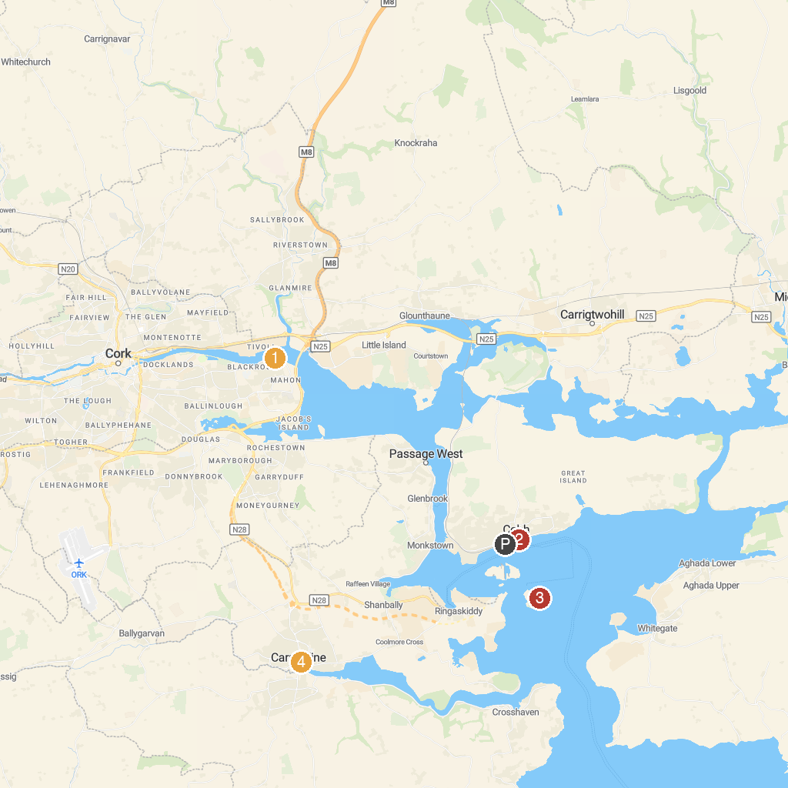
MAP KEY
1. Rocky Bay | 5. Saint Fin Barre's Cathedral
2. Blackrock Castle Observatory | 6. Spike Island
3. Cork Opera House | 7. Fort Mitchel, Spike Island
4. Triskel Arts Centre | 8. Church Of Our Lady and Saint John, Carrigaline
P. Cruise port / terminal
Map © MapTiler © OpenStreetMap contributors · cruiseports.org

