Cleveland, Ohio, USA
Cleveland punches well above its size on a Great Lakes itinerary — world-class museums, a buzzing waterfront, and one of America's great public markets, all within easy reach of a downtown pier.
⚓ Docked (Dock 28, downtown) · 🕒 Typical call: 8-10 hrs · 💵 US Dollar · 🗣️ English
✍️ MY DAY IN PORT (FILL IN)
Ship / Date
In port | arrive ______ · all aboard ______
Booked excursion
Notes / meeting point
GETTING ASHORE
- Docking: Dock 28, west of Huntington Bank Field — a 10–15 min walk to North Coast Harbor
- Walk to center: 10–15 min on foot to Rock & Roll Hall of Fame; 20 min to West Side Market
- Best For: Music history, art museums, lakefront walks, craft food markets
- Don't Miss: Rock & Roll Hall of Fame — budget at least 3 hours
GETTING AROUND
- 🚕 Taxi: $10–$25 — Metered taxis are available at the terminal. The short distance to downtown keeps fares low; request one at the port or
- 📱 Rideshare: ✅ Uber, Lyft
TOP THINGS TO DO
- Rock & Roll Hall of Fame — The anchor attraction of Cleveland's waterfront.
- West Side Market — Operating since 1840 and housed in its landmark 1912 yellow-brick building with a 137-ft clock tower, this is one of America's…
- Cleveland Museum of Art — One of the finest art museums in the US, with a permanent collection spanning 6,000 years — and free admission to the permanent…
- Goodtime III River & Lake Cruise — Board Cleveland's largest sightseeing vessel for a narrated 2-hour cruise along the Cuyahoga River and out onto Lake Erie.
- North Coast Harbor Waterfront Walk — The compact harbor area clusters the Rock Hall, Great Lakes Science Center, USS Cod submarine museum, and the Steamship William G.
BEST WALKS
- North Coast Harbor Loop: 2.5 km · Flat · 45 min — Walk east from Dock 28 along the lakefront path to North Coast Harbor.
- Downtown to The Flats: 3 km · Flat · 1 hr — Head south from the waterfront into downtown Cleveland, exploring Public Square and the historic…
WEATHER · DAYLIGHT · MONEY
Month | High °F | Low °F | Rainy days
May | 66 | 52 | 13
Jul | 79 | 67 | 13
Sep | 73 | 61 | 11
Daylight: May 6:07AM–8:39PM · Jul 6:06AM–8:58PM · Sep 7:07AM–7:35PM
cruiseports.org/cleveland-oh · Confirm terminal & all-aboard time with your ship

Cleveland, Ohio, USA — Port Map
Red = walkable sights · Amber = excursions farther out · P = cruise terminal
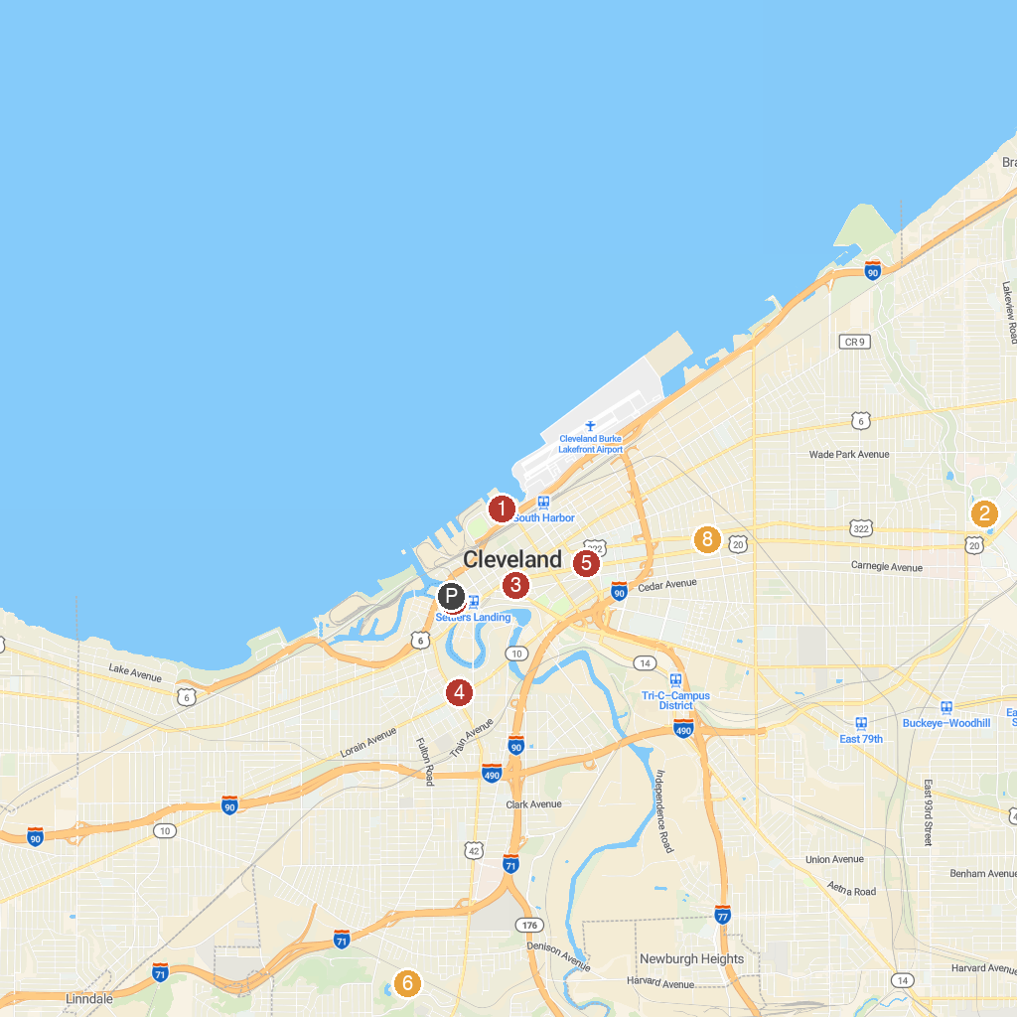
MAP KEY
1. Rock & Roll Hall of Fame | 5. Playhouse Square
2. The Cleveland Museum of Art | 6. Cleveland Metroparks Zoo
3. JACK Cleveland Casino | 7. Greater Cleveland Aquarium
4. West Side Market | 8. The Children's Museum of Cleveland
P. Cruise port / terminal
Map © MapTiler © OpenStreetMap contributors · cruiseports.org

