Ciutadella, Menorca, Spain
Menorca's ancient capital wears its history lightly — golden limestone palaces ring a working harbour, prehistoric tombs dot the countryside, and turquoise coves hide just beyond the city walls.
⚓ Tender (most large ships) · 🕒 Typical call: 7-9 hrs · 💶 Euro (EUR) · 🗣️ Catalan / Spanish
✍️ MY DAY IN PORT (FILL IN)
Ship / Date
In port | arrive ______ · all aboard ______
Booked excursion
Notes / meeting point
GETTING ASHORE
- Docking: Tender for most cruise ships; small luxury vessels may dock at Moll de Ponent
- Walk to Centre: 10 min from tender dock to Plaça des Born old town
- Best For: Medieval streets, prehistoric ruins, secluded cove boat trips
- Don't Miss: Naveta des Tudons (3,000-yr-old megalithic tomb) & harbour-front seafood
GETTING AROUND
- 🚕 Taxi: €7–€9 — Regulated taxis queue at the port. The ride to the city center takes about 3 minutes. Fares are fixed; a port surcharge
- 📱 Rideshare: ❌ not available
TOP THINGS TO DO
- Ciutadella Old Town Walk — Wander the tangle of Gothic lanes around Ses Voltes, peer into aristocratic palaces, and step inside the 14th-century Cathedral…
- Naveta des Tudons — Prehistoric Tomb — Drive or taxi 5 km east to Spain's oldest roofed structure still in its original form: a 3,000-year-old megalithic burial chamber…
- Boat Trip to Hidden Coves — Half-day excursions depart the old port to Son Saura, Cala Turqueta, Macarella, and Macarelleta — protected coves with…
- Camí de Cavalls Coastal Walk — Tackle Stage 11 from Ciutadella's port towards Cap d'Artrutx along this historic 185 km island-encircling trail.
- Castle of Sant Nicolau — This 17th-century octagonal watchtower guards the harbour mouth and houses a small exhibition on Menorca's Biosphere Reserve.
BEST WALKS
- Old Town Circuit: 1.5 km · 45 min · Easy — From the tender quay, climb to Plaça des Born, explore the cathedral, duck through Ses Voltes…
- Harbour to Cap d'Artrutx (Camí de Cavalls Stage 11 section): 6 km one-way · 2 hrs · Easy — Follow the coastal path south from the port past Cala Santandria to Cala Blanca, then along open…
WEATHER · DAYLIGHT · MONEY
Month | High °F | Low °F | Rainy days
May | 68 | 60 | 5
Jul | 82 | 73 | 2
Sep | 78 | 71 | 6
Daylight: May 6:29AM–8:53PM · Jul 6:28AM–9:12PM · Sep 7:25AM–7:53PM
cruiseports.org/ciutadella · Confirm terminal & all-aboard time with your ship

Ciutadella, Menorca, Spain — Port Map
Red = walkable sights · Amber = excursions farther out · P = cruise terminal
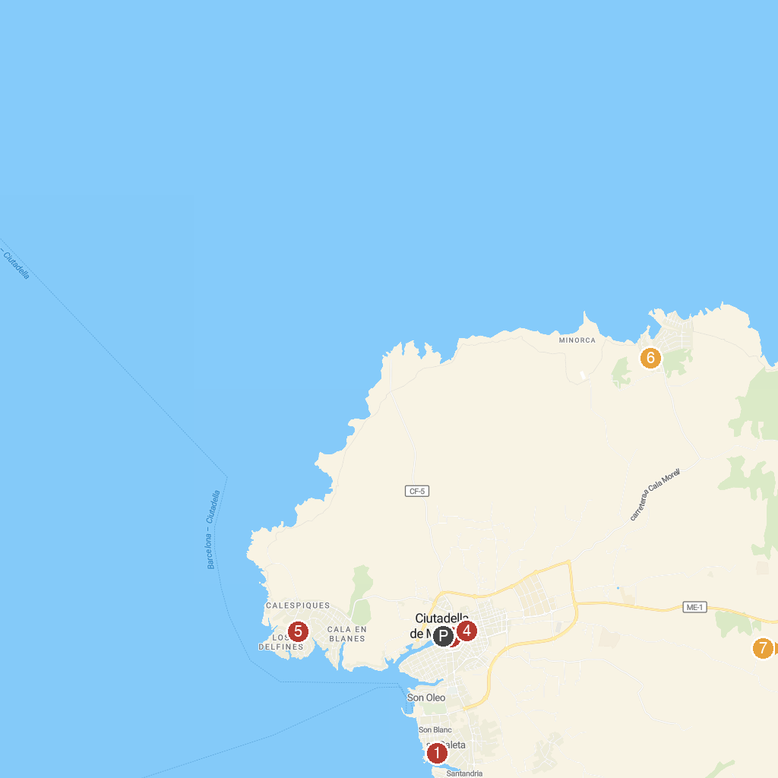
MAP KEY
1. Sa Caleta | 5. Aqua Center Menorca
2. Puerto Antiguo de Ciutadella de Menorca | 6. Necròpolis de Son Morell Nou
3. Palacio Olivar | 7. Torrellafuda
4. Plaça d'Alfons III
P. Cruise port / terminal
Map © MapTiler © OpenStreetMap contributors · cruiseports.org

