Cincinnati, Ohio, USA
Where the Ohio River meets one of America's great comeback cities. The Banks district lines the water with ballparks and breweries; two blocks away, Over-the-Rhine packs 19th-century architecture, craft beer halls, and Findlay Market into a neighborhood unlike anywhere else in the Midwest.
⚓ Docked — Public Landing riverfront · 🕒 Typical call: 8-10 hrs · 💵 USD · 🗣️ English · 🌡️ Best Apr–Oct
✍️ MY DAY IN PORT (FILL IN)
Ship / Date
In port | arrive ______ · all aboard ______
Booked excursion
Notes / meeting point
GETTING ASHORE
- Docking: Public Landing, Cincinnati waterfront — steps from The Banks district
- Walk to center: 5-minute walk to Great American Ball Park; free streetcar to OTR in 10 min
- Best For: History, craft beer, baseball, National Underground Railroad Freedom Center
- Don't Miss: Findlay Market on weekends; Roebling Bridge walk to Covington, KY
GETTING AROUND
- 🚕 Taxi: $12–15 — Uber and Lyft are both available and are the easiest option. From Newport Landing to downtown Cincinnati takes about 8–1
- 📱 Rideshare: ✅ Uber, Lyft
TOP THINGS TO DO
- National Underground Railroad Freedom Center — One of America's most moving museums, sitting right on the riverfront where freedom seekers once crossed the Ohio River.
- Over-the-Rhine Historic District — The largest intact urban historic district in the US, OTR is packed with 19th-century Italianate buildings now housing craft…
- Cincinnati Museum Center at Union Terminal — A spectacular 1933 Art Deco rail terminal housing the Cincinnati History Museum, Museum of Natural History & Science, and Duke…
- Findlay Market & OTR Brewery Scene — Ohio's oldest continuously operated public market (est.
- Ohio River Sightseeing Cruise (BB Riverboats) — See the skyline from the water on a narrated sightseeing or lunch/dinner cruise with BB Riverboats.
BEST WALKS
- Riverfront & Roebling Bridge Loop: 1.5 miles · Easy · 30-45 min — Walk west from the Public Landing along the Ohio River Trail through Smale Riverfront Park — don't…
- Over-the-Rhine Stroll: 0.8 miles in OTR · Easy · 1-2 hrs browsing — Hop the free Connector streetcar to the Findlay Market stop and explore the market, then walk south…
WEATHER · DAYLIGHT · MONEY
Month | High °F | Low °F | Rainy days
May | 74 | 55 | 14
Jul | 85 | 68 | 13
Sep | 79 | 61 | 7
Daylight: May 6:24AM–8:44PM · Jul 6:24AM–9:02PM · Sep 7:19AM–7:45PM
cruiseports.org/cincinnati-oh · Confirm terminal & all-aboard time with your ship

Cincinnati, Ohio, USA — Port Map
Red = walkable sights · Amber = excursions farther out · P = cruise terminal
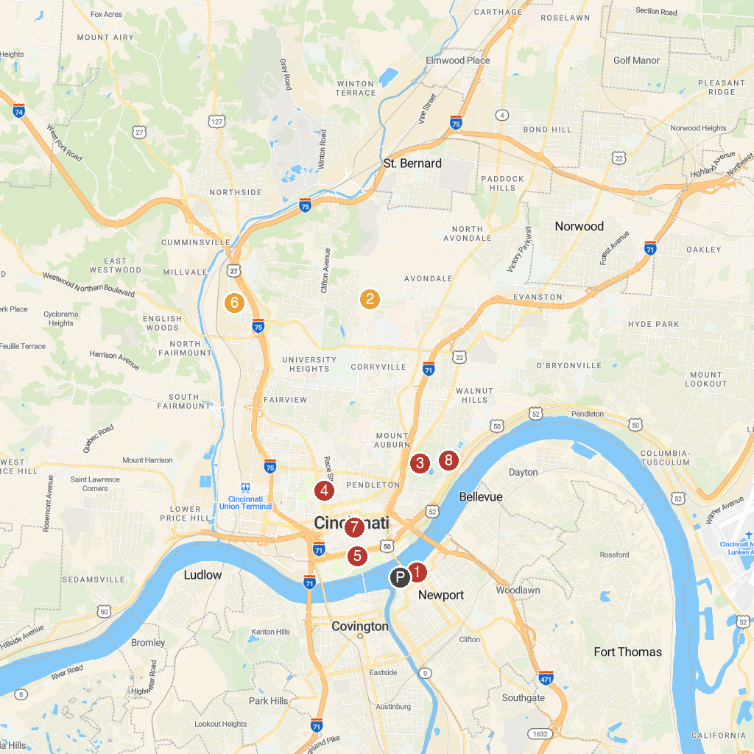
MAP KEY
1. Newport Aquarium | 5. National Underground Railroad Freedom Center
2. Cincinnati Zoo & Botanical Garden | 6. American Sign Museum
3. Cincinnati Art Museum | 7. Contemporary Arts Center (CAC)
4. Cincinnati Music Hall | 8. Krohn Conservatory
P. Cruise port / terminal
Map © MapTiler © OpenStreetMap contributors · cruiseports.org

