Cienfuegos, Cuba
Cienfuegos is Cuba's most refined city — a UNESCO-listed neoclassical gem on a stunning bay where French colonial elegance meets Caribbean warmth. Ships dock just blocks from one of the island's most walkable historic centers.
⚓ Docked (cruise wharf) · 🕒 Typical call: 7-9 hrs · 💵 Cuban Peso (CUP); EUR/CAD preferred for exchange · 🗣️ Spanish
✍️ MY DAY IN PORT (FILL IN)
Ship / Date
In port | arrive ______ · all aboard ______
Booked excursion
Notes / meeting point
GETTING ASHORE
- Docking: Cruise ships berth at the Cienfuegos wharf; the historic center is about a 10-12 min walk
- Walk to center: ~10-12 min on foot to Parque José Martí and the UNESCO historic core
- Best For: Colonial architecture, Cuban culture, day trip to Trinidad (UNESCO)
- Don't Miss: Teatro Tomás Terry, Palacio de Valle rooftop, and a horse-taxi ride along Paseo del Prado
GETTING AROUND
- 🚕 Taxi: $5–15 USD — Private taxis — often colorful vintage American cars — wait at the pier. Always negotiate the fare before you get in; me
- 📱 Rideshare: ❌ not available
TOP THINGS TO DO
- UNESCO Historic Center Walk — Parque José Martí is the heart of it — Cathedral de la Purísima Concepción, Teatro Tomás Terry, and the Provincial Government…
- Castillo de Jagua — This 18th-century Spanish fortress guards the entrance to Cienfuegos Bay.
- Trinidad Day Trip — Cuba's most photogenic colonial city is just 80 km away.
- El Nicho Waterfalls & Pools — In the Escambray mountains, El Nicho is a series of turquoise pools and cascades with jungle hiking trails.
- Jardín Botánico de Cienfuegos — One of Cuba's finest botanical gardens, with over 2,000 tropical plant species including 400+ orchid varieties.
BEST WALKS
- Paseo del Prado & Parque José Martí Loop: 2-3 hrs | Easy | 2-3 km — Start at the pier and follow the waterfront to Parque José Martí.
- Malecón to Punta Gorda: 1-1.5 hrs | Easy | 2 km — Walk the Malecón south from the city center to the Punta Gorda peninsula.
WEATHER · DAYLIGHT · MONEY
Month | High °F | Low °F | Rainy days
May | 88 | 74 | 17
Jul | 91 | 77 | 17
Sep | 89 | 77 | 20
Daylight: May 6:42AM–7:54PM · Jul 6:47AM–8:08PM · Sep 7:08AM–7:24PM
cruiseports.org/cienfuegos · Confirm terminal & all-aboard time with your ship

Cienfuegos, Cuba — Port Map
Red = walkable sights · Amber = excursions farther out · P = cruise terminal
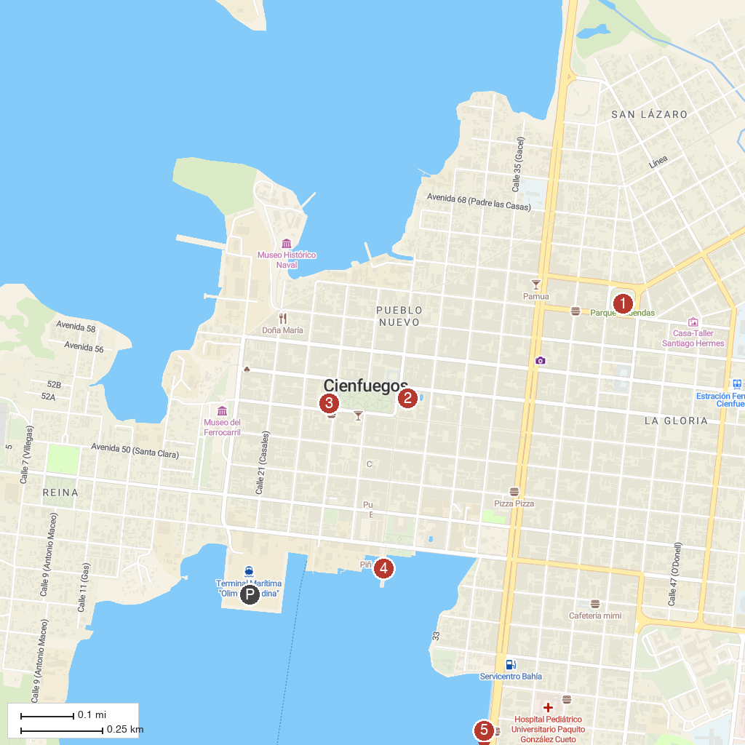
MAP KEY
1. Parque Villuendas | 4. Muelle Real
2. Cathedral of Our Lady of the Immaculate Conception | 5. Malecón de Cienfuegos
3. Museo de las Artes Palacio Ferrer
P. Cruise port / terminal
Map © MapTiler © OpenStreetMap contributors · cruiseports.org

