Churchill, Manitoba, Canada
The Polar Bear Capital of the World sits where the Churchill River meets Hudson Bay — a rare subarctic port call combining big Arctic wildlife, 18th-century fortifications, and Inuit heritage.
⚓ Docked (Port of Churchill grain pier) · 🕒 Typical call: 8-10 hrs · 💵 Canadian Dollar (CAD) · 🗣️ English · 🐻‍❄️ Wildlife: polar bears & beluga whales
✍️ MY DAY IN PORT (FILL IN)
Ship / Date
In port | arrive ______ · all aboard ______
Booked excursion
Notes / meeting point
GETTING ASHORE
- Docking: Deep-water bulk cargo pier at Port of Churchill; cruise ships dock portside, short walk to town
- Walk to centre: ~10 min on foot from pier to town centre
- Best For: Beluga whale encounters (June–Aug), polar bear sightings, Arctic history
- Don't Miss: Cape Merry National Historic Site and the Itsanitaq Museum
GETTING AROUND
- 🚕 Taxi: Varies (metered/arranged) — North Coast Taxi Company provides local taxi service within Churchill. Pricing is not published; arrange directly or thr
TOP THINGS TO DO
- Beluga Whale Boat Tour — Thousands of beluga whales gather in the Churchill River from June through August.
- Tundra Buggy Polar Bear Tour — Ride a purpose-built Tundra Buggy across the Churchill Wildlife Management Area for a safe, close-up look at polar bears on the…
- Prince of Wales Fort — A massive stone fortress built by the Hudson's Bay Company starting in 1731, across the Churchill River from town.
- Helicopter Tundra & Coast Flight — A 60–90 minute helicopter tour over Hudson Bay, the tundra, and the Churchill River delta offers sweeping views of the subarctic…
- Itsanitaq Museum & Town Walk — The Itsanitaq Museum (founded 1944) holds one of Canada's finest collections of Inuit carvings and artifacts dating back 3,700…
BEST WALKS
- Pier to Cape Merry: 2.5 km one-way | Easy | Polar bear caution — Walk from the Port of Churchill pier along the waterfront toward Cape Merry National Historic Site…
- Town Centre Stroll: 1-2 km loop | Easy | Guided recommended — Walk from the pier into the small town centre to visit the Itsanitaq Museum on La Verendrye Avenue…
WEATHER · DAYLIGHT · MONEY
Month | High °F | Low °F | Rainy days
May | 39 | 26 | 7
Jul | 63 | 48 | 10
Sep | 52 | 42 | 12
Daylight: May 5:20AM–8:55PM · Jul 5:12AM–9:20PM · Sep 6:46AM–7:24PM
cruiseports.org/churchill-mb · Confirm terminal & all-aboard time with your ship

Churchill, Manitoba, Canada — Port Map
Red = walkable sights · Amber = excursions farther out · P = cruise terminal
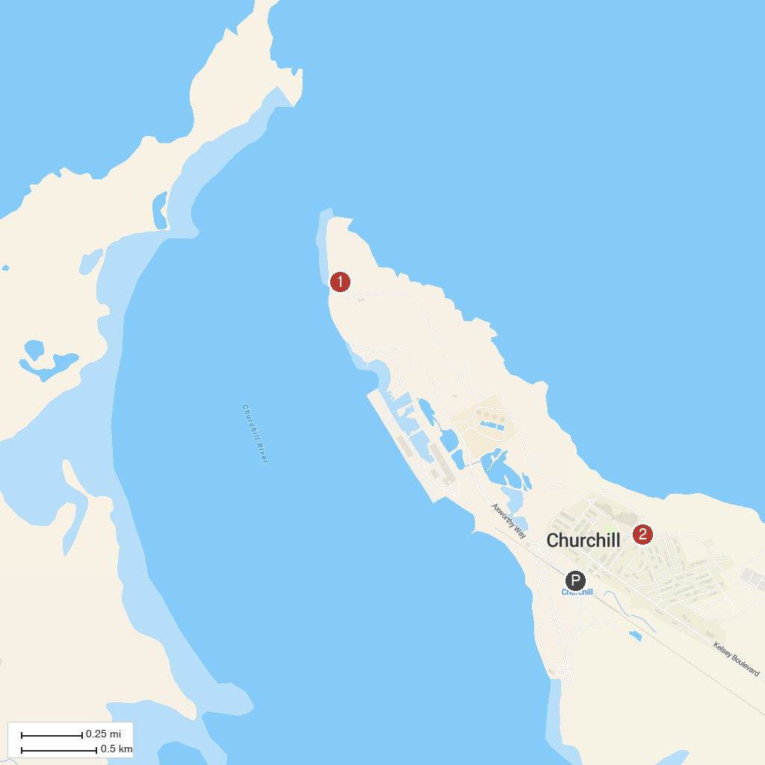
MAP KEY
1. Cape Merry | 2. Itsanitaq Museum
P. Cruise port / terminal
Map © MapTiler © OpenStreetMap contributors · cruiseports.org

