Chios Island, Aegean Islands, Greece
A quieter corner of the Aegean where medieval fortress villages sport black-and-white geometric facades, mastic trees drip their rare resin, and an 11th-century monastery glows with gold Byzantine mosaics.
⚓ Docked (Chios Town harbor) · 🕒 Typical call: 7–9 hrs · 💶 Euro (€) · 🗣️ Greek
✍️ MY DAY IN PORT (FILL IN)
Ship / Date
In port | arrive ______ · all aboard ______
Booked excursion
Notes / meeting point
GETTING ASHORE
- Docking: Quay berths at Chios Town harbor, 5-min walk to town center
- Best For: Mastic villages, Byzantine art, authentic island culture
- Don't Miss: Pyrgi's xysta facades and Nea Moni UNESCO monastery
- Getting Around: Car hire or taxi essential — villages are 25–35 km from port
GETTING AROUND
- 🚕 Taxi: €3–€10 — Taxis wait at the port entrance. The base fare is ~€3 and the city center is only a short distance; reliable local compa
TOP THINGS TO DO
- Pyrgi & the Painted Village — Pyrgi is the largest mastic village and the most visually arresting — every building facade is etched in intricate…
- Mesta — Medieval Fortress Village — Mesta is the best-preserved of the mastic villages, its stone houses locked together in a single defensive mass against pirate…
- Nea Moni UNESCO Monastery — Built by Byzantine Emperor Constantine IX in 1042, this hilltop monastery is one of Greece's three UNESCO-listed Byzantine…
- Chios Mastic Museum & Groves — Chios is the world's only source of natural mastic gum — a resin unique to this corner of the island, where it has been…
- Chios Castle & Old Town Walk — The Byzantine-era castle that towers over the port is free to enter and offers sweeping harbor views.
BEST WALKS
- Chios Town Waterfront & Castle Walk: 1.5 km · 30–45 min · Easy — From the cruise pier, stroll north along the harbor promenade to the main square, then turn inland…
- Kampos Citrus Estate Walk: Easy walk around estate roads · 45 min · Flat — The Kampos district, 4 km south of the port by taxi, is a grid of quiet lanes running between…
WEATHER · DAYLIGHT · MONEY
Month | High °F | Low °F | Rainy days
May | 77 | 62 | 4
Jul | 92 | 76 | 0
Sep | 84 | 70 | 2
Daylight: May 6:04AM–8:19PM · Jul 6:04AM–8:38PM · Sep 6:57AM–7:23PM
cruiseports.org/chios-island · Confirm terminal & all-aboard time with your ship

Chios Island, Aegean Islands, Greece — Port Map
Red = walkable sights · Amber = excursions farther out · P = cruise terminal
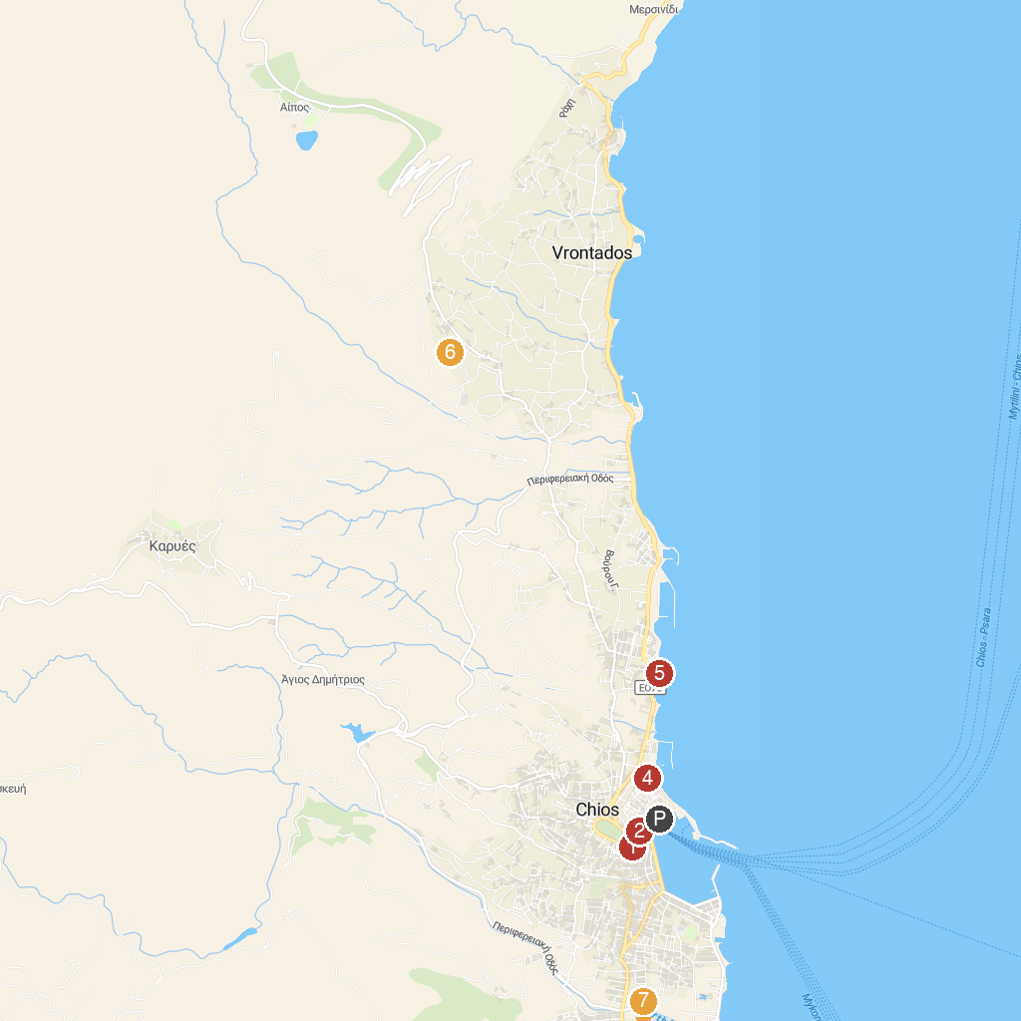
MAP KEY
1. Çiftlik Köy Cami | 5. Ottoman Bath in the Castle of Chios
2. Byzantine Museum of Chios (Mecidiye Mosque) | 6. Windmill of Chios
3. Castle of Chios | 7. Filoproodos Omilos Vrontadou (F.O.V.)
4. Chios Port | 8. Kampos
P. Cruise port / terminal
Map © MapTiler © OpenStreetMap contributors · cruiseports.org

