Chioggia, Veneto, Italy
Called 'Little Venice' for good reason — Chioggia's fishermen have worked these lagoon waters for centuries, and the city wears its seafaring soul proudly. Come for the canals and stay for the fish market.
⚓ Docked (pier) · 🕒 Typical call: 7–9 hrs · 💶 Euro (€) · 🗣️ Italian
✍️ MY DAY IN PORT (FILL IN)
Ship / Date
In port | arrive ______ · all aboard ______
Booked excursion
Notes / meeting point
GETTING ASHORE
- Docking: Porto di Chioggia / Via Isola Saloni — approx. 1 km from town center
- Walk to center: 15–20 min on foot or water shuttle (Viking and some lines offer it)
- Best For: Authentic lagoon culture, seafood, a Venice day trip without the Mestre detour
- Don't Miss: Mercato del Pesce (fish market), Canal Vena, Duomo di Chioggia
GETTING AROUND
- 🚕 Taxi: €10–€20 — Local taxis use metered fares; a short ride within Chioggia to the historic center typically runs €10–€20. Taxis can be
- 📱 Rideshare: ✅ Uber
TOP THINGS TO DO
- Venice & the Venetian Islands — Take the ferry to Venice and spend the day at St.
- Chioggia Fish Market & Old Town Walk — The Mercato del Pesce is one of Italy's oldest fish markets, bustling until midday.
- Venetian Lagoon Boat Tour — A small-boat tour through the lagoon takes in Pellestrina island, fishing valleys, and migratory bird habitat — a quieter…
- Sottomarina Beach — Just across the bridge from Chioggia, Sottomarina stretches several kilometers of Adriatic sand with beach clubs, bars, and calm…
- Padua Day Trip — Board a regional bus to Padua (1 hr) and visit the Basilica of St.
BEST WALKS
- Corso del Popolo & Canal Vena: 2–3 km · Easy · 1–1.5 hrs — Start at Piazzetta Vigo with its 1685 bridge and the winged lion of St.
- Sottomarina Waterfront Stroll: 2 km · Easy · 45 min — Cross the bridge to Sottomarina and walk the broad promenade along the Adriatic beach.
WEATHER · DAYLIGHT · MONEY
Month | High °F | Low °F | Rainy days
May | 70 | 58 | 13
Jul | 84 | 72 | 8
Sep | 75 | 64 | 10
Daylight: May 5:41AM–8:33PM · Jul 5:38AM–8:55PM · Sep 6:49AM–7:21PM
cruiseports.org/chioggia · Confirm terminal & all-aboard time with your ship

Chioggia, Veneto, Italy — Port Map
Red = walkable sights · Amber = excursions farther out · P = cruise terminal
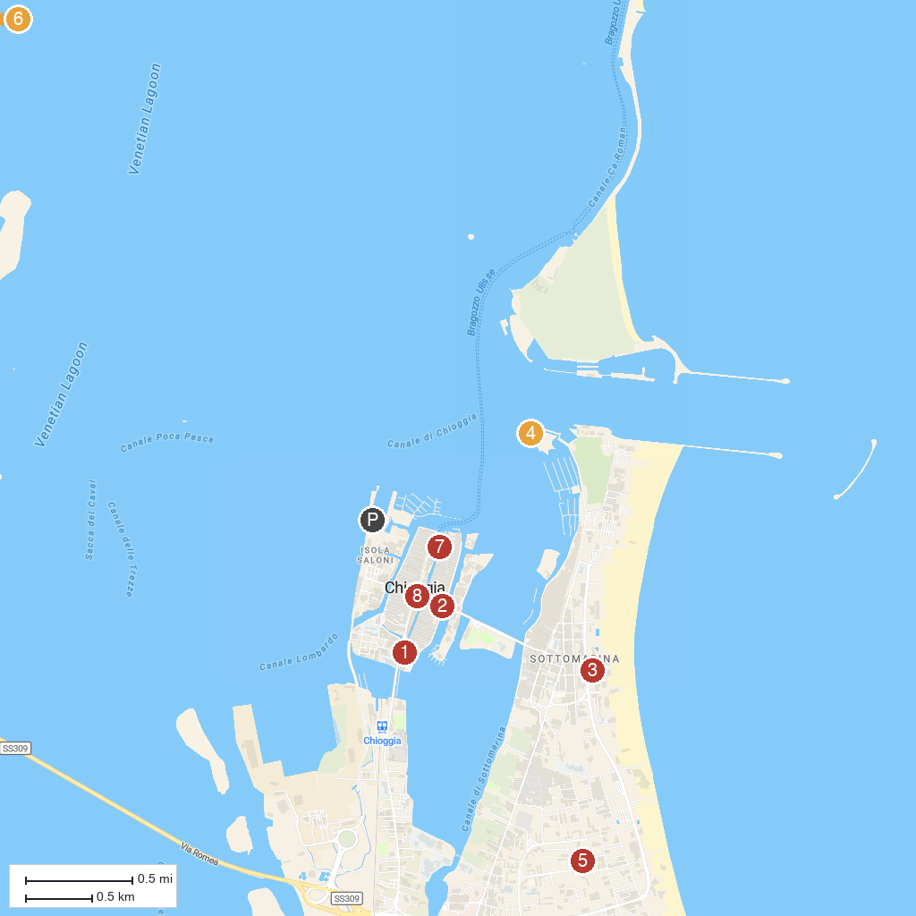
MAP KEY
1. Museo Civico della Laguna Sud “San Francesco fuori le mura” | 5. Chiesa Parrocchiale del Buon Pastore
2. Riva Vena | 6. the Boschettona Beach
3. Astoria Village | 7. Museum of Adriatic Zoology "G. Olivi"
4. Forte San Felice | 8. Church of Saint James Apostle
P. Cruise port / terminal
Map © MapTiler © OpenStreetMap contributors · cruiseports.org

