Chichagof Island (Icy Strait Point), Alaska, USA
Owned and operated by the Huna Tlingit people, Icy Strait Point delivers some of Alaska's most authentic wildlife encounters — brown bears patrol the rainforest, humpbacks breach offshore, and a 5,495-foot zipline drops you through it all.
⚓ Docked (two dedicated cruise piers) · 🕒 Typical call: 7-9 hrs · 💵 USD · 🗣️ English / Tlingit heritage
✍️ MY DAY IN PORT (FILL IN)
Ship / Date
In port | arrive ______ · all aboard ______
Booked excursion
Notes / meeting point
GETTING ASHORE
- Docking: Two dedicated piers: Wilderness Landing & Ocean Landing (Adventure Landing); free gondola connects them
- Walk to village: Hoonah village ~1.5 miles via paved path or shuttle (~$5 each way)
- Best For: Brown bear viewing, whale watching, Tlingit culture, ZipRider adventure
- Don't Miss: Bear Search in Spasski River Valley and the Skyglider Gondola panorama over Glacier Bay
GETTING AROUND
- 🚕 Taxi: $7–$10 — Local taxis can make the short ~3-minute ride to Hoonah, but they are not readily available and may require pre-arrangem
- 📱 Rideshare: ❌ not available
TOP THINGS TO DO
- Brown Bear Search — Spasski River Valley — Chichagof Island has one of the highest brown bear densities per square mile in the world.
- ZipRider — World's Largest Zip Line — The ZipRider at Icy Strait Point stretches 5,495 feet with a 1,330-foot vertical drop, topping 60 mph through old-growth…
- Whale Watching at Point Adolphus — The waters off Point Adolphus are among Alaska's best for humpback whale sightings (May–September).
- Hoonah Village & Huna Tribal House — Walk or shuttle 1.5 miles to Hoonah, the largest Tlingit village in Alaska.
- Sea Kayaking — Port Frederick Bay — Paddle through the calm, glacier-carved waters of Port Frederick Bay with a guided kayak tour.
BEST WALKS
- Pier Trail — Wilderness Landing to Ocean Landing: 0.5 miles · Easy · 15 min one-way — A flat, paved half-mile rainforest path connects the two cruise piers through Tongass old-growth.
- Icy Strait Point to Hoonah Village: 1.5 miles · Easy · 30 min one-way — A paved walking path runs from the port complex to the heart of Hoonah village.
WEATHER · DAYLIGHT · MONEY
Month | High °F | Low °F | Rainy days
May | 54 | 43 | 14
Jul | 62 | 53 | 16
Sep | 56 | 48 | 19
Daylight: May 4:36AM–9:21PM · Jul 4:22AM–9:51PM · Sep 6:32AM–7:19PM
cruiseports.org/chichagof-island · Confirm terminal & all-aboard time with your ship

Chichagof Island (Icy Strait Point), Alaska, USA — Port Map
Red = walkable sights · Amber = excursions farther out · P = cruise terminal
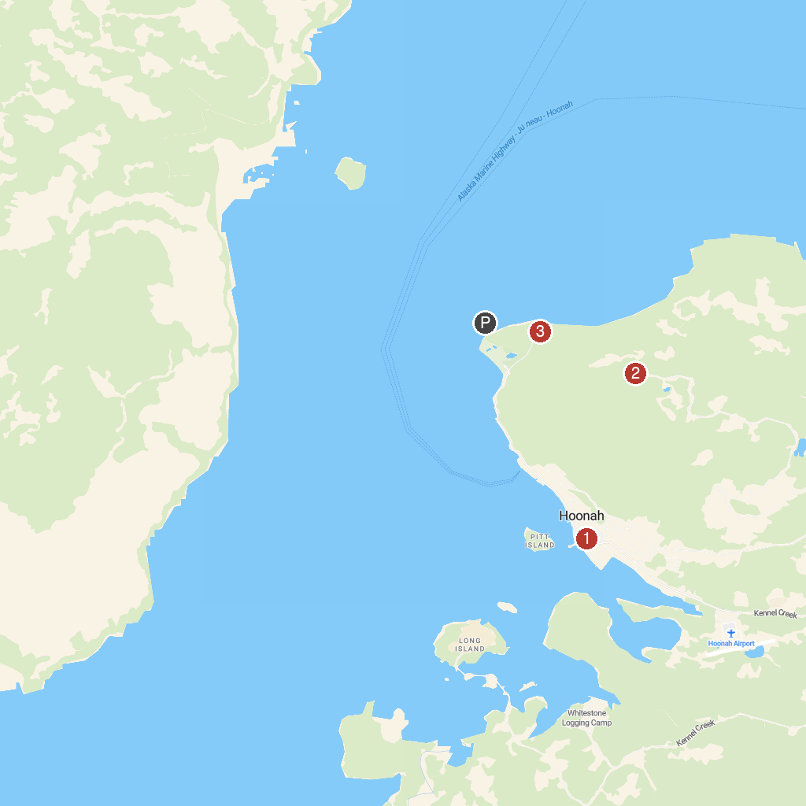
MAP KEY
1. Wilderness Island Tours, LLC | 3. Skyglider Gondola
2. Ziprider
P. Cruise port / terminal
Map © MapTiler © OpenStreetMap contributors · cruiseports.org

