Chicago, Illinois, USA
The city that reinvented the skyscraper greets Great Lakes cruisers at Navy Pier — a natural launching pad for architecture tours, lakefront strolls, and one of America's most walkable downtowns.
⚓ Docked — Navy Pier · 🕒 Typical call: 8–12 hrs (often overnight) · 💵 USD · 🗣️ English
✍️ MY DAY IN PORT (FILL IN)
Ship / Date
In port | arrive ______ · all aboard ______
Booked excursion
Notes / meeting point
GETTING ASHORE
- Docking: Navy Pier, Lake Michigan shore — ships dock alongside (broadside)
- Walk to center: Millennium Park ~1.5 mi on foot or short ride-share; Magnificent Mile ~0.8 mi
- Best For: Architecture fans, museum-goers, foodies, first-time USA visitors
- Don't Miss: Chicago Architecture Foundation River Cruise from Michigan Avenue Bridge
GETTING AROUND
- 🚕 Taxi: $11–$14 — Short taxi ride from Navy Pier to downtown Chicago, typically under 10 minutes. Cabs are readily available at the pier.
- 📱 Rideshare: ✅ Uber, Lyft
- 🚌 Hop-on hop-off: ✅ Big Bus Tours Chicago
TOP THINGS TO DO
- Chicago Architecture River Cruise — A narrated boat tour along the Chicago River is the single best introduction to the city.
- Millennium Park & The Bean — Cloud Gate (universally known as 'The Bean') anchors Millennium Park, Chicago's 24.5-acre lakefront showpiece.
- Art Institute of Chicago — One of the world's great encyclopedic art museums — home to Seurat's Sunday on La Grande Jatte, Grant Wood's American Gothic, and…
- Field Museum & Museum Campus — The Field Museum of Natural History houses Sue, one of the most complete T.
- Skydeck Chicago — Willis Tower — Step out onto The Ledge, a glass-floored balcony 1,353 feet above street level at the former Sears Tower.
BEST WALKS
- Navy Pier to Millennium Park Lakefront Walk: 1.5 mi one-way | ~30 min | flat, paved — Head west from Navy Pier along the lake, passing Olive Park and the Ohio Street Beach.
- Chicago Riverwalk Stroll: 1.3 mi one-way | ~25 min | flat, café-lined — The Chicago Riverwalk runs along the south bank of the Chicago River from Lake Shore Drive to Lake…
WEATHER · DAYLIGHT · MONEY
Month | High °F | Low °F | Rainy days
May | 66 | 50 | 13
Jul | 80 | 66 | 12
Sep | 74 | 61 | 10
Daylight: May 5:30AM–8:04PM · Jul 5:29AM–8:23PM · Sep 6:31AM–6:59PM
cruiseports.org/chicago · Confirm terminal & all-aboard time with your ship

Chicago, Illinois, USA — Port Map
Red = walkable sights · Amber = excursions farther out · P = cruise terminal
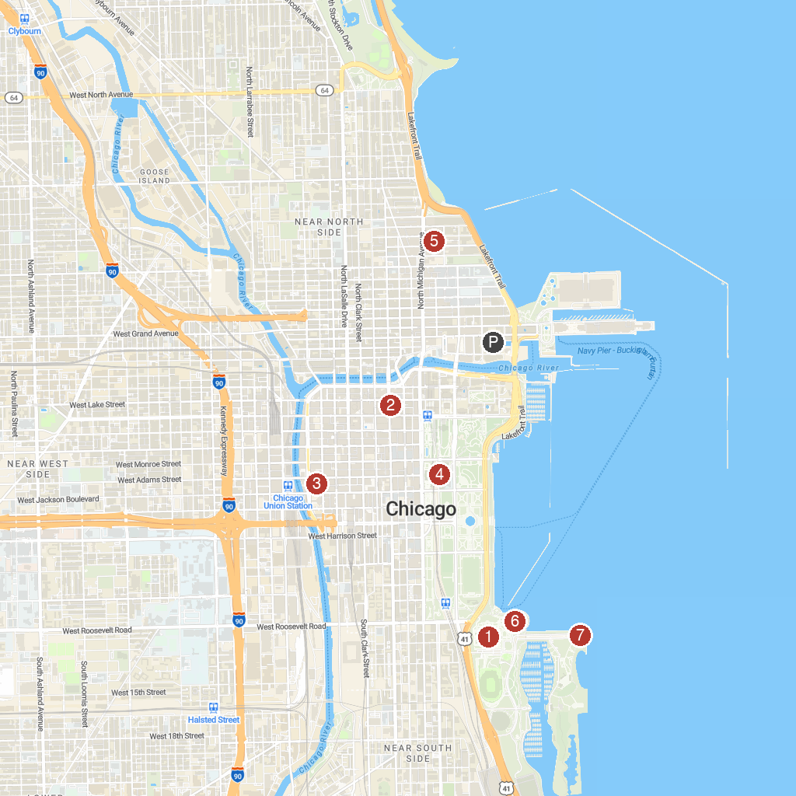
MAP KEY
1. Field Museum | 5. 875 North Michigan Avenue
2. The Chicago Theatre | 6. Shedd Aquarium
3. Willis Tower | 7. Adler Planetarium
4. The Art Institute of Chicago
P. Cruise port / terminal
Map © MapTiler © OpenStreetMap contributors · cruiseports.org

