Cherbourg, France
Maritime Heritage and Norman Charm
⚓ Deep-water Port · 🏰 Fortress City · 🇫🇷 Normandy · 🐚 Seafood
✍️ MY DAY IN PORT (FILL IN)
Ship / Date
In port | arrive ______ · all aboard ______
Booked excursion
Notes / meeting point
GETTING ASHORE
- Currency: Euro (€)
- Language: French
- Climate: Maritime/Temperate
- Key Landmark: La Cité de la Mer
GETTING AROUND
- 🚕 Taxi: €8–€17 — Taxis wait dockside at the terminal. The ride to Cherbourg city center takes 5–10 minutes; metered fares typically run €
- 📱 Rideshare: ✅ Bolt, Uber
TOP THINGS TO DO
- Fort du Roule — Climb to this historic fortress for sweeping harbor views and the Musée de la Libération, which tells the story of the 1944…
- La Cité de la Mer — World-class maritime museum inside the old submarine base.
- Cap de la Hague — Scenic drive to Normandy's western tip.
- Mont Saint-Michel — Longer excursion to the iconic tidal-island abbey, one of France's most visited landmarks.
BEST WALKS
- Harborfront Stroll: Easy — Walk from the cruise terminal along the waterfront, visiting local seafood bistros and boutiques.
- Fort du Roule Walk: Moderate — Hike up to the fortress for historic ramparts and sweeping views over the harbor and city.
- City Center Exploration: Easy — Wander narrow streets and markets, sampling Norman cider, cheeses, and fresh seafood.
WEATHER · DAYLIGHT · MONEY
Month | High °F | Low °F | Rainy days
May | 60 | 50 | 12
Jul | 69 | 59 | 10
Sep | 66 | 57 | 10
Daylight: May 6:22AM–9:44PM · Jul 6:16AM–10:08PM · Sep 7:43AM–8:19PM
cruiseports.org/cherbourg · Confirm terminal & all-aboard time with your ship

Cherbourg, France — Port Map
Red = walkable sights · Amber = excursions farther out · P = cruise terminal
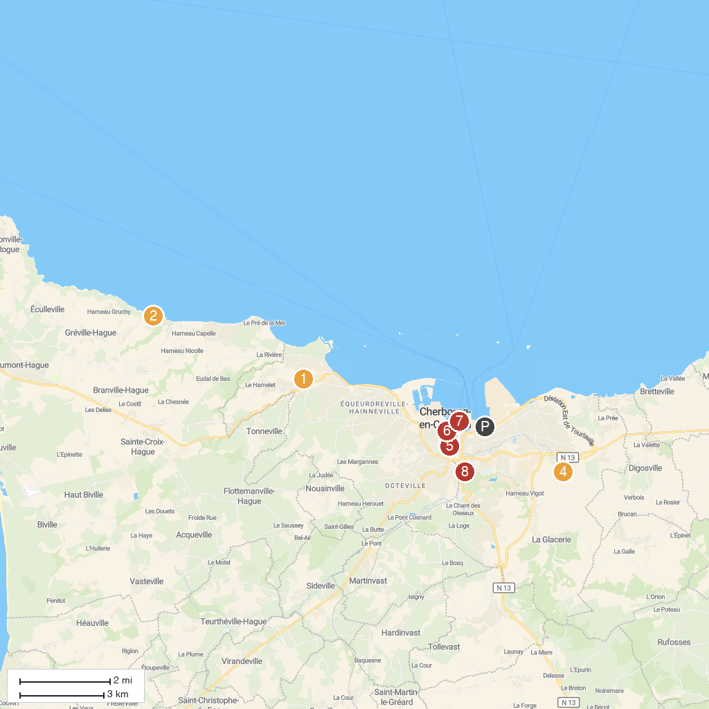
MAP KEY
1. Manoir de la Coquerie | 5. Fontaine Mouchel
2. Landemer | 6. Equestrian Statue of Napoléon I
3. Basilique Sainte-Trinité de Cherbourg-en-Cotentin | 7. La Cité de la Mer
4. Ravalet Castle | 8. Batterie Du Roule
P. Cruise port / terminal
Map © MapTiler © OpenStreetMap contributors · cruiseports.org

