Châteauneuf-du-Rhône, Drôme, France
A quiet medieval village on the Rhône riverbank, Châteauneuf-du-Rhône punches above its size — 13th-century ramparts, lavender-scented Provençal countryside, and the best nougat in France just nine kilometres away.
⚓ Docked (river quay) · 🕒 Typical call: 5–7 hrs · 💶 Euro (€) · 🗣️ French
✍️ MY DAY IN PORT (FILL IN)
Ship / Date
In port | arrive ______ · all aboard ______
Booked excursion
Notes / meeting point
GETTING ASHORE
- Docking: Ships tie up alongside the Rhône riverbank quay; no tender required.
- Walk to centre: 5–10 min on foot from the quay into the old village.
- Best For: Cycling the ViaRhôna, Rhône wine tasting, and easy Provence day trips.
- Don't Miss: The 13th-century ramparts and the nougat shops of Montélimar (9 km).
GETTING AROUND
- 🚕 Taxi: €8–€20 — Local taxis operate under Drôme department metered rates (€8 minimum, ~€2.32/km daytime). Short trips within the village
- 📱 Rideshare: ✅ Uber
TOP THINGS TO DO
- Grignan Castle & Village — About twenty-three kilometres east, Grignan hosts the largest Renaissance castle in south-east France — the château of the…
- Montélimar Nougat Tour — The nougat capital of France is just 9 km south.
- ViaRhôna Cycling — Jump on a bike and join the ViaRhôna, an 815 km motor-free trail from Lake Geneva to the Mediterranean.
- Gorges de l'Ardèche Day Trip — About 30 km west, the Ardèche Gorges carve through 300-metre limestone cliffs.
- Orange Roman Theatre — One of the world's best-preserved Roman theatres — a UNESCO World Heritage site — stands in Orange, roughly 40 km south.
BEST WALKS
- Old Village & Ramparts Loop: 1.5 km · 30–45 min · Easy — From the quay, walk up to the old village entrance and follow the medieval lanes past the Church of…
- ViaRhôna Riverside Walk: 2–5 km · 45 min–1.5 hrs · Easy, flat — Head south along the ViaRhôna path hugging the Rhône riverbank.
WEATHER · DAYLIGHT · MONEY
Month | High °F | Low °F | Rainy days
May | 72 | 54 | 9
Jul | 87 | 68 | 5
Sep | 78 | 61 | 7
Daylight: May 6:13AM–9:01PM · Jul 6:10AM–9:22PM · Sep 7:20AM–7:51PM
cruiseports.org/chateauneuf-du-rhone · Confirm terminal & all-aboard time with your ship

Châteauneuf-du-Rhône, Drôme, France — Port Map
Red = walkable sights · Amber = excursions farther out · P = cruise terminal
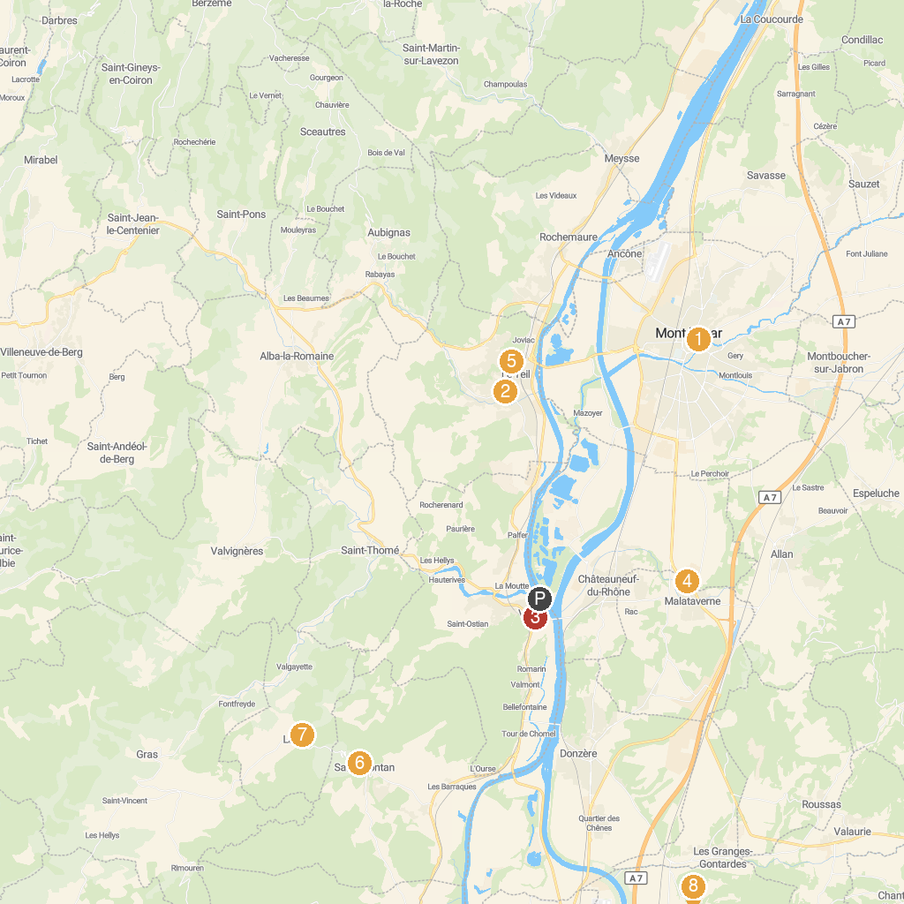
MAP KEY
1. Montelimar Castle | 5. Joncas Aventure
2. Musée de la Résistance et de la Déportation en Ardèche | 6. Medieval Castle of Saint Montan
3. Viviers Cathedral | 7. Église Saint-Pierre de Larnas
4. Recrea 9 Aire de jeux | 8. Jardin des Herbes
P. Cruise port / terminal
Map © MapTiler © OpenStreetMap contributors · cruiseports.org

