Charlotteville, Tobago, Trinidad and Tobago
Tucked into the northeastern tip of Tobago, Charlotteville is an authentic Caribbean fishing village where the rainforest meets a horseshoe bay. Ships tender into Man-O-War Bay — no crowds, no cruise terminals, just turquoise water and warm locals.
⚓ Tender port (Man-O-War Bay) · 🕒 Typical call: 6-8 hrs · 💵 TTD & USD accepted · 🗣️ English · 🌿 Rainforest & diving destination
✍️ MY DAY IN PORT (FILL IN)
Ship / Date
In port | arrive ______ · all aboard ______
Booked excursion
Notes / meeting point
GETTING ASHORE
- Docking: Tender to Man-O-War Bay jetty — no cruise pier
- Walk to Village: Tender lands in the village center; everything walkable from there
- Best For: Snorkeling, diving, Pirate's Bay, rainforest hikes
- Don't Miss: Pirate's Bay beach and the Argyle Waterfall
GETTING AROUND
- 🚕 Taxi: Negotiate fare in advance — Private taxis are available near the pier. No meters are used — agree on a fare before you go. Short trips within the vi
- 📱 Rideshare: ❌ not available
TOP THINGS TO DO
- Pirate's Bay Snorkel & Swim — A short boat ride (or 165-step descent on foot) reveals Pirate's Bay — calm, crystal-clear water with healthy coral and abundant…
- Argyle Waterfall Hike — Tobago's tallest waterfall cascades 175 feet in three tiers through lush rainforest.
- Main Ridge Forest Reserve Walk — The oldest legally protected rainforest in the Western Hemisphere (est.
- Lover's Bay Boat Tour — Accessible only by boat from the Man-O-War Bay jetty, Lover's Bay is a secluded pink-sand cove with crystal water ideal for…
- Scuba Diving — NE Tobago Reefs — Northeastern Tobago is home to over 50 established dive sites, and nearby Speyside boasts the largest brain coral in the Western…
BEST WALKS
- Man-O-War Bay Beachfront Stroll: 1 km · 20 min · Easy · Flat — Walk the golden-sand beach from the village jetty westward along Man-O-War Bay.
- Flagstaff Hill Viewpoint: 2 km round trip · 45 min · Moderate · Uphill — A signposted track rises steeply from the village to Flagstaff Hill, rewarding the effort with…
WEATHER · DAYLIGHT · MONEY
Month | High °F | Low °F | Rainy days
May | 64 | 45 | 13
Jul | 77 | 60 | 13
Sep | 69 | 53 | 10
Daylight: May 5:36AM–8:14PM · Jul 5:35AM–8:33PM · Sep 6:39AM–7:07PM
cruiseports.org/charlotteville · Confirm terminal & all-aboard time with your ship

Charlotteville, Tobago, Trinidad and Tobago — Port Map
Red = walkable sights · Amber = excursions farther out · P = cruise terminal
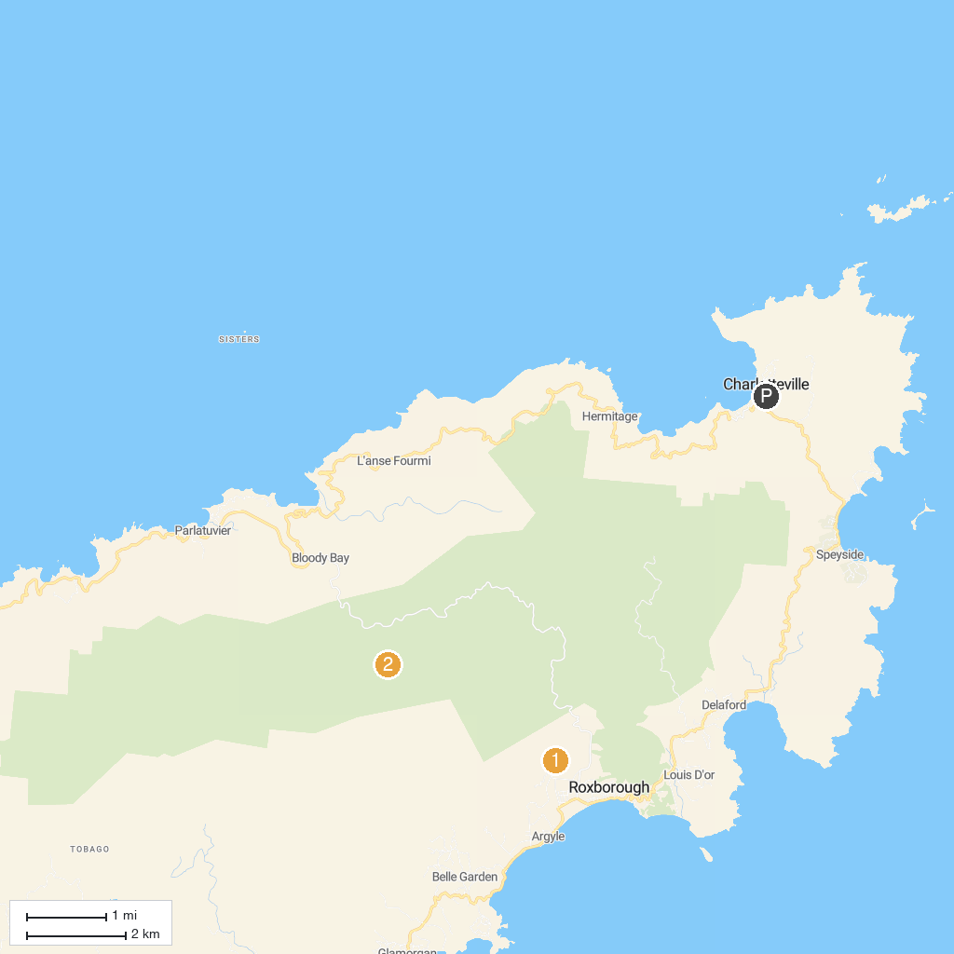
MAP KEY
1. Argyle Falls | 2. Tobago Main Ridge Forest Reserve
P. Cruise port / terminal
Map © MapTiler © OpenStreetMap contributors · cruiseports.org

