Charleston, South Carolina, USA
One of America's most beautifully preserved colonial cities, Charleston puts its cobblestone streets, antebellum mansions, and legendary food scene within easy walking distance of the pier.
⚓ Pier (docked) · 🕒 Typical call: 8-10 hrs · 💵 USD · 🗣️ English
✍️ MY DAY IN PORT (FILL IN)
Ship / Date
In port | arrive ______ · all aboard ______
Booked excursion
Notes / meeting point
GETTING ASHORE
- Docking: Union Pier Terminal, foot of Market St — no tender required
- Walk to center: 5 min on foot to City Market; 10 min to Rainbow Row
- Best For: History lovers, foodies, walkers, Civil War enthusiasts
- Don't Miss: Fort Sumter ferry, Rainbow Row, sweetgrass baskets at City Market
GETTING AROUND
- 🚕 Taxi: $17 minimum, ~$3/mile — Metered taxis available at the port. Minimum fare is $17; extra passengers beyond two cost $7 each per trip.
- 📱 Rideshare: ✅ Uber, Lyft
TOP THINGS TO DO
- Fort Sumter National Monument — Ferry out to the island fort where Confederate forces fired the opening shots of the Civil War in April 1861.
- Rainbow Row & The Battery Walk — Stroll the 13 pastel Georgian row houses on East Bay Street, then continue south along The Battery seawall for harbor views and…
- Charleston City Market & Sweetgrass Baskets — Four blocks of artisan vendors in a covered market dating to the 1800s.
- Magnolia Plantation & Gardens — America's oldest public garden (established 1676) with azalea-draped pathways, a wildlife refuge, and a sobering Slavery to…
- Boone Hall Plantation — The iconic avenue of live oaks leads to an antebellum cotton plantation with original slave cabins, a cotton gin, and costumed…
BEST WALKS
- Historic District Loop: 2.5 miles · 1-1.5 hrs · Easy — From the pier gate, walk to Charleston City Market, down Meeting Street past St.
- King Street Shopping & Galleries: 1 mile · 1 hr · Easy — Head west from the Market on Market Street to King Street — Charleston's main shopping corridor…
WEATHER · DAYLIGHT · MONEY
Month | High °F | Low °F | Rainy days
May | 80 | 67 | 10
Jul | 87 | 77 | 17
Sep | 83 | 72 | 15
Daylight: May 6:20AM–8:11PM · Jul 6:22AM–8:28PM · Sep 7:03AM–7:25PM
cruiseports.org/charleston-sc · Confirm terminal & all-aboard time with your ship

Charleston, South Carolina, USA — Port Map
Red = walkable sights · Amber = excursions farther out · P = cruise terminal
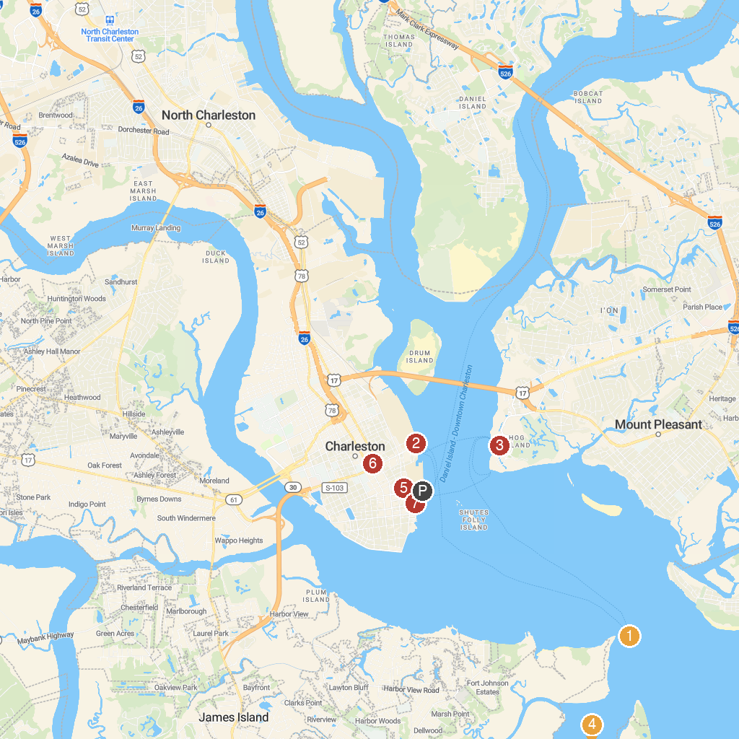
MAP KEY
1. Fort Sumter National Monument | 5. Palmetto Carriage Works
2. South Carolina Aquarium | 6. Marion Square
3. Patriots Point Naval & Maritime Museum | 7. Boone Hall Plantation & Gardens
4. Morris Island Lighthouse | 8. Waterfront Park
P. Cruise port / terminal
Map © MapTiler © OpenStreetMap contributors · cruiseports.org

