Champion Islet, Floreana, Galapagos, Ecuador
A tiny volcanic islet off Floreana, Champion is famous for some of the clearest snorkeling in the Galapagos — sea lions, hammerheads, and green turtles all in one swim. No landings allowed; the magic is entirely in and around the water.
⚓ Zodiac/panga only (no landing permitted) · 🕒 Typical call: 3-5 hrs · 💵 USD (Ecuador) · 🗣️ Spanish / English guides · 🐠 World-class snorkeling
✍️ MY DAY IN PORT (FILL IN)
Ship / Date
In port | arrive ______ · all aboard ______
Booked excursion
Notes / meeting point
GETTING ASHORE
- Docking: No pier or landing — zodiac/panga access only from expedition cruise ship
- Location: Off the north coast of Floreana Island, southern Galapagos Archipelago
- Best For: Snorkeling, sea lion encounters, rare birdwatching (Floreana Mockingbird)
- Don't Miss: The coral wall snorkel and a panga ride to spot the critically endangered Floreana Mockingbird
GETTING AROUND
- 📱 Rideshare: ❌ not available
TOP THINGS TO DO
- Champion Islet Snorkel — Swim the crystal-clear waters around the islet to encounter playful Galapagos sea lions, green sea turtles, hammerhead sharks…
- Panga Wildlife Cruise — Zodiac rides around the islet's rugged shoreline offer close-up views of Galapagos penguins, blue-footed and Nazca boobies…
- Floreana Island Combination Day — Many itineraries pair Champion Islet with nearby Floreana Island, adding a visit to the Post Office Bay barrel (a 19th-century…
- Scuba Diving — Champion Wall — The submerged coral wall at Champion is a renowned drift dive site covered in black and yellow corals, with frequent sightings of…
WEATHER · DAYLIGHT · MONEY
Month | High °F | Low °F | Rainy days
May | 75 | 70 | 16
Jul | 71 | 66 | 11
Sep | 69 | 64 | 6
Daylight: May 5:56AM–5:59PM · Jul 6:06AM–6:09PM · Sep 5:53AM–5:59PM
cruiseports.org/champion-island · Confirm terminal & all-aboard time with your ship

Champion Islet, Floreana, Galapagos, Ecuador — Port Map
Red = walkable sights · Amber = excursions farther out · P = cruise terminal
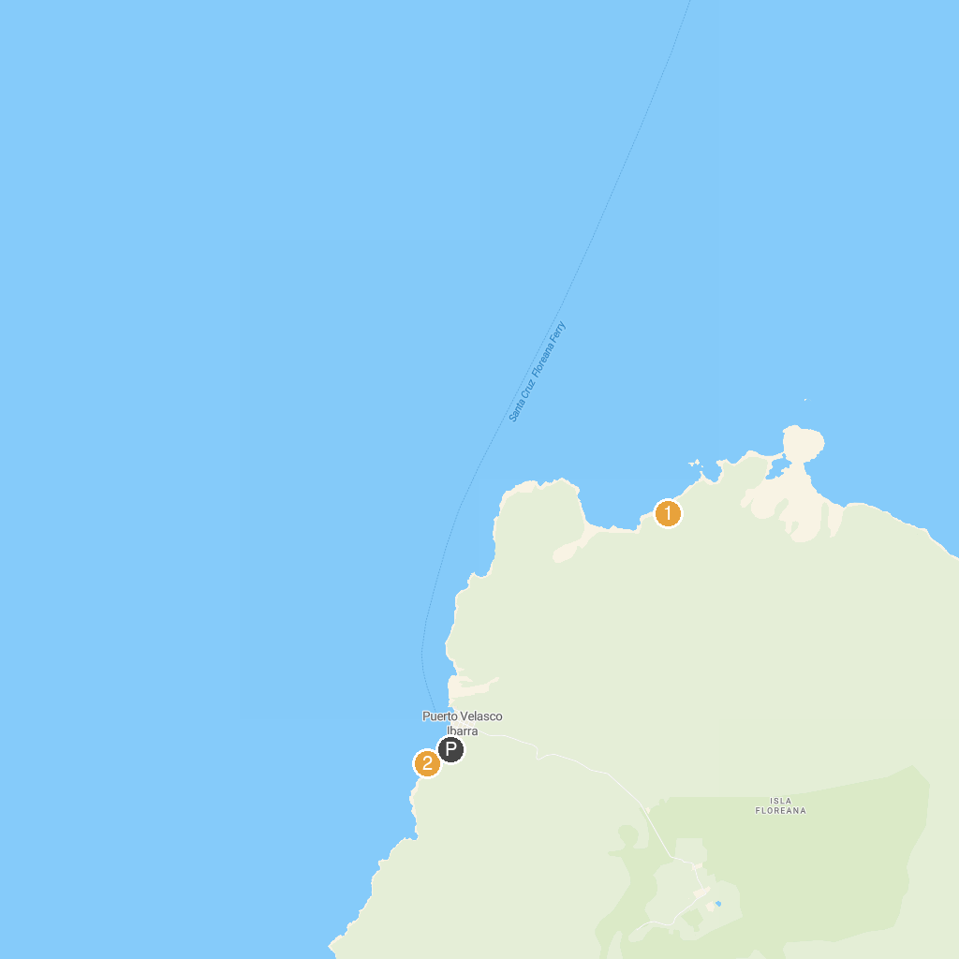
MAP KEY
1. Post Office Bay | 2. La Loberia Isla Floreana
P. Cruise port / terminal
Map © MapTiler © OpenStreetMap contributors · cruiseports.org

