Ceuta, Ceuta, Spain
A Spanish city on the tip of Africa, where Europe and the Maghreb collide at the edge of the Strait of Gibraltar. Two cultures, two continents, one remarkable port call.
⚓ Docked (Muelle de España) · 🕒 Typical call: 6–8 hrs · 💶 Euro (€) · 🗣️ Spanish
✍️ MY DAY IN PORT (FILL IN)
Ship / Date
In port | arrive ______ · all aboard ______
Booked excursion
Notes / meeting point
GETTING ASHORE
- Docking: Ships dock at Muelle de España or Muelle de Poniente, steps from the city center
- Walk to center: ~100 m from Muelle de España — most sights within 20 min on foot
- Best For: History, multicultural atmosphere, duty-free shopping, Morocco day trips
- Don't Miss: The Royal Walls & navigable moat — the only navigable moat in Spain
GETTING AROUND
- 🚕 Taxi: €3.50 start + ~€1.10/km — Taxis queue at the Alfao pier. A short city ride costs roughly €6–10. Supplements apply for luggage (€0.50/bag) and even
- 📱 Rideshare: ✅ Uber
TOP THINGS TO DO
- Royal Walls & Navigable Moat — Ceuta's 15th-century Portuguese fortifications are the star attraction.
- Monte Hacho Panorama — Monte Hacho is one of the legendary Pillars of Hercules.
- Tetouan, Morocco Day Trip — Cross the border into Morocco and explore Tetouan's UNESCO-listed medina — whitewashed streets, artisan souks, and a very…
- Maritime Park of the Mediterranean — Designed by César Manrique, this waterfront park features saltwater lakes, waterfalls, and botanical gardens.
- City Highlights Walk — From the port, stroll to Plaza de África, the Sanctuary of Our Lady of Africa, the House of the Dragons, and the Cathedral — a…
BEST WALKS
- Port to Royal Walls & Old Town Loop: 2–2.5 km · 45–60 min · Easy — Walk from the cruise pier through Plaza de España to Plaza de África, then follow the fortification…
- Cathedral & House of the Dragons: 1 km · 20–30 min · Easy — A short stroll from the port to the Cathedral of Santa María de la Asunción and the nearby Casa de…
WEATHER · DAYLIGHT · MONEY
Month | High °F | Low °F | Rainy days
May | 70 | 61 | 4
Jul | 79 | 69 | 0
Sep | 77 | 68 | 5
Daylight: May 7:15AM–9:19PM · Jul 7:16AM–9:37PM · Sep 8:04AM–8:28PM
cruiseports.org/ceuta · Confirm terminal & all-aboard time with your ship

Ceuta, Ceuta, Spain — Port Map
Red = walkable sights · Amber = excursions farther out · P = cruise terminal
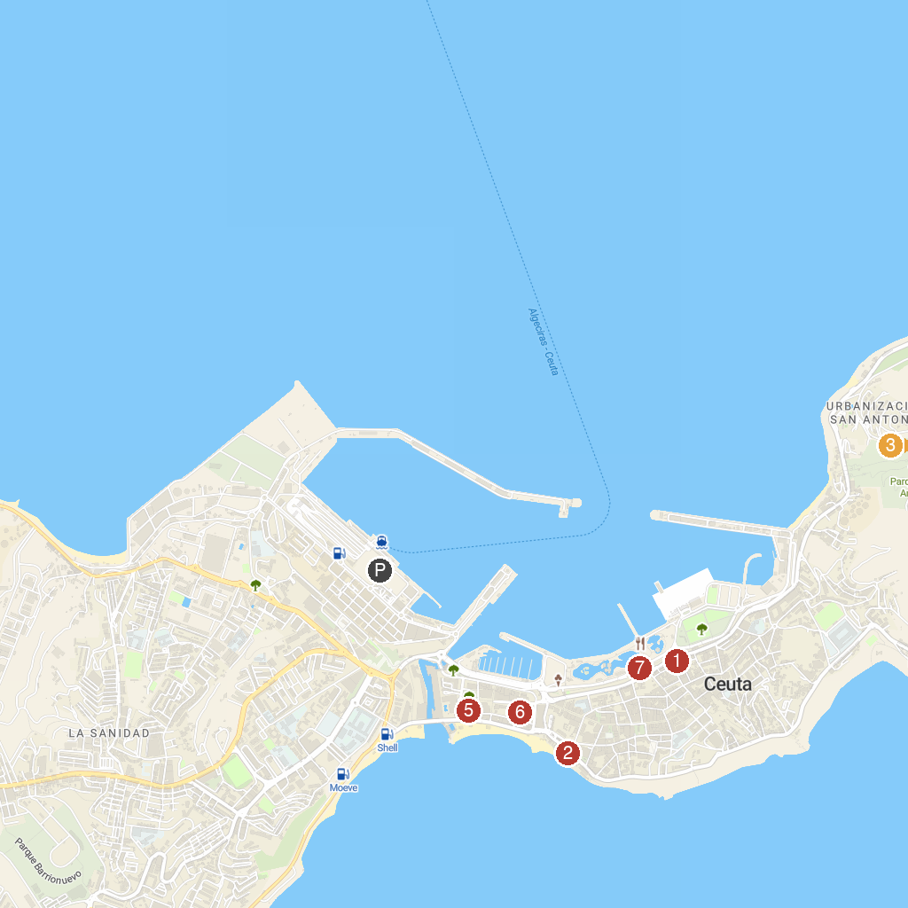
MAP KEY
1. Arab Baths of Ceuta | 5. Cathedral of the Assumption of Ceuta
2. Military Museum of the Legion | 6. Museo de la Basilica Tardorromana
3. Faro Punta Almina | 7. Parque Marítimo del Mediterráneo
4. Puerto de Ceuta
P. Cruise port / terminal
Map © MapTiler © OpenStreetMap contributors · cruiseports.org

