Cetate, Dolj County, Romania
A quiet Danube village opposite Vidin, Bulgaria, Cetate offers a glimpse of rural Romanian river life.
⚓ Docked (river pier) · 🕒 Typical call: 4-6 hrs · 💵 Romanian Leu (RON) · 🗣️ Romanian
✍️ MY DAY IN PORT (FILL IN)
Ship / Date
In port | arrive ______ · all aboard ______
Booked excursion
Notes / meeting point
GETTING ASHORE
- Docking: River pier on the Danube embankment
- Best For: Danube scenery, views across to Vidin fortress, rural Romania
- Don’t Miss: View of Vidin Fortress across the river
- Walk to Center: ~5 minutes from the river pier
cruiseports.org/cetate · Confirm terminal & all-aboard time with your ship

Cetate, Dolj County, Romania — Port Map
Red = walkable sights · Amber = excursions farther out · P = cruise terminal
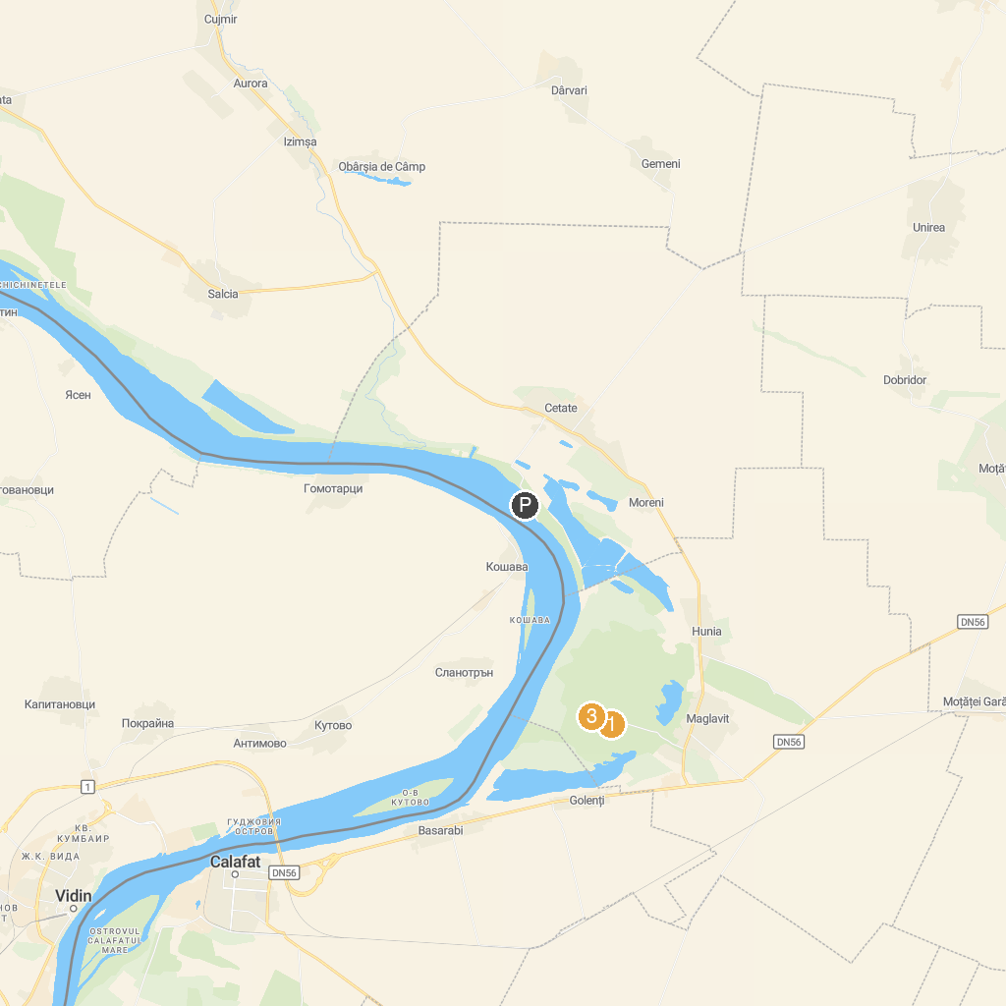
MAP KEY
1. Mănăstirea Maglavit | 3. Port Cultural Cetate
2. Sunny Beach Bascov | 4. Salcia lui Petrache Lupu
P. Cruise port / terminal
Map © MapTiler © OpenStreetMap contributors · cruiseports.org

