Celukan Bawang, North Bali, Indonesia
North Bali's understated cruise gateway trades glossy terminals for genuine island life — rice paddies, volcanic waterfalls, and centuries-old temples, all without the south's traffic gridlock.
⚓ Docked (industrial pier) · 🕒 Typical call: 8-10 hrs · 💵 Indonesian Rupiah (IDR) · 🗣️ Indonesian / Balinese
✍️ MY DAY IN PORT (FILL IN)
Ship / Date
In port | arrive ______ · all aboard ______
Booked excursion
Notes / meeting point
GETTING ASHORE
- Docking: Ships berth directly at Pier 2 (commercial cargo port; no cruise terminal building)
- Walk to Center: Nothing walkable from the pier — private driver or tour bus required
- Best For: Waterfalls, Hindu temples, coffee highlands, Lovina's black-sand beaches
- Don't Miss: Ulun Danu Beratan Temple on Lake Beratan and Sekumpul Waterfall
GETTING AROUND
- 🚕 Taxi: ~IDR 450,000 ($28–$30 USD) one-way — Lovina Beach is ~30 minutes from the port and is the closest tourist area. Negotiate fare before departure; metered taxi
TOP THINGS TO DO
- Ulun Danu Beratan Temple — Bali's most photographed water temple floats on misty Lake Beratan in the central highlands, its multi-tiered shrines reflected…
- Sekumpul & Munduk Waterfalls — Sekumpul — widely considered Bali's most spectacular waterfall — plunges through jungle canyon in multiple cascades.
- Lovina Beach & Dolphin Watching — Just 30 minutes from the port, Lovina's quiet black-sand beaches offer a calm alternative to Bali's crowded south coast.
- Munduk Coffee Plantation Tour — Bali's highland Munduk region grows arabica and robusta coffee in cool volcanic soil.
- Singaraja Colonial Town — Bali's former Dutch colonial capital retains crumbling European facades, Chinese shophouses, and a working port esplanade.
BEST WALKS
- Lovina Beach Stroll: Easy • ~1 km • Flat — From the main Lovina beachfront, walk the black-sand shore past outrigger jukung fishing boats…
- Singaraja Harbour & Old Town Walk: Easy • ~1.5 km • Flat — Start at the Buleleng Harbour esplanade and walk inland along Jalan Ahmad Yani to the old Dutch-era…
WEATHER · DAYLIGHT · MONEY
Month | High °F | Low °F | Rainy days
May | 87 | 76 | 17
Jul | 85 | 74 | 12
Sep | 87 | 74 | 13
Daylight: May 6:24AM–6:09PM · Jul 6:36AM–6:17PM · Sep 6:14AM–6:17PM
cruiseports.org/celukan-bawang · Confirm terminal & all-aboard time with your ship

Celukan Bawang, North Bali, Indonesia — Port Map
Red = walkable sights · Amber = excursions farther out · P = cruise terminal
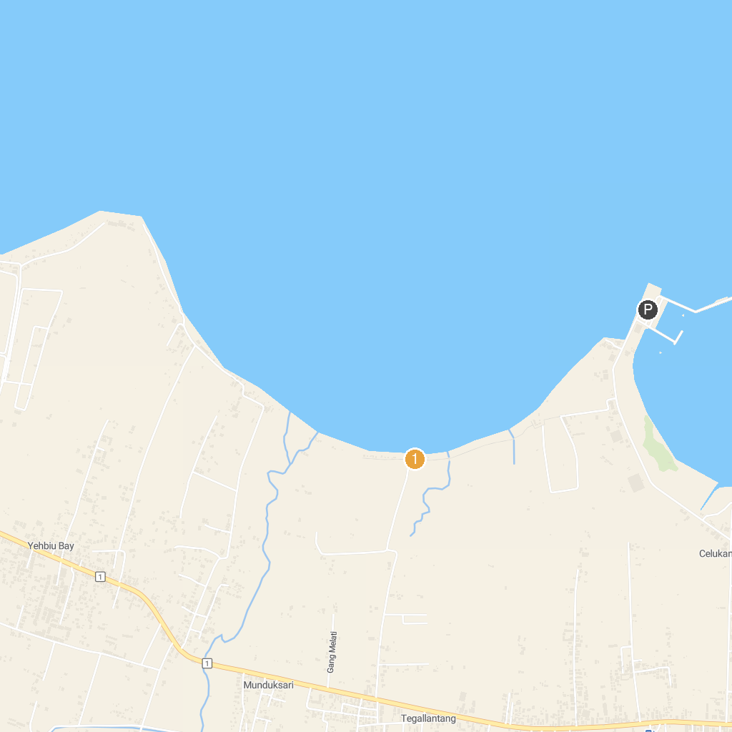
MAP KEY
1. Banjar Hot Spring | 3. Karang Rata Beach
2. Brahmavihara-Arama
P. Cruise port / terminal
Map © MapTiler © OpenStreetMap contributors · cruiseports.org

