Cefalù, Sicily, Italy
A medieval Sicilian town huddled beneath a towering limestone rock, Cefalù packs a UNESCO cathedral, a sandy beach, and one of Sicily's most charming old towns into a single unhurried shore day.
⚓ Tender port · 🕒 Typical call: 7-9 hrs · 💶 Currency: Euro (€) · 🗣️ Language: Italian
✍️ MY DAY IN PORT (FILL IN)
Ship / Date
In port | arrive ______ · all aboard ______
Booked excursion
Notes / meeting point
GETTING ASHORE
- Docking: Anchor & tender to Porto Presidiana
- Walk to centre: 5-10 min from tender dock
- Best For: History, beaches, scenic walks
- Don't Miss: Christ Pantocrator mosaic in the Cathedral
GETTING AROUND
- 🚕 Taxi: €5–10 — Local taxis serve the port area with a base fare of €3–5 plus ~€1.50/km. Short rides within town are typically €5–8; use
- 📱 Rideshare: ✅ Uber
TOP THINGS TO DO
- Cefalù Cathedral & Byzantine Mosaics — The 12th-century Norman Duomo di Cefalù is a UNESCO World Heritage site.
- Hike La Rocca — A steep but rewarding climb up the limestone crag above town.
- Museo Mandralisca — A small but excellent museum housing the famous 'Portrait of an Unknown Man' by Antonello da Messina, plus Greek ceramics, coins…
- Cefalù Beach (Lungomare) — One of Sicily's finest sandy town beaches stretches right along the lungomare.
- Coastal Boat Tour — Hop on a small-group or private boat from Porto Presidiana to explore sea caves, hidden coves, and snorkelling spots along the…
BEST WALKS
- Old Town & Cathedral Loop: 1.5 km · 45 min · Easy — From the tender dock, stroll along the waterfront to the old harbour (Porticciolo), then head up…
- La Rocca Hike: 2.5 km return · 1.5-2 hrs · Moderate-strenuous — From the town centre, follow the signed path up to La Rocca.
WEATHER · DAYLIGHT · MONEY
Month | High °F | Low °F | Rainy days
May | 72 | 61 | 8
Jul | 87 | 76 | 3
Sep | 80 | 71 | 10
Daylight: May 5:53AM–8:07PM · Jul 5:53AM–8:25PM · Sep 6:45AM–7:11PM
cruiseports.org/cefalu · Confirm terminal & all-aboard time with your ship

Cefalù, Sicily, Italy — Port Map
Red = walkable sights · Amber = excursions farther out · P = cruise terminal
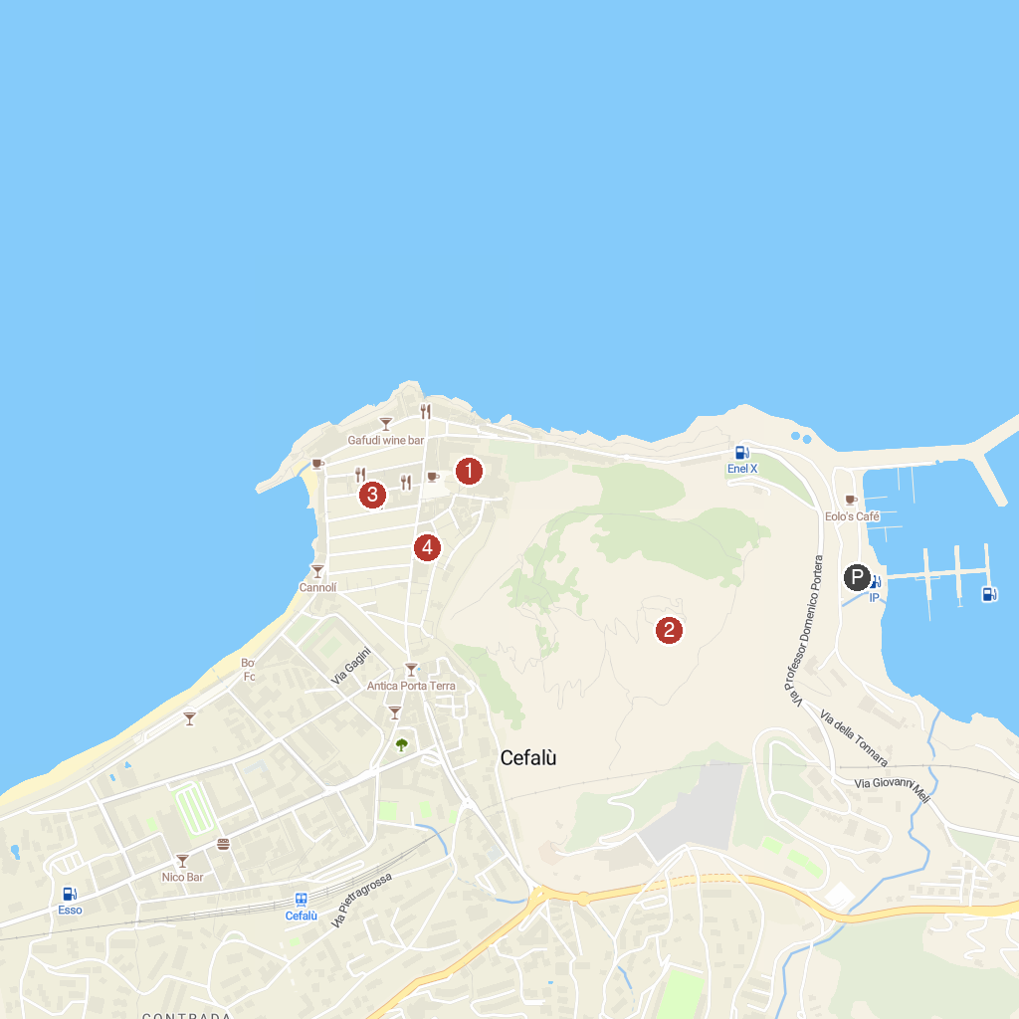
MAP KEY
1. Duomo di Cefalù | 5. Gole di Tiberio
2. Ruins of Cefalù Castle | 6. Museo Mandralisca
3. Castello di Roccella | 7. Chiesa di Santo Stefano Protomartire del Purgatorio
4. Civic Museum of Castelbuono
P. Cruise port / terminal
Map © MapTiler © OpenStreetMap contributors · cruiseports.org

