Catskill, New York, USA
A quiet Hudson River town punching above its weight — birthplace of the Hudson River School, gateway to the Catskill Mountains, and home to a resurgent Main Street of galleries, cafés, and bookshops.
⚓ Docked (Dutchman's Landing) · 🕒 Typical call: 7-9 hrs · 💵 US Dollar · 🗣️ English
✍️ MY DAY IN PORT (FILL IN)
Ship / Date
In port | arrive ______ · all aboard ______
Booked excursion
Notes / meeting point
GETTING ASHORE
- Docking: Dutchman's Landing Park, eastern end of Main Street — ~15-min walk to town center
- Best For: Hudson River School art, mountain hikes, antiques & galleries
- Don't Miss: Thomas Cole National Historic Site and the drive to Kaaterskill Falls
- Currency: US Dollar — cards accepted everywhere
GETTING AROUND
- 🚕 Taxi: Meter / call for quote — Several local taxi companies serve Catskill including Catskill NY Taxi (518-316-5900) and City Taxi (518-943-6666). Usef
- 📱 Rideshare: ✅ Uber, Lyft
TOP THINGS TO DO
- Thomas Cole National Historic Site — Visit the restored home and studio of Thomas Cole, the founder of the Hudson River School of painting.
- Olana State Historic Site — Cross the Rip Van Winkle Bridge to Frederic Church's ornate Persian-inspired hilltop estate with sweeping Hudson Valley panoramas…
- Kaaterskill Falls Hike — The Catskills' most famous waterfall — a two-tiered, 260-foot drop that inspired generations of Hudson River School painters.
- Main Street Walk & Galleries — Catskill's revived Main Street is lined with art galleries, the Magpie Bookshop, antique stores, and cafés like Citiot.
- Rail Explorers: Catskills Division — Pedal a four-wheeled rail bike along the historic Ulster & Delaware Railroad through mountain scenery — a fun, family-friendly…
BEST WALKS
- Dutchman's Landing to Main Street: 0.6 mi · 15 min · Flat — Follow the riverfront path west from the pier into town.
- Main Street to Thomas Cole House: 0.4 mi · 10 min · Easy — From Main Street, head south on Spring Street to reach the Thomas Cole National Historic Site on…
WEATHER · DAYLIGHT · MONEY
Month | High °F | Low °F | Rainy days
May | 70 | 50 | 10
Jul | 84 | 66 | 12
Sep | 76 | 59 | 9
Daylight: May 5:34AM–8:09PM · Jul 5:33AM–8:29PM · Sep 6:36AM–7:04PM
cruiseports.org/catskill-ny · Confirm terminal & all-aboard time with your ship

Catskill, New York, USA — Port Map
Red = walkable sights · Amber = excursions farther out · P = cruise terminal
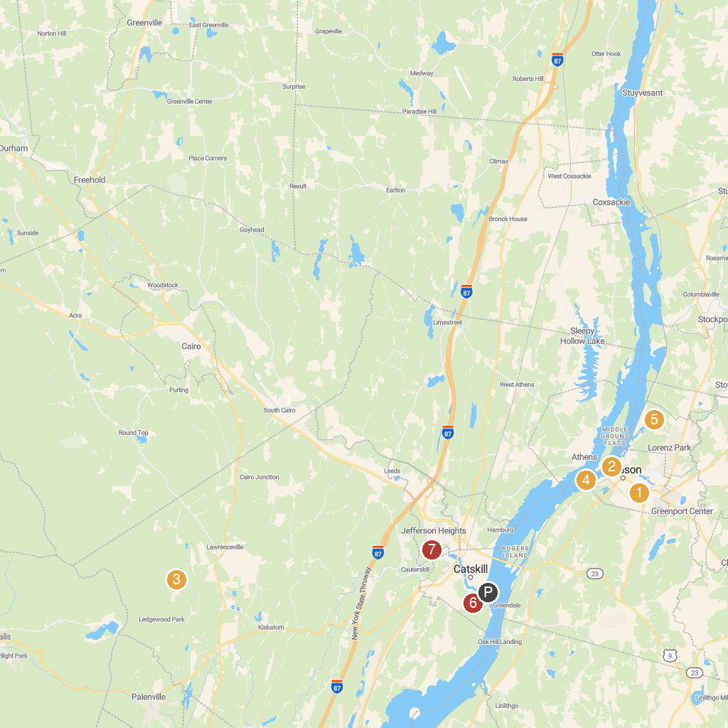
MAP KEY
1. Mahayana Temple | 5. Hudson Athens Lighthouse
2. Public Square | 6. Greenport Conservation Area
3. Promenade Hill Park | 7. RamsHorn-Livingston Audubon Sanctuary
4. Bailiwick Animal Park and Riding Stables | 8. Mawignack Preserve
P. Cruise port / terminal
Map © MapTiler © OpenStreetMap contributors · cruiseports.org

