Catania, Sicily, Italy
Sicily's second city wears its volcanic heart on its sleeve — black lava-stone Baroque palaces, a roaring fish market, and the brooding cone of Mount Etna looming at the end of every street.
⚓ Docked (cruise terminal) · 🕒 Typical call: 8-10 hrs · 💶 Euro (€) · 🗣️ Italian
✍️ MY DAY IN PORT (FILL IN)
Ship / Date
In port | arrive ______ · all aboard ______
Booked excursion
Notes / meeting point
GETTING ASHORE
- Docking: Berths at Stazione Marittima (Catania Cruise Port); up to 5 ships at Pier 25 and Sporgente Centrale
- Walk to center: ~15-20 min on foot (1.5 km) to Piazza del Duomo; flat and straightforward
- Best For: Baroque architecture, Mount Etna tours, Taormina day trips, Sicilian food
- Don't Miss: La Pescheria fish market (mornings), Fontana dell'Elefante, a cable car up Etna
GETTING AROUND
- 🚕 Taxi: €5–€10 — Licensed taxis wait outside the terminal. Meters are required by law, but confirm before boarding. Surcharges apply on S
- 📱 Rideshare: ✅ Uber
- 🚌 Hop-on hop-off: ✅ · from €15
TOP THINGS TO DO
- Mount Etna Volcano — Europe's most active volcano dominates the Catania skyline.
- Taormina & Ancient Greek Theater — Sicily's most photogenic hill town perches 200 m above the Ionian Sea.
- Syracuse & Ortygia Island — One of the greatest Greek cities of antiquity, Syracuse features the Neapolis Archaeological Park (Greek theater, Roman…
- Catania Food & Market Tour — La Pescheria, the raucous fish market behind the cathedral, is a riot of swordfish, sea urchins, and vendor theater.
- Baroque Catania City Walk — Catania's UNESCO-listed Baroque center was rebuilt entirely in black lava stone after the 1693 earthquake.
BEST WALKS
- Baroque Core Walk: 2-3 hrs | 3-4 km | Easy | Start: cruise terminal — The classic introduction to Catania.
- Castle & Gardens Loop: 1.5 hrs | 2.5 km | Easy | Start: Piazza del Duomo — From the cathedral, head southwest to Castello Ursino (the 13th-century Hohenstaufen fortress)…
WEATHER · DAYLIGHT · MONEY
Month | High °F | Low °F | Rainy days
May | 75 | 60 | 5
Jul | 90 | 74 | 1
Sep | 84 | 70 | 8
Daylight: May 5:50AM–8:01PM · Jul 5:50AM–8:20PM · Sep 6:41AM–7:07PM
cruiseports.org/catania · Confirm terminal & all-aboard time with your ship

Catania, Sicily, Italy — Port Map
Red = walkable sights · Amber = excursions farther out · P = cruise terminal
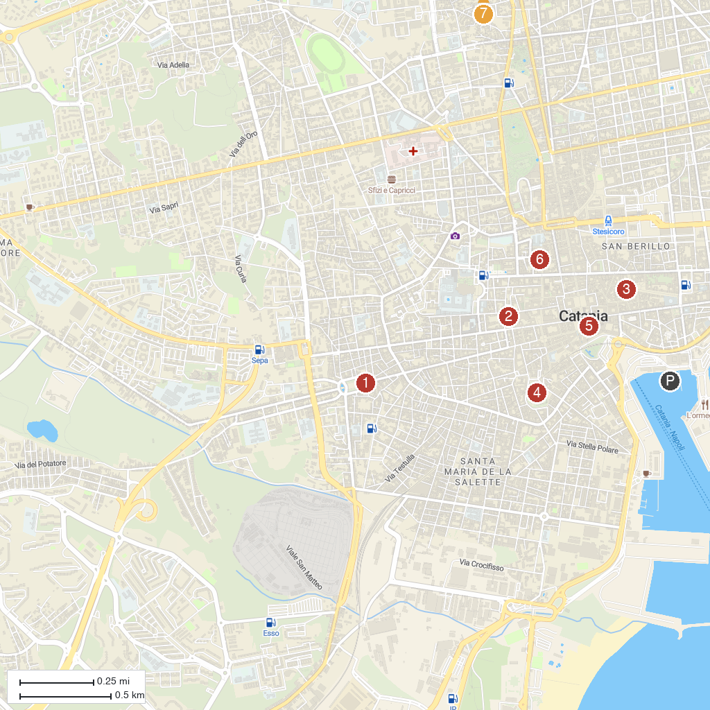
MAP KEY
1. Porta Garibaldi | 5. Basilica Cattedrale di Sant'Agata
2. Roman Odeon | 6. Etnaland
3. Massimo Bellini Theater | 7. Church of St. Camillus
4. Ursino Castle | 8. Parco Gioeni
P. Cruise port / terminal
Map © MapTiler © OpenStreetMap contributors · cruiseports.org

