Catalina Island, California, USA
Twenty-six miles off the Southern California coast, Avalon charms cruise visitors with turquoise waters, a beloved Art Deco ballroom, and resident bison roaming the island's rugged interior. Everything worth seeing is steps from the tender pier.
⚓ Tender port (no cruise pier) · 🕒 Typical call: 7-9 hrs · 💵 USD · 🗣️ English · 🇺🇸 No passport needed
✍️ MY DAY IN PORT (FILL IN)
Ship / Date
In port | arrive ______ · all aboard ______
Booked excursion
Notes / meeting point
GETTING ASHORE
- Docking: Anchor & tender — ships anchor in Avalon Bay; tender boats land at Green Pleasure Pier
- Walk to town: Immediate — Avalon's shops, restaurants, and beach are steps from the tender dock
- Best For: Snorkeling, glass-bottom boat tours, golf-cart sightseeing, Art Deco history
- Don't Miss: Catalina Casino landmark (not a gambling hall), Wrigley Memorial & Botanic Garden
GETTING AROUND
- 🚕 Taxi: $5.95 meter start + $1.60/min — Avalon Taxi Service meets every boat at the terminal with 7-passenger vans. A $3 road maintenance fee and fuel surcharge
- 📱 Rideshare: ❌ not available
TOP THINGS TO DO
- Glass-Bottom Boat & Semi-Submersible Tour — Peer into Avalon's kelp forests and Lover's Cove Marine Preserve without getting wet.
- Catalina Zip-Line Eco Tour — Five zip-lines fly you over Descanso Canyon at up to 45 mph with sweeping views of the harbor and Pacific.
- Catalina Casino Tour — The 1929 Art Deco landmark was never a gambling house — 'casino' is Italian for 'little house' and here signifies a place of…
- Jeep Interior Eco-Tour — Venture beyond Avalon into Catalina's rugged backcountry to spot the island's famous bison herd, golden eagles, island foxes, and…
- Snorkeling at Casino Point Dive Park — Avalon's Casino Point is an official underwater park with exceptional visibility.
BEST WALKS
- Avalon Waterfront Stroll: 1 mile · Flat · 30–45 min — Walk Crescent Avenue from Green Pleasure Pier west to the Catalina Casino, passing boutique shops…
- Hermit Gulch Trail: 2 miles round-trip · Moderate · 1–1.5 hrs — Head up Avalon Canyon Road from town to pick up this trail past the campground.
WEATHER · DAYLIGHT · MONEY
Month | High °F | Low °F | Rainy days
May | 64 | 58 | 2
Jul | 71 | 65 | 0
Sep | 73 | 66 | 1
Daylight: May 5:53AM–7:46PM · Jul 5:55AM–8:03PM · Sep 6:37AM–6:58PM
cruiseports.org/catalina-island · Confirm terminal & all-aboard time with your ship

Catalina Island, California, USA — Port Map
Red = walkable sights · Amber = excursions farther out · P = cruise terminal
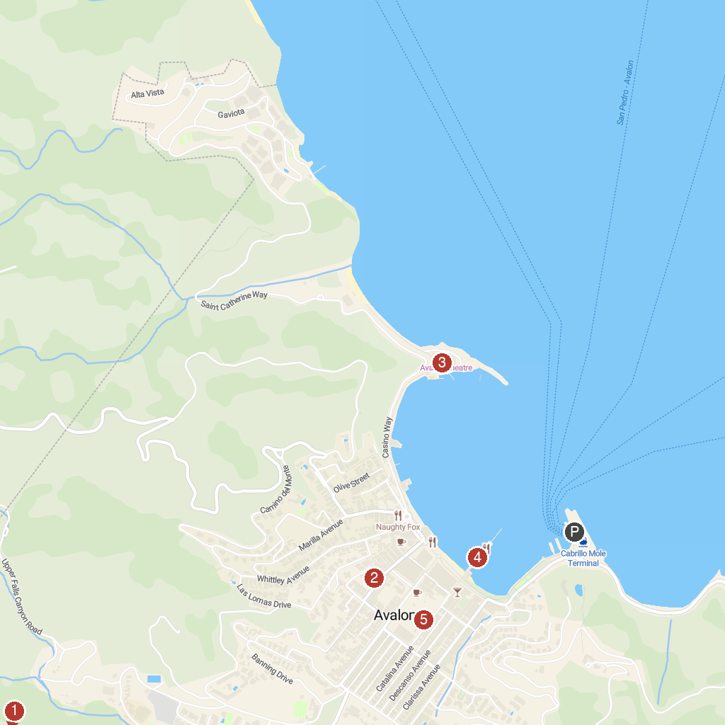
MAP KEY
1. Wrigley Memorial | 4. Catalina Island Company Ticket Booth
2. Catalina Museum For Art & History | 5. IMMERSED
3. Casino Ballroom
P. Cruise port / terminal
Map © MapTiler © OpenStreetMap contributors · cruiseports.org

