Castine, Maine, USA
One of the oldest continuously settled towns in North America, Castine sits at the tip of a peninsula on Penobscot Bay — four centuries of French, British, Dutch, and American history wrapped in a compact, elm-shaded village that's entirely walkable from the Town Dock.
⚓ Tender port · 🕒 Typical call: 6-8 hrs · 💵 US Dollar · 🗣️ English · 🏛️ National Historic Register
✍️ MY DAY IN PORT (FILL IN)
Ship / Date
In port | arrive ______ · all aboard ______
Booked excursion
Notes / meeting point
GETTING ASHORE
- Docking: Tender to Town Dock floating pier
- Walk to center: 2 min from Town Dock to Main St
- Best For: History buffs, walkers, kayakers
- Don't Miss: Fort George earthworks & Witherle Woods trails
GETTING AROUND
- 🚕 Taxi: Varies; ~$140/hr (regional) — No taxis typically stage at the dock. For travel to nearby towns (Blue Hill, Belfast, Bar Harbor), pre-arrange a regiona
TOP THINGS TO DO
- Fort George & Historic Markers Walk — Fort George (1779) is the site of the Penobscot Expedition — America's worst naval defeat before Pearl Harbor.
- Sea Kayaking on Penobscot Bay — Castine Kayak Adventures runs guided half-day paddles around the peninsula — seals, porpoises, osprey, and dramatic shoreline…
- Witherle Woods Preserve Hike — 193 acres of coastal forest with 4+ miles of trails maintained by Maine Coast Heritage Trust.
- Tapley Cove Oyster Tasting Trip — Castine Cruises runs boat trips to a working sustainable oyster farm at Tapley Cove where you can learn the harvest process and…
- Golf Cart Historic Tour — The Castine Touring Company offers 60–90 min narrated tours of the town's highlights in a six-passenger golf cart, led by…
BEST WALKS
- Town Dock to Fort George Loop: 1.5 miles · 45–60 min · Easy — From the dock, walk up Main Street to the elm-lined Common, then up Battle Avenue to the Fort…
- Witherle Woods Preserve Loop: 2–3 miles · 1-2 hrs · Easy–moderate — Head west from town to the Maine Coast Heritage Trust trailhead.
WEATHER · DAYLIGHT · MONEY
Month | High °F | Low °F | Rainy days
May | 59 | 46 | 10
Jul | 73 | 62 | 11
Sep | 68 | 57 | 8
Daylight: May 5:07AM–7:55PM · Jul 5:05AM–8:16PM · Sep 6:14AM–6:44PM
cruiseports.org/castine-me · Confirm terminal & all-aboard time with your ship

Castine, Maine, USA — Port Map
Red = walkable sights · Amber = excursions farther out · P = cruise terminal
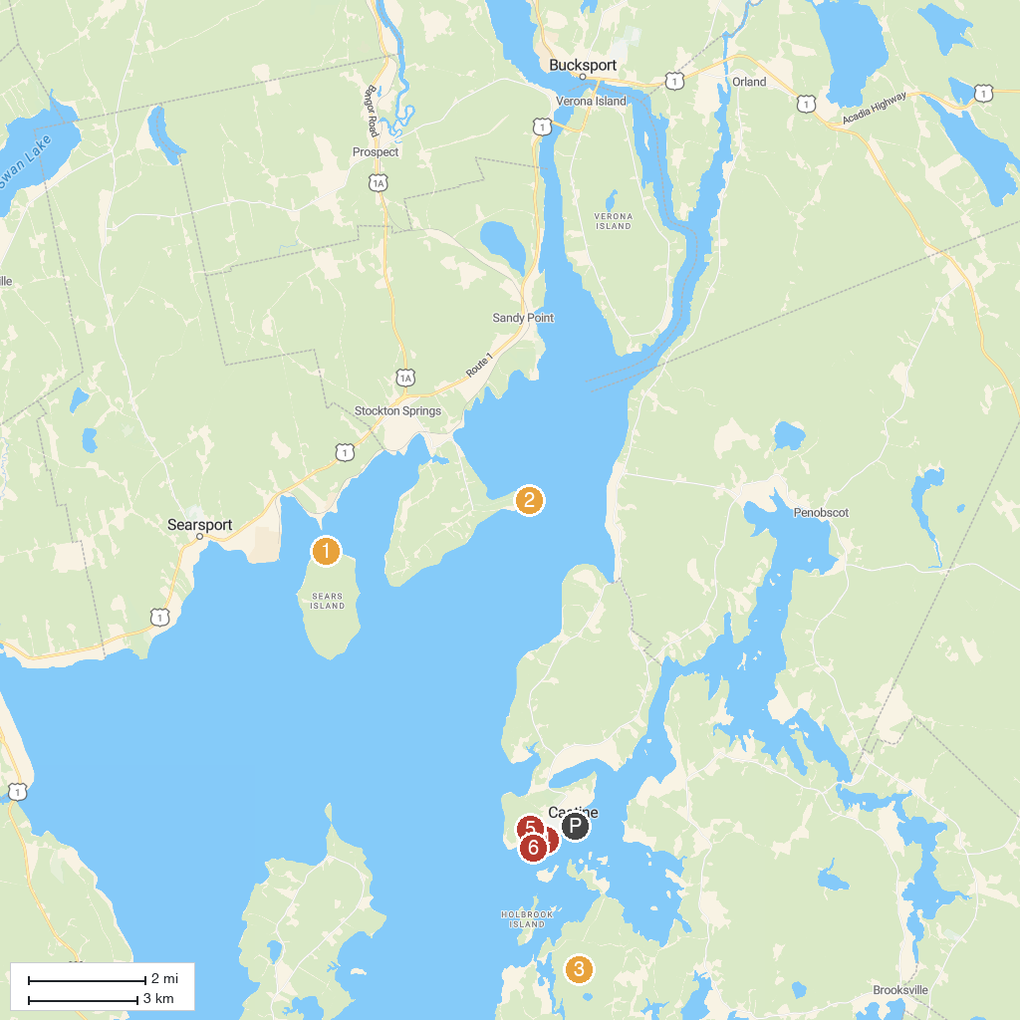
MAP KEY
1. Friends of Sears Island | 5. Moose Point State Park
2. Fort Point State Park | 6. Wilson Museum
3. Penobscot Marine Museum | 7. Witherle Woods
4. Holbrook Island Sanctuary | 8. Fort Madison
P. Cruise port / terminal
Map © MapTiler © OpenStreetMap contributors · cruiseports.org

