Castellón de la Plana, Valencia, Spain
Valencia's lesser-known coast delivers medieval towers, wide sandy beaches, and easy access to the walled hilltop town of Peñíscola — without the crowds of Barcelona or Valencia.
⚓ Docked (cruise terminal) · 🕒 Typical call: 8–10 hrs · 💵 Euro (€) · 🗣️ Spanish / Valencian
✍️ MY DAY IN PORT (FILL IN)
Ship / Date
In port | arrive ______ · all aboard ______
Booked excursion
Notes / meeting point
GETTING ASHORE
- Docking: Ships berth at Puerto de Castellón (El Grao), ~4 km from the city centre; free shuttle bus provided
- Walk to centre: Not walkable from port — free shuttle or taxi to Plaza Mayor (~10 min ride)
- Best For: History lovers, beach days, foodies, day trips to Peñíscola or Valencia
- Don't Miss: Climbing El Fadrí bell tower for panoramic rooftop views over the city
GETTING AROUND
- 🚕 Taxi: €5–10 — Taxis are available at the port. The city center is roughly 5–6 km away; metered fare starts at €4.90 for the first 2.7
TOP THINGS TO DO
- El Fadrí Tower & Cathedral — The 16th-century octagonal bell tower stands 60 m tall beside the Concatedral de Santa María.
- Day Trip to Peñíscola — Drive about 50 minutes north to the 'Papal City,' where Papa Luna Castle — a 13th-century Templar fortress that later housed…
- Coves de Sant Josep — Float through Europe's longest navigable underground river in these stunning limestone caves at La Vall d'Uixó, about 25 km…
- Valencia City Day Trip — Spain's third city is under an hour away and delivers the City of Arts and Sciences, La Lonja market (UNESCO), and the birthplace…
- Columbretes Islands Boat Trip — These remote volcanic islands about 30 nautical miles (~50 km) offshore are a protected marine reserve — superb snorkelling…
BEST WALKS
- Historic Centre Loop: 2–3 km · 1.5–2 hrs · Easy — A stroll taking in all the main monuments within a few blocks of Plaza Mayor.
- El Grao Seafront Stroll: 2 km · 45 min · Easy — Walk the maritime promenade in the port district, past the fishing harbour and seafood restaurants…
WEATHER · DAYLIGHT · MONEY
Month | High °F | Low °F | Rainy days
May | 73 | 58 | 5
Jul | 85 | 72 | 2
Sep | 80 | 67 | 7
Daylight: May 6:44AM–9:08PM · Jul 6:44AM–9:27PM · Sep 7:41AM–8:08PM
cruiseports.org/castellon-de-la-plana · Confirm terminal & all-aboard time with your ship

Castellón de la Plana, Valencia, Spain — Port Map
Red = walkable sights · Amber = excursions farther out · P = cruise terminal
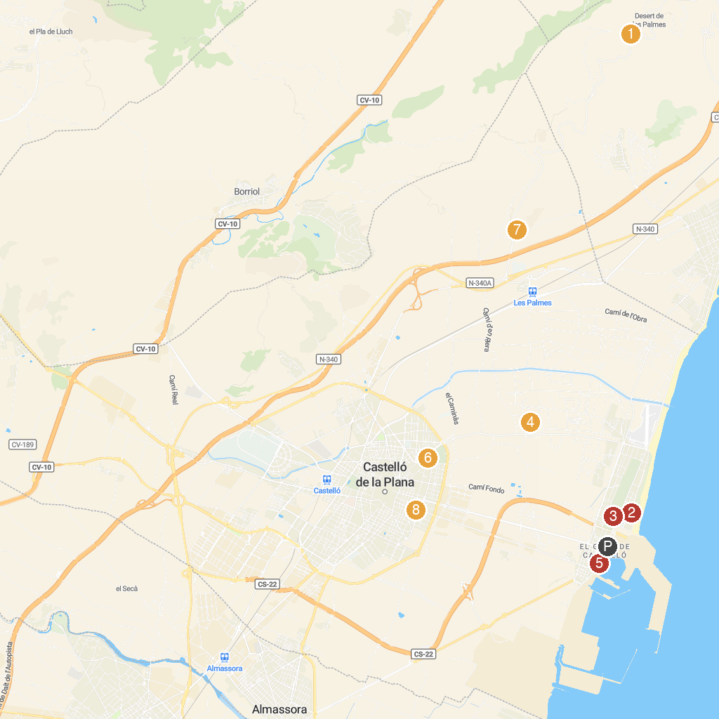
MAP KEY
1. Desert de les Palmes | 5. Puerto Azahar
2. Litoral Park | 6. Parque de Rafalafena
3. Parque Del Pinar | 7. Castell Vell
4. Meridiano Park | 8. Museo de Bellas Artes de Castellón
P. Cruise port / terminal
Map © MapTiler © OpenStreetMap contributors · cruiseports.org

