Cassis, Provence, France
Limestone cliffs plunge into impossible turquoise water at the edge of a sun-baked Provençal village. Cassis is compact, walkable, and utterly beautiful — the calanques alone are worth the tender ride.
⚓ Tender port (small ships only) · 🕒 Typical call: 6-8 hrs · 💶 Euro (€) · 🗣️ French
✍️ MY DAY IN PORT (FILL IN)
Ship / Date
In port | arrive ______ · all aboard ______
Booked excursion
Notes / meeting point
GETTING ASHORE
- Docking: Tender only — small/luxury ships anchor offshore; larger ships dock at Marseille and coach to Cassis (~45 min)
- Walk to center: Tender lands at Vieux Port — harbor, cafes, and beaches immediately on foot
- Best For: Calanques boat tours, wine tasting, scenic coastal walks, French seafood
- Don't Miss: Boat tour into the Calanques National Park (Port-Miou, Port-Pin, En-Vau)
GETTING AROUND
- 🚕 Taxi: €5 base + €1.80/km — Taxis are available in Cassis for short hops around town. A typical in-town ride runs €10–€15. For trips to/from Marseil
- 📱 Rideshare: ✅ Uber, Bolt
TOP THINGS TO DO
- Calanques Boat Tour — The essential Cassis experience: a scenic cruise from the harbor into the Calanques National Park, visiting the dramatic…
- Kayaking the Calanques — Paddle your own way into sea caves and hidden coves along the Calanques coastline.
- Route des Crêtes & Cap Canaille — Drive or join a tour along the scenic ridge road to Cap Canaille, the highest sea cliff in France (394 m).
- Cassis Wine Tasting — Cassis earned one of France's first AOC wine designations (1936) — the first AOC white wine of Provence — prized for crisp…
- Village Stroll & Museum — Wander the cobbled lanes behind the harbor, spot the medieval Château de Cassis overlooking the bay, and visit the Municipal…
BEST WALKS
- Harbor to Calanque de Port-Miou: 2 km | ~20 min one-way | Easy–moderate — A well-marked path leads west from the Cassis harbor along the coast to Port-Miou, the closest…
- Village Loop & Château Viewpoint: 1.5 km | ~30 min | Easy — Walk from the harbor through Place Baragnon and the old quarter, then climb to the overlook below…
WEATHER · DAYLIGHT · MONEY
Month | High °F | Low °F | Rainy days
May | 71 | 57 | 8
Jul | 85 | 70 | 1
Sep | 78 | 64 | 6
Daylight: May 6:14AM–8:54PM · Jul 6:11AM–9:15PM · Sep 7:17AM–7:47PM
cruiseports.org/cassis · Confirm terminal & all-aboard time with your ship

Cassis, Provence, France — Port Map
Red = walkable sights · Amber = excursions farther out · P = cruise terminal
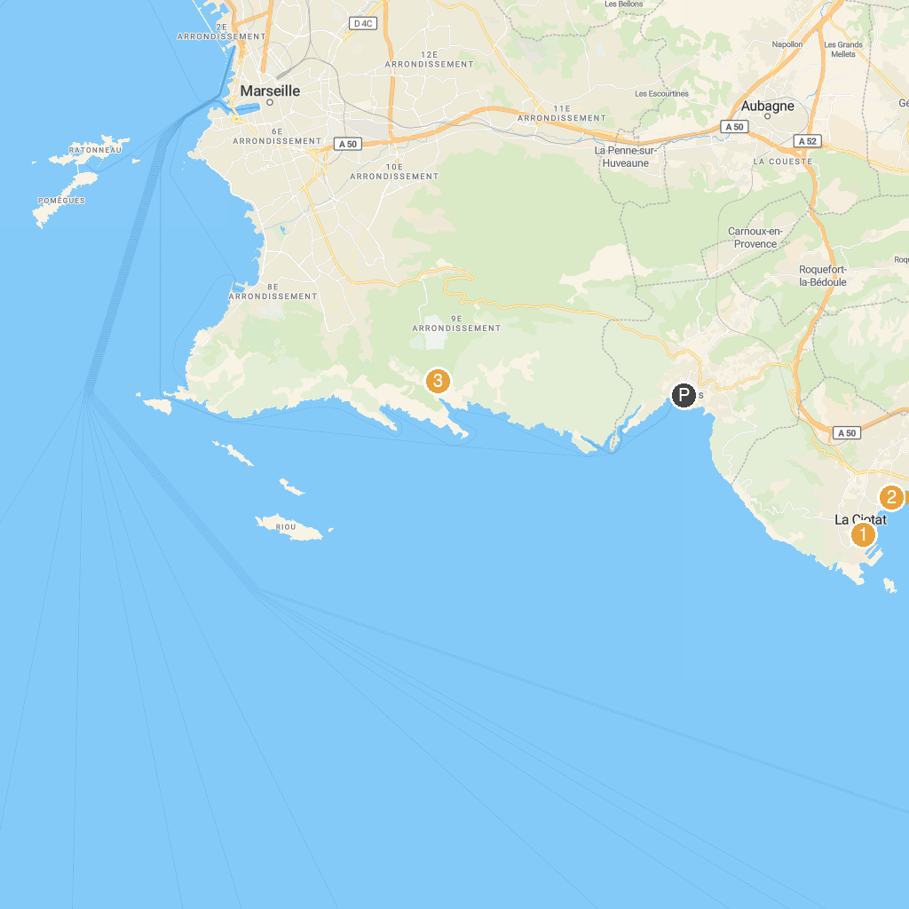
MAP KEY
1. Unité d'Habitation | 5. Patinoire Palais Omnisports Marseille Grand-Est
2. Orange Vélodrome | 6. Green Island Shuttle
3. Parc Borély | 7. Plage Lumière
4. Pas de la Demi Lune | 8. Parc national des Calanques
P. Cruise port / terminal
Map © MapTiler © OpenStreetMap contributors · cruiseports.org

