Casablanca, Morocco
Morocco's commercial capital delivers one of the world's great mosques, a maze of Art Deco boulevards, a fragrant market quarter, and easy rail access to the elegant capital Rabat — all from a brand-new terminal that opened in 2026.
⚓ Docked (new terminal, Jetée Moulay Youssef) · 🕒 Typical call: 9–11 hrs · 💵 Moroccan Dirham (MAD) · 🗣️ Arabic · French · some English
✍️ MY DAY IN PORT (FILL IN)
Ship / Date
In port | arrive ______ · all aboard ______
Booked excursion
Notes / meeting point
GETTING ASHORE
- Docking: New cruise terminal (GPH, opened Jan 2026)
- To city center: ~1 km · short taxi or shuttle
- Best For: Hassan II Mosque · Habous Quarter · Rabat day trip
- Don't Miss: Guided interior tour of Hassan II Mosque
GETTING AROUND
- 🚕 Taxi: 100–150 MAD (~$10–15 USD) — Small metered taxis for city-limit rides. Drivers often prefer a flat fare with tourists — agree on the price before get
- 📱 Rideshare: ✅ Uber, Bolt
TOP THINGS TO DO
- Hassan II Mosque — Interior Tour — One of the world's largest mosques, with a 210-metre minaret visible from the sea and sections of the prayer hall built out over…
- Art Deco & Mohammed V Square — Casablanca's French colonial architects blended Art Deco with Moorish arches in the 1930s to create a distinctive 'Mauresque'…
- Habous Quarter (New Medina) — Built by the French in the 1930s to relieve overcrowding, the Habous Quarter is a planned medina — orderly lanes of…
- Rabat Day Trip — Morocco's elegant capital is ~1 hr by train (Casa-Port → Rabat-Agdal) and a world away from Casablanca's bustle.
- Corniche Ain Diab & Coast — The Atlantic seafront west of the Hassan II Mosque — a long promenade of cafés, the El Hank lighthouse, and crashing waves.
BEST WALKS
- Mohammed V Square to Habous Quarter: ~2.5 km · 1.5 hrs · easy — Start at Mohammed V Square to take in the Art Deco civic buildings, then walk south through the new…
- Hassan II Mosque to Corniche: ~1.5 km · 45 min · easy — After the mosque tour, walk north-west along the Corniche (Boulevard de la Corniche / Boulevard…
- Old Medina wander: ~1 km · 45 min · moderate — Casablanca's walled old medina is small by Moroccan standards but atmospheric — crumbling…
WEATHER · DAYLIGHT · MONEY
Month | High °F | Low °F | Rainy days
May | 75 | 60 | 3
Jul | 81 | 67 | 0
Sep | 80 | 66 | 2
Daylight: May 6:30AM–8:24PM · Jul 6:31AM–8:41PM · Sep 7:14AM–7:36PM
cruiseports.org/casablanca · Confirm terminal & all-aboard time with your ship

Casablanca, Morocco — Port Map
Red = walkable sights · Amber = excursions farther out · P = cruise terminal
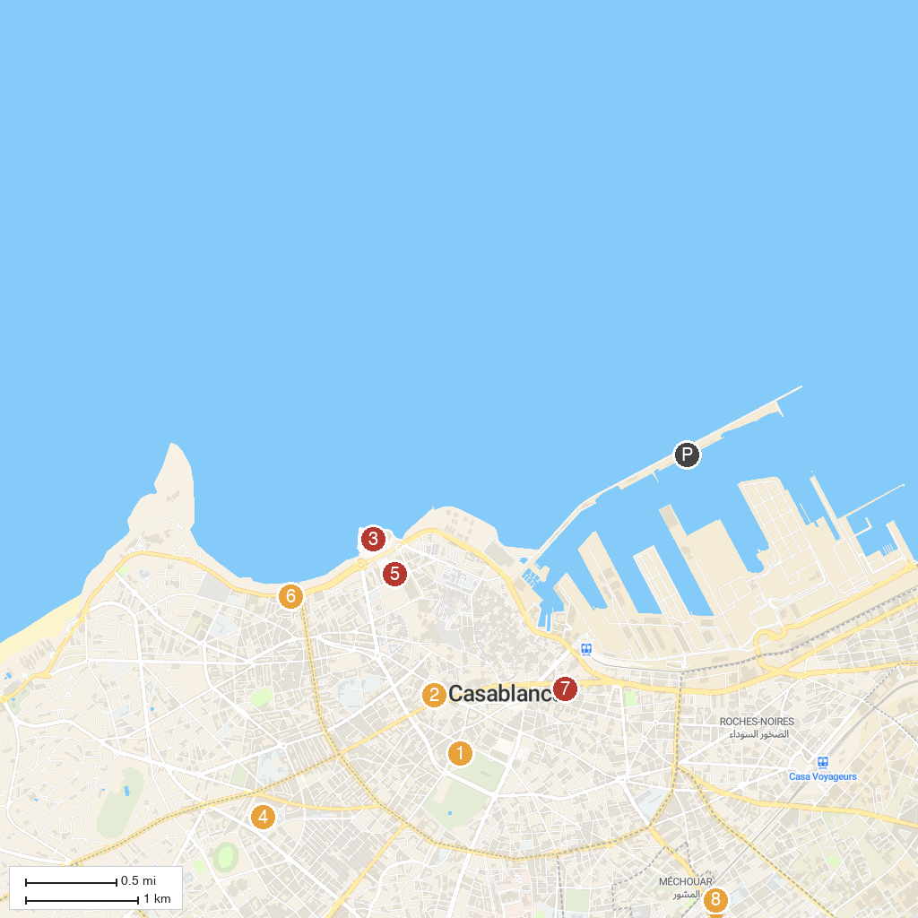
MAP KEY
1. Sacred Heart Cathedral | 5. Hassan II Mosque Museum
2. Beth-El Temple | 6. BMPT
3. Hassan II Mosque | 7. Aisha Morocco Tours
4. L'Atelier 21 | 8. المسجد العتيق عين الشق
P. Cruise port / terminal
Map © MapTiler © OpenStreetMap contributors · cruiseports.org

