Marina di Carrara, Tuscany, Italy
Gateway to the snow-white Apuan Alps, where Roman emperors and Renaissance sculptors sourced the world's finest marble — and Pisa is just a 40-minute train ride away.
⚓ Docked (pier) · 🕒 Typical call: 8-10 hrs · 💶 Euro (€) · 🗣️ Italian · 🚢 Ships up to 295 m LOA
✍️ MY DAY IN PORT (FILL IN)
Ship / Date
In port | arrive ______ · all aboard ______
Booked excursion
Notes / meeting point
GETTING ASHORE
- Docking: Direct pier — Tagliercio or Eugenio Chiesa quay; no tender
- Walk to center: Marina di Carrara town ~2 km (25 min walk or free shuttle)
- Best For: Marble quarry 4x4 tours, Pisa & Leaning Tower, Cinque Terre
- Don't Miss: Lardo di Colonnata in the quarrymen's village of Colonnata
GETTING AROUND
- 🚕 Taxi: €6–€14 — Official taxis wait outside the port gates. Expect €6–8 to Carrara-Avenza (train station) and €11–14 to Carrara's histor
- 📱 Rideshare: ❌ not available
TOP THINGS TO DO
- Marble Quarries 4x4 Jeep Tour — Bounce up into the Apuan Alps in an open jeep to see the blinding white excavation faces where Michelangelo himself selected stone.
- Pisa & the Leaning Tower — A 40-minute train ride brings you to Pisa Centrale, then a 20-minute walk or bus to the Campo dei Miracoli — the Leaning Tower…
- Cinque Terre Villages & Portovenere — The five colorful cliffside villages of Cinque Terre sit just up the Ligurian coast.
- Lucca & Pisa Combo — Lucca's Renaissance walls are so wide you can cycle along the top.
- Historic Carrara & Cathedral Walk — The city of Carrara is 6 km inland — a short taxi ride to Piazza Alberica, the 12th-century Duomo di Carrara, and the Accademia…
BEST WALKS
- Marina di Carrara Seafront Stroll: 2 km one-way · 25 min · Flat · Paved promenade — Turn left out of the port gate and follow the coast road into the seaside resort of Marina di…
- Port Perimeter Walk: 2.5 km loop · 30 min · Flat · Industrial scenery — A short walkway runs around the port perimeter offering views of the Apuan Alps rising dramatically…
WEATHER · DAYLIGHT · MONEY
Month | High °F | Low °F | Rainy days
May | 69 | 57 | 13
Jul | 82 | 69 | 5
Sep | 76 | 63 | 9
Daylight: May 5:53AM–8:39PM · Jul 5:51AM–9:00PM · Sep 6:59AM–7:29PM
cruiseports.org/carrara · Confirm terminal & all-aboard time with your ship

Marina di Carrara, Tuscany, Italy — Port Map
Red = walkable sights · Amber = excursions farther out · P = cruise terminal
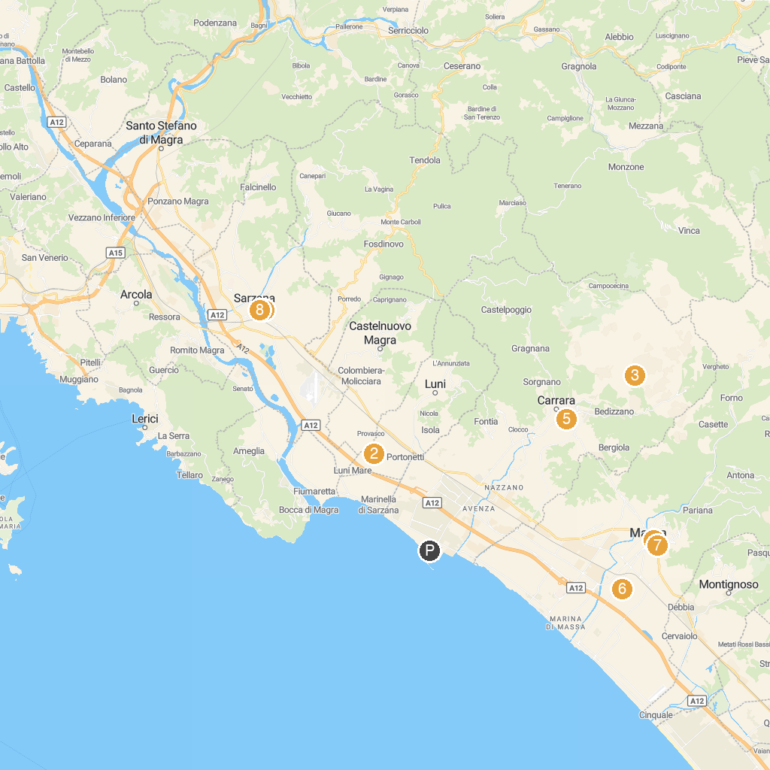
MAP KEY
1. Fortezza Firmafede | 5. Palazzo Cucchiari
2. National Archaeological Museum and Archaeological Area of Luni | 6. I Giardini della Rinchiostra
3. MarmoTour Fantiscritti | 7. RAM Anti-aircraft refuge of Martana
4. Palazzo Ducale di Massa | 8. Sarzana Cathedral Santa Maria Assunta
P. Cruise port / terminal
Map © MapTiler © OpenStreetMap contributors · cruiseports.org

