Carloforte, Sardinia, Italy
The only town on Isola di San Pietro, Carloforte is a sun-drenched anomaly — a piece of Liguria transplanted to southwestern Sardinia, ringed by turquoise coves and famous for its heritage red-tuna fishery.
⚓ Tender port · 🕒 Typical call: 6-8 hrs · 💶 Euro (€) · 🗣️ Italian / Tabarchino dialect
✍️ MY DAY IN PORT (FILL IN)
Ship / Date
In port | arrive ______ · all aboard ______
Booked excursion
Notes / meeting point
GETTING ASHORE
- Docking: Tender — tenders land at the town quay in the harbor
- Walk to center: Immediate — you step off tenders directly into the waterfront
- Best For: Coastal walks, tuna cuisine, boat trips, relaxed island atmosphere
- Don't Miss: Red tuna at a waterfront trattoria and a boat trip to Le Colonne sea stacks
GETTING AROUND
- 🚕 Taxi: Varies (fixed island fares) — A small number of local taxis operate on the island with fixed fares to beaches and inland areas. Payment is made to the
- 📱 Rideshare: ❌ not available
TOP THINGS TO DO
- Boat Tour of San Pietro Island — Circle the island by boat, stopping at Cala Fico, Grotta delle Oche, Le Colonne sea stacks, and secluded coves for swimming.
- Carloforte Old Town Walking Tour — A guided stroll through the narrow carruggi reveals the town's unique Ligurian-Sardinian identity — pastel houses, Piazza Carlo…
- Tuna & Tabarchino Food Experience — Carloforte is Italy's red-tuna capital.
- Capo Sandalo & Eleonora's Falcon Reserve — Drive or cycle to Italy's westernmost point at Capo Sandalo Lighthouse, where the rocky headland is a key nesting site for…
- Scooter or E-Bike Island Loop — Rent a scooter or e-bike at the harbor and circuit San Pietro Island's 25 km coastal road.
BEST WALKS
- Carloforte Carruggi & Waterfront Loop: 1.5 km · 30 min · Easy — From the harbor quay, thread through the narrow carruggi to Piazza Carlo Emanuele III, then up past…
- Coastal Path to Spiaggia Guidi: 3 km one way · 45 min · Easy–Moderate — Head north from town along the coastal road to reach Spiaggia Guidi, one of the island's most…
WEATHER · DAYLIGHT · MONEY
Month | High °F | Low °F | Rainy days
May | 71 | 60 | 7
Jul | 86 | 73 | 1
Sep | 81 | 70 | 5
Daylight: May 6:13AM–8:32PM · Jul 6:13AM–8:51PM · Sep 7:08AM–7:34PM
cruiseports.org/carloforte · Confirm terminal & all-aboard time with your ship

Carloforte, Sardinia, Italy — Port Map
Red = walkable sights · Amber = excursions farther out · P = cruise terminal
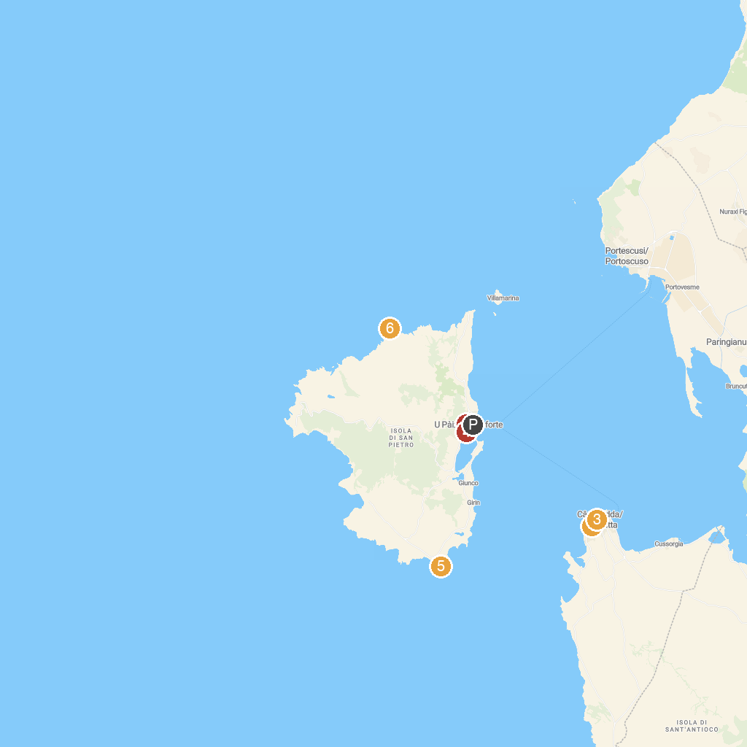
MAP KEY
1. Spiaggia di Sottotorre | 4. Monumento ai Caduti
2. Church of Saint Charles Borromeo | 5. Punta delle Colonne
3. Museo MACC - Museo d'Arte Contemporanea Calasetta | 6. Scogliera della Punta delle Oche
P. Cruise port / terminal
Map © MapTiler © OpenStreetMap contributors · cruiseports.org

